GOVERNMENT OF ARUNACHAL PRADESH

Press Communiqué

Dated Nov 11th, 2024

First-Ever Eaglenest Butterfly Festival 2024 Concludes in Doimara, Celebrating Conservation and Biodiversity

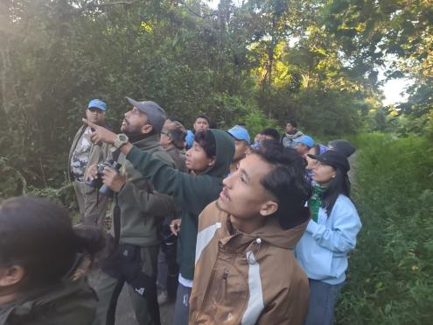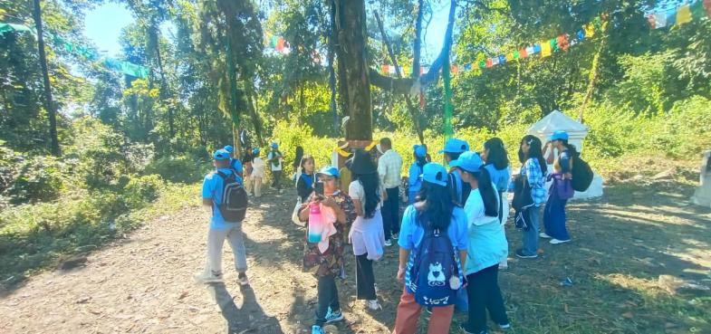
Doimara: The inaugural three-day Eaglenest Butterfly Festival 2024 was celebrated at Doimara in Arunachal Pradesh’s West Kameng district, marking a vibrant event dedicated to raising awareness about the crucial role of butterflies in maintaining ecological balance. The festival, organized by Nature’s Friendship Rupa and Mahila Shakti Kendra Balipara with support from the Department of Tourism and the Department of Environment, Forest & Climate Change, Government of Arunachal Pradesh, attracted participants from the region and beyond.
The festival was officially inaugurated by Chief Guest D.K. Thongdok, former Minister, alongside Guest of Honour Millo Tassar (IFS), Conservator of Forest, and Tracy Thongdok, District Tourism Officer of West Kameng. Attendees included representatives from Tezpur University, Rangapara College, Balipara College, PRI members, and senior residents from the local communities of Doimara, Kamengbari, and Rupa.
The event featured a series of butterfly and bird walks in the scenic Doimara and Khellong areas, allowing participants to experience the region’s rich biodiversity firsthand. Alongside these outdoor activities, discussions emphasized the vital role butterflies play in maintaining ecological health, and the importance of their conservation in the face of environmental challenges.
The festival concluded with a ceremony recognizing the participants and supporting departments for their contributions to this unique event, with certificates awarded to all participants and supporting bodies.
The success of the Eaglenest Butterfly Festival 2024 highlights the commitment of local organizations and government bodies to environmental conservation and education. It is hoped that this annual event will continue to inspire greater awareness and community involvement in preserving Arunachal Pradesh’s rich natural heritage.

