Dated : 29th October 2024
PRESS RELEASE
Entrepreneurship Development Cell, DNGC concludes 3 batches of Entrepreneurship Awareness Programme

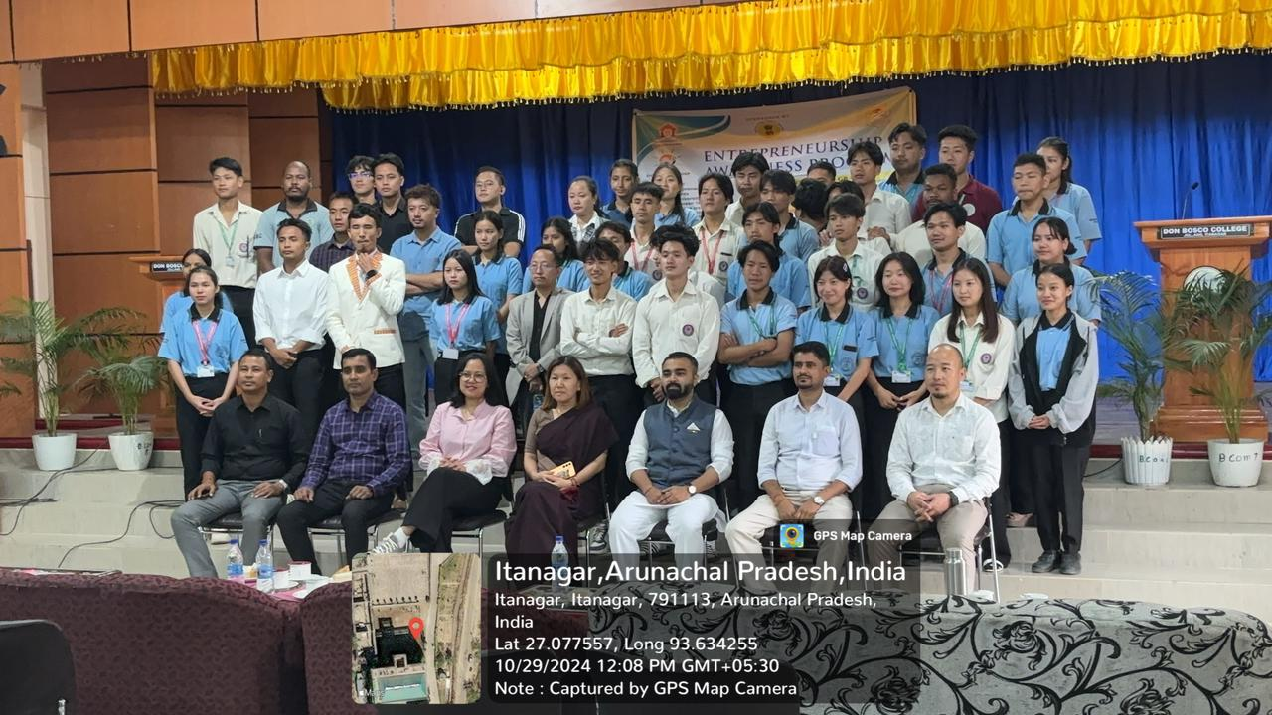
The Entrepreneurship Development Cell of Dera Natung Government College (DNGC), Itanagar, concluded 3 batches of One day Entrepreneurship Awareness Programme (EAP) in collaboration with the Indian Institute of Entrepreneurship, Guwahati, under the project “Establish, Develop and Manage Entrepreneurship Development Centres (EDCs) and Incubation Centers (ICs) in the Educational Institutes of North Eastern Region” which is sponsored by North Eastern Council (NEC), Shillong, Govt. of India.and funded by the North Eastern Council, Shillong. The sessions were held at Dera Natung Government College on 23rd and 24th October; and on 29th October concluded at Don Bosco College, Jullang, as a part of the outreach programme. In total 150 participants took part in the three EAPs.
The sessions included an overview of the NEC-sponsored project provided by Ms. Pate Jumshi, EDC coordinator, EDC. Mr. Manish Mall, Project Consultant at the Arunachal Pradesh Innovation & Investment Park, led sessions on business plan development and state government grants for startups. Other resource persons included local entrepreneurs from Arunachal Pradesh Mr. Likam Markia, proprietor of Ita Motors, Ms. Agnes Linko Proprietor Okno studio and Ms Tumi Riba Proprietor Oven Yums. Out of the 150 participants a total of 30 participants shall be selected for the upcoming 5 Days Entrepreneurship Development Programme (EDPs) to be organized at Dera Natung Govt. College Itanagr in the month of November, 2024..

