Press Release
Dated: 6th Nov, 2024
Education Minister reviews school merger plans in follow up to Chintan Shivir.
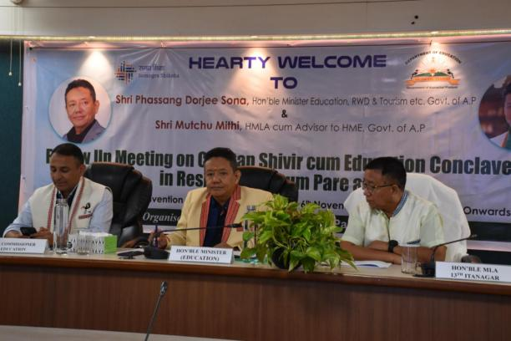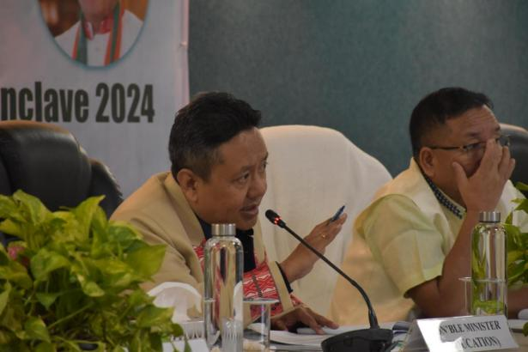
A follow-up meeting on the key strategies formulated during the Chintan Shivir cum Education Conclave held from August 8-10 in Itanagar, was held for Papum Pare District and ICR region in DK Convention centre , Itanagar on Wednesday.
This review marks a significant step towards consolidating various factors, including merger of low and zero enrollment schools as well as the impact on local communities and meeting infrastructural and manpower gaps to foster better learning environments and access to quality education.
Minister Education Shri P D Sona while highlighting that “this review is a necessary step towards a more responsive and efficient educational system that prioritizes student needs; advised the DDSE to prepare the merger plans after proper ground verifications and the welfare of the students as a priority.
“The District merger plans should be practical and not hypothetical. Plans should be devoid of cultural, social and political differences ” the Minister added while urging all the stakeholders including the PRI members and officials of the Education department to diligently prepare the plans.
The Minister further stated that the outcome of the entire exercises under the Chintan Shivir may be slow, but there definitely will be a tangible improvement in the education scenario in the coming years.
“ Our current focus is to improve the quality of education at the Elementary level. This is our first step in this direction.” He added while urging all the stakeholders to cooperate with the Education department.
The Minister also announced that the improvement of kitchen sheds and welfare measures for the cooks under PM Poshan is under consideration.
HMLA 13- Itanagar Shri Techi Kaso while highlighting the education scenario of his constituency appealed to the Education Minister to support and assist in making the twin capital of Itanagar- Naharlagun an education hub not just for Arunachal Pradesh but the entire north east.
HMLA 15-Sagalee Er.Ratu Techi, ZPC Nabam Yakum also spoke on occasion.
DDSE ICR Shri Sorang Tapi Jara and Papum Pare DPC Tang Moromi presented PowerPoint on the merger plans for schools under ICR and Papumpare region respectively.
The review meeting was attended by Commissioner Education Amjad Tak, Secretary Education Duly Kamduk, DC Papum Pare Jiken Bomjen, DC ICR Talo Potom, PRI members,Officials of education department and CBOs.

