Dated : 28th October 2024
PRESS RELEASE
East Siang Hosted a DLO Workshop on universalization of PRI-CBO Convergence
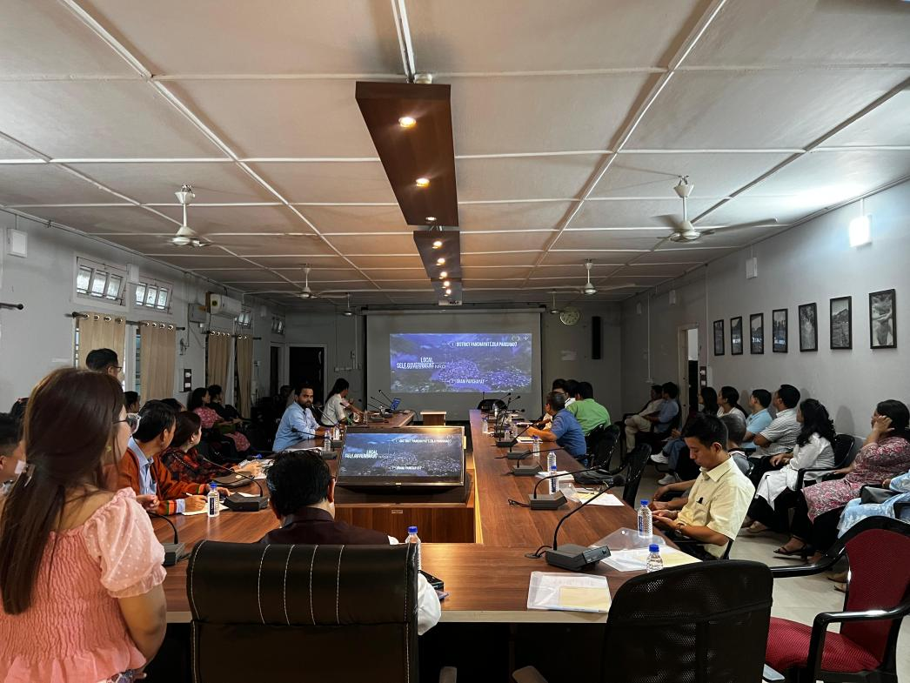
East Siang district hosted a pivotal district-level orientation and discussion with line departments, focused on the universalization of convergence between Panchayati Raj and Community-Based Organizations. The event took place at the DC Conference Hall, Pasighat on Monday and was organized by the District Mission Management Unit Pangin, Arunachal State Rural Livelihoods Mission in collaboration with District Administration East Siang.
The orientation was chaired by Shri Tagi Taggu, Deputy Commissioner of East Siang, who led the discussions on enhancing the convergence between PRI and CBOs. The gathering included heads of various departments, including Panchayati Raj, State Bank of India, Public Work Development, Public Health Engineering, Departmet of Planning, Textile and Handicraft, Gas Agency, along with PRI member and block officials from Ruksin, Pasighat and Mebo.
The event began with a welcome address by DMM Pangin Dr. Jarbom Taipodia followed by an overview of ArSRLM's structure presention by Shri Mie Doke (BMM, Pasighat). Ms. Onam Nayam, District Coordinator for Social Inclusion & Social Development, outlined the workshop objectives through video and PPT presentation.
DC emphasized the role of convergence in poverty alleviation and awareness related to various schemes within rural areas, urging PRI members and line departments to collaborate closely and provide the necessary support required.
A district level Line Departments’ Discussion Pointers Sheet outlining the convergence strategies for East Siang District was shared with various line departments present in the workshop. Representatives of the line departments present including Panchayati Raj, State Bank of India, Public Work Development, Public Health Engineering, Department of Planning, Textile and Handicraft, Department of Animal Husbandry and Veterinary (DAHV) Gas Agency provided a presentation and discussed about their existing implementation challenges, convergence program, schemes, benefits and strategies. They also implied upon the utmost importance of liaising through PRI and ArSRLM to impart convergence programs and schemes successfully.
Er. MijingDupak, EE PHED &WSD, Pasighat highlight the importance of hygiene, JJM, RE/BE, construction of IHHL, Drainage, soak pit and dustbin. He also encouraged ArSRLM to bring the SHG network to their representatives present at block for a better convergence.
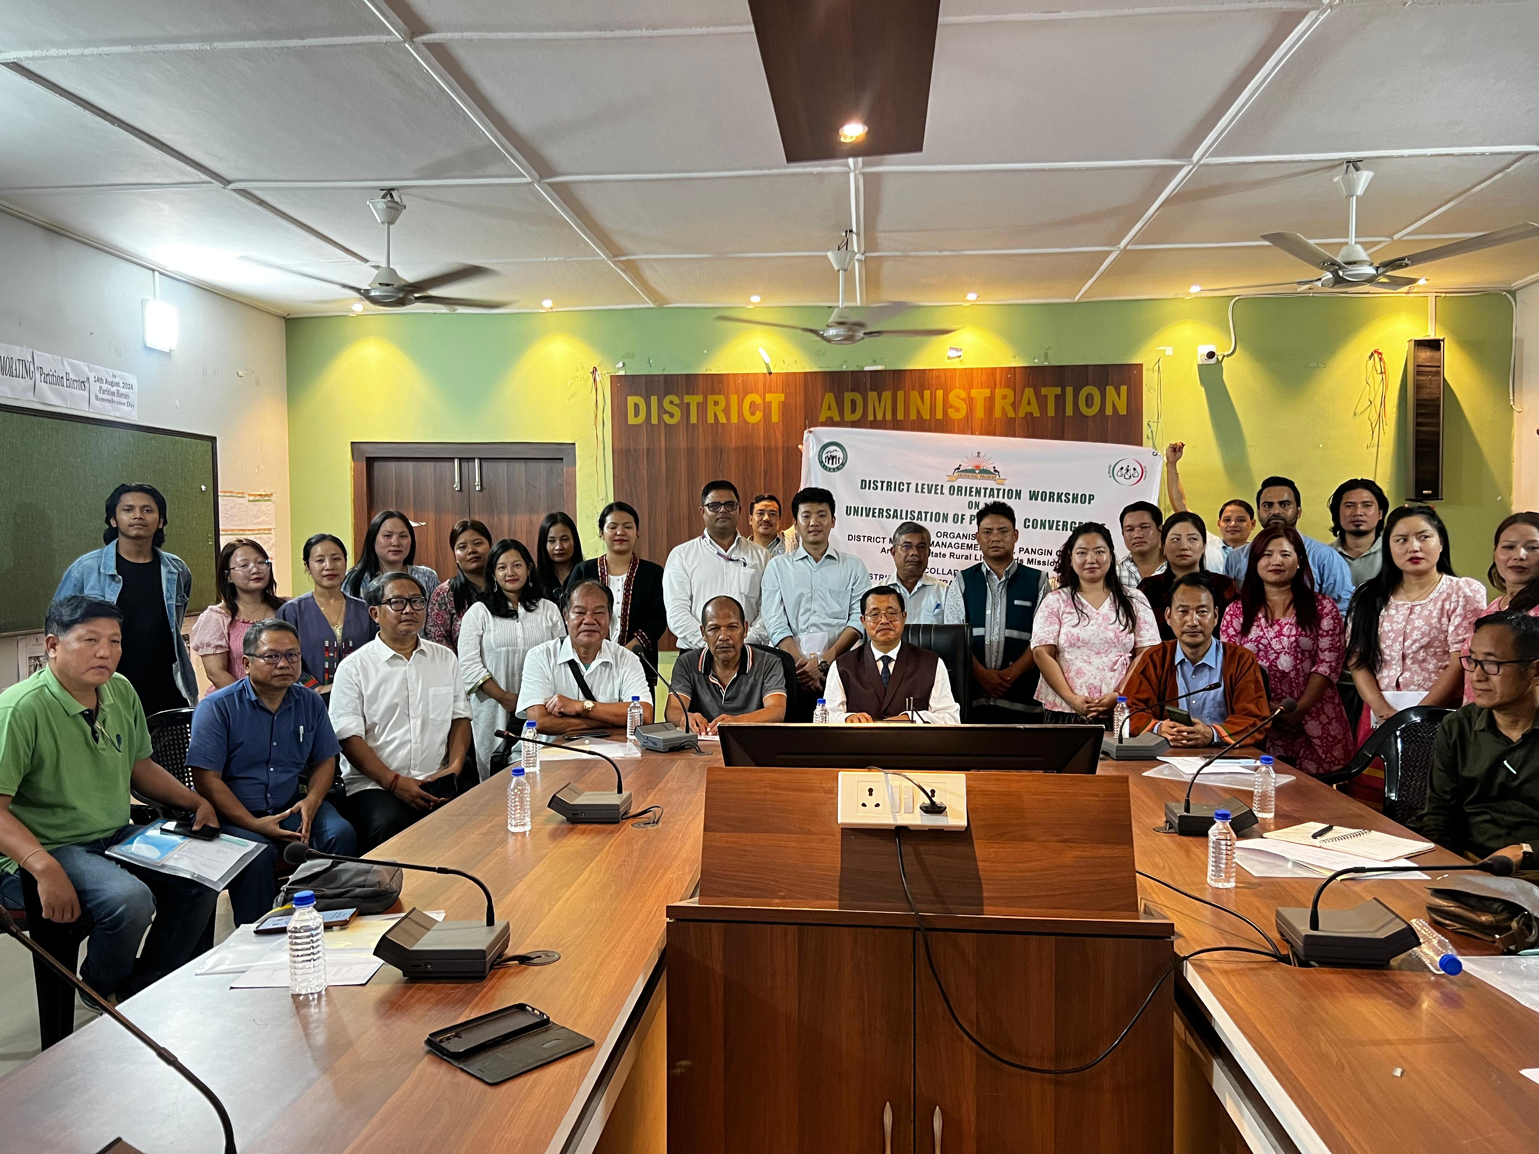
Shri Tatak Mibang, DPO Pasighat, provide the future scope of convergence on programmes like Sarkar Aapke Dwar,Vikshit Bharat etc. and urged ArSRLM to mobilize the SHG members during these programmes.
Sh. Arun Kumar, Chief Manager SBI Pasighat emphasize on the coordination with respective department for identifications of beneficiaries and provide the details of various schemes like Atma Nirbhar Scheme, DDU Scheme, PMEGP, PMJJBY, PMSBY, PM Mudra, SHG Credit Linkage for the benefit for CBOs.The orientation concluded with a vote of thanks delivered by Ms. JumnamYigam Maro (DTC FI) District Mission Management Unit, Pangin.

