Press Release
Dated: 5th Nov, 2024
Dy CM Chowna Mein Inspects Parshuram Kund Development Ahead of 2025 Mela
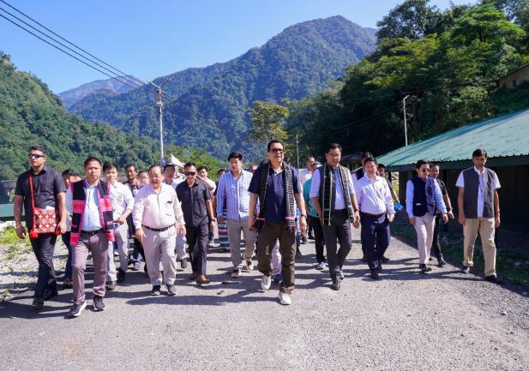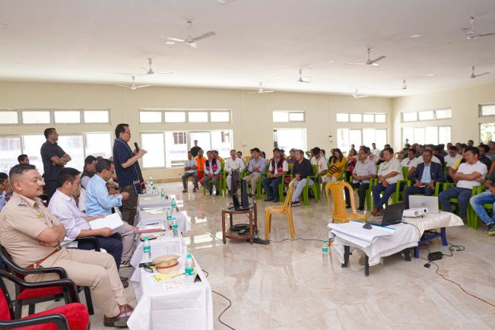
Wakro: Deputy Chief Minister Chowna Mein conducted an on-site inspection of the River Front Development project at Parshuram Kund today, reviewing ongoing infrastructure projects aimed at enhancing facilities for the upcoming Parshuram Kund Mela 2025. The inspection included key developments, such as the construction of a Guest House, Pilgrims Lodge, and improvements to existing structures. Following the site visit, Mein convened a meeting with the District Administration and Parshuram Kund Development Trust to discuss logistical arrangements for the event.
In preparation for the influx of pilgrims during the Mela, coinciding with Makar Sankranti in January, Mein directed the authorities to arrange accommodation for at least 2,000 pilgrims per night. "Our goal is to ensure a seamless experience for all visitors, prioritizing comfort and safety," Mein stated.
Reaffirming the State Government’s vision to establish Parshuram Kund as Northeast India’s largest pilgrimage destination, Mein announced an additional allocation of ₹50 crore from the State Government to bolster infrastructure, supplementing ₹50 crore already sanctioned by the Ministry of Development of North Eastern Region (DoNER). This funding will support permanent infrastructure upgrades and riverfront development to make Parshuram Kund a sustainable and well-equipped destination for future events.
“We are committed to preserving the spiritual essence of Parshuram Kund while enhancing facilities to welcome thousands of pilgrims with ease,” said Mein. He emphasized the importance of this year’s event in highlighting Parshuram Kund’s spiritual and cultural significance.
Mein was accompanied by Tezu HMLA and Advisor Dr. Mohesh Chai, ADC Wakro, Heads of Departments, and other key stakeholders during the inspection and meeting.

