Press Release

Dated Nov 7th, 2024

District level orientation workshop on universalisation of PRI CBO convergence held at Yingkiong

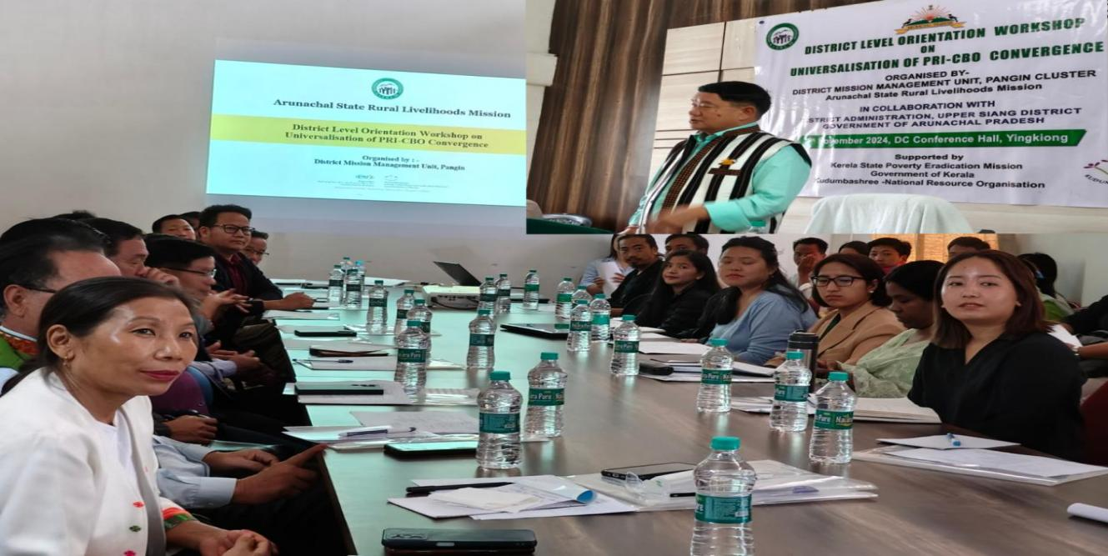

Yingkiong: District Mission Management Unit, Pangin Cluster ArSLM ( Arunachal State Rural Livelihood Mission) in collaboration District Administration Upper Siang organized one day District Level Orientation Workshop on Universalization of PRI-CBO Convergence here at DC conference hall, Yingkiong today on 7th November’2024. The workshop was supported by Kerela State Poverty Eradication Mission, Govt of Kerela, Kudumbashree- National Resource Organization.
Presiding over the orientation workshop the Deputy Commissioner Upper Siang Sri Talo Jerang in his key note address, highlighted the various aspects of ArSLM and informed that it is the nodal agency for implementing the National rural Livelihood Mission and Aajeevika schemes in the state which particularly aims to uplift and empower the womenfolk at grassroot level to make them socially, economically and financially independent.
He further said ‘ in Upper Siang District so far 397 Self Help Groups have been registered and 13 Lakhpati DiDis have been awarded certificates which is very encouraging and numbers can go up if we work more diligently with dedication to through universalization of Panchayat members and community based organisations convergence project’. DC also urged upon all HoDs to provide all kinds of support required from line department to ArSLM and said that convergence between line departments , PRIs and CBOs will create better understanding for holistic development.
Meanwhile, the Mentor from Kudumbashree – National Resource Organisation shared her work experience on PRI-CBO Convergence project in Arunachal Pradesh and Ms Onam Naya, DTC,SISD, ArSLM presented Ppt on introduction to PRI-CBO Convergence project. During the orientation session annual action plan of line department and platform to facilitate the convergence aspects of the block and district were discussed.
All HoDs from Line Departments, Admin officers, DMM, BMMs, BCs, Cluster Coordinators of ArSLM Upper Siang attended the programme.

