Press Release
Dated: 5th Nov, 2024
Deputy Commissioner Talo Jerang Chairs Coordination Meeting with ArSLM Staff in Upper Siang to Boost Rural Livelihood Initiatives
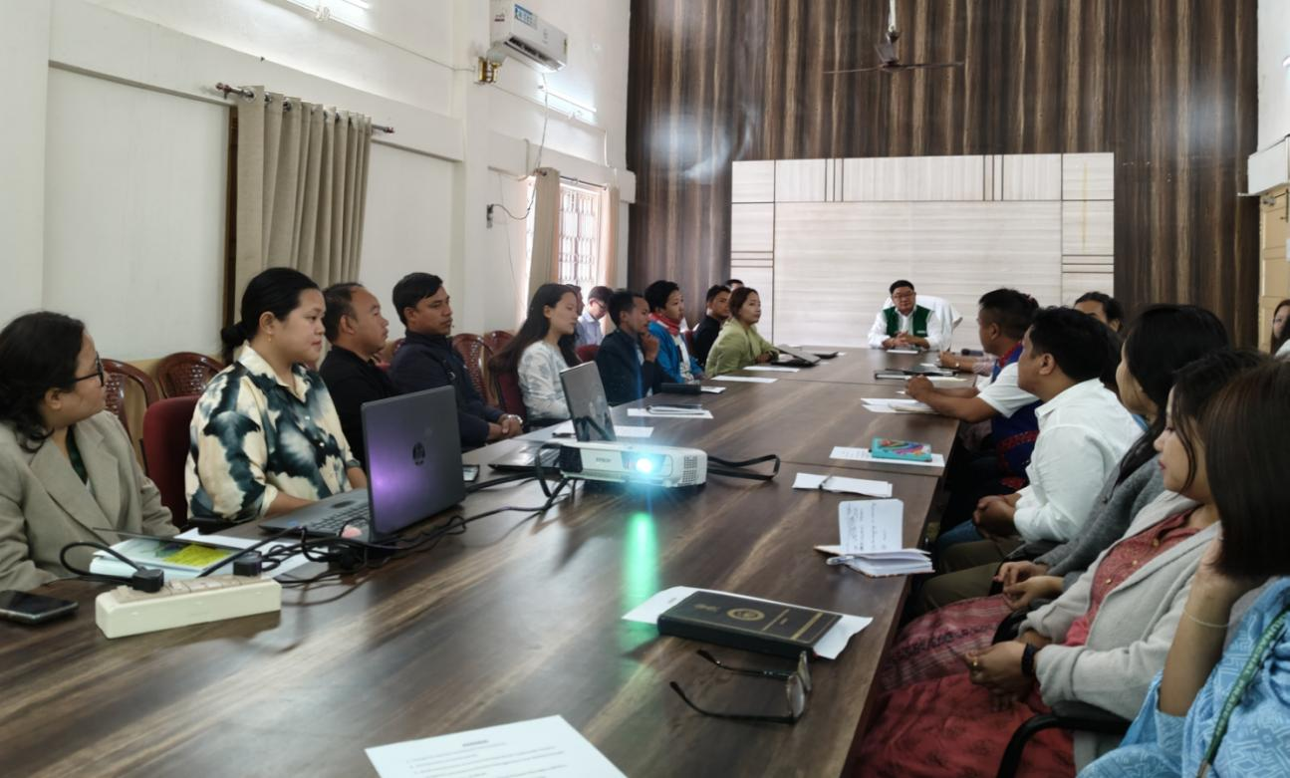
Yingkiong: A coordination meeting with all Arunachal State Rural Livelihood Mission (ArSLM) staff of Upper Siang was held under the chairmanship of Deputy Commissioner Sri Talo Jerang at the DC Office conference hall in Yingkiong on November 5th, 2024.
During the meeting, DC Jerang interacted with the ArSLM team and reviewed the performance of ArSLM activities across various blocks in the district. He emphasized the core objectives of the Deendayal Antyodaya Yojana (DAY) - National Rural Livelihood Mission (NRLM) and encouraged the mission staff to work with dedication towards alleviating poverty, improving livelihoods, and empowering rural communities. Highlighting the need to ensure the mission’s benefits reach the poorest, he urged staff to actively support and motivate more women, including elderly and isolated individuals, to form Self-Help Groups (SHGs). Engaging in sustainable income-generating activities, he noted, would uplift individuals and benefit entire communities.
Following a review of ArSLM’s performance, DC Jerang directed Mission Managers to present accurate and realistic data in their reports and to ensure the effective implementation of schemes across their designated blocks. He underscored the importance of training and urged mission staff to thoroughly understand ArSLM guidelines, advising them to conduct training sessions in collaboration with other departments to better equip SHGs with essential knowledge and resources.
The Deputy Commissioner acknowledged the efforts of hardworking women in remote areas like Zido and Ngaming villages from the Tuting Sub-Division, encouraging the Block Mission Manager of Tuting to support these women in forming SHGs and creating market linkages to sell their products. He also recommended exploring modern farming solutions in fisheries and allied activities to boost income generation for local farmers.
Earlier in the session, Dr. Jarbom Taipodia, District Mission Manager, presented an overview of ArSLM’s initiatives through a PowerPoint presentation. Block Mission Managers from Tuting, Yingkiong, Mariyang, and Geku also shared detailed presentations on ArSLM activities. Other attendees included ADC Rajiv Chiduni, CO K. Jongkey, DIO Rishi Raj, HA Tako Modi, Block Mission Managers, Block Coordinators, and Cluster Coordinators.
This coordination meeting reinforced the district’s commitment to rural development, aiming to uplift the socio-economic status of vulnerable communities in Upper Siang.

