GOVERNMENT OF ARUNACHAL PRADESH

Press Communiqué

Dated Nov 10th, 2024

Deputy Chief Minister Chowna Mein attends the Adi Youth Fest 2024 as Chief Guest

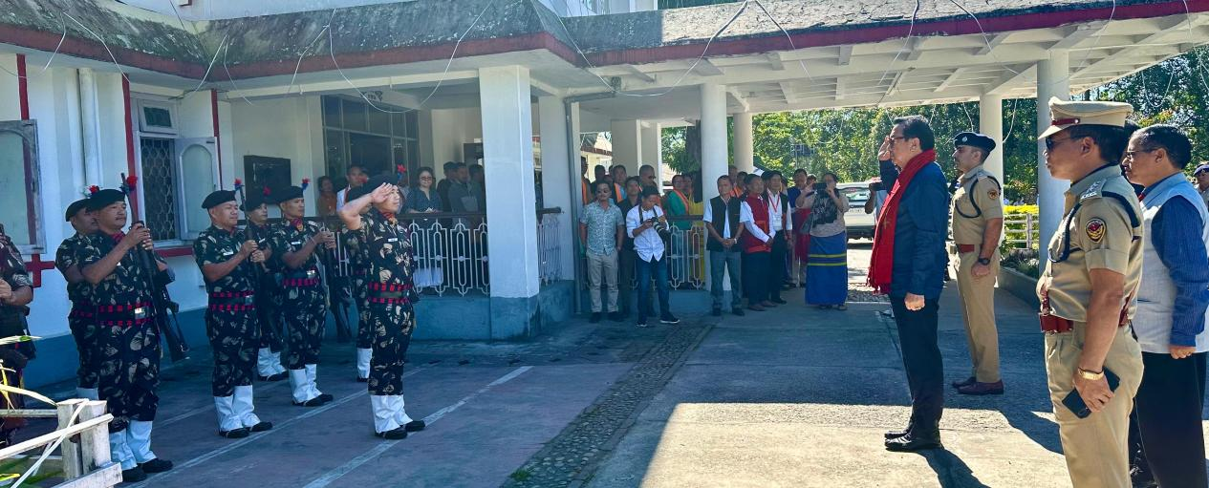

Pasighat: Deputy Chief Minister Chowna Mein graced the Adi Youth Fest 2024 as the Chief Guest today in Pasighat, an event organized by the Adi Ba:ne Kebang Youth Wing (ABKYW) with the theme, ‘Say No To Drugs’.

Addressing the gathering, Mein highlighted the crucial role of youth in shaping a brighter future for society, emphasizing the importance of embracing social responsibilities. He noted that youth involvement can manifest in various ways—through education, community service, and other societal contributions—and stated that even small, positive actions collectively foster a more harmonious and prosperous community.

Mein urged the youth to actively engage in initiatives promoting growth and development, remarking that they are a driving force behind sustainable progress and essential to societal advancement.

Expressing concern over the pressing issue of drug abuse, Mein addressed its detrimental impact on communities and reiterated the government's commitment to addressing this challenge and lauded the efforts of the community, especially the ABK Women Wing and Women Against Social Evils (WASE) for their active drive against drugs menace. He advocated for stringent actions against drug peddlers in order to eradicate the growing drug menace from society.

Highlighting the government’s vision, Mein reaffirmed that 2024 has been declared as the "Year of the Youth," dedicated to empowering young people with enhanced opportunities in education, sports, and personal development. On the occasion, he also felicitated Joluk Minung, founding president of the ABK Fest, for his exceptional dedication to youth development and his efforts in organizing the festival.

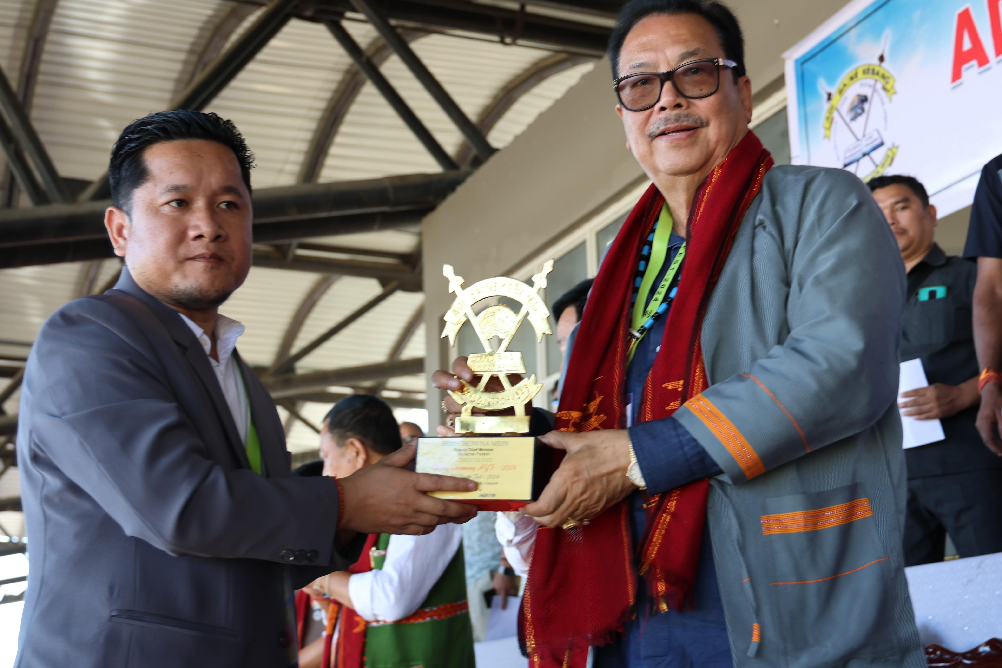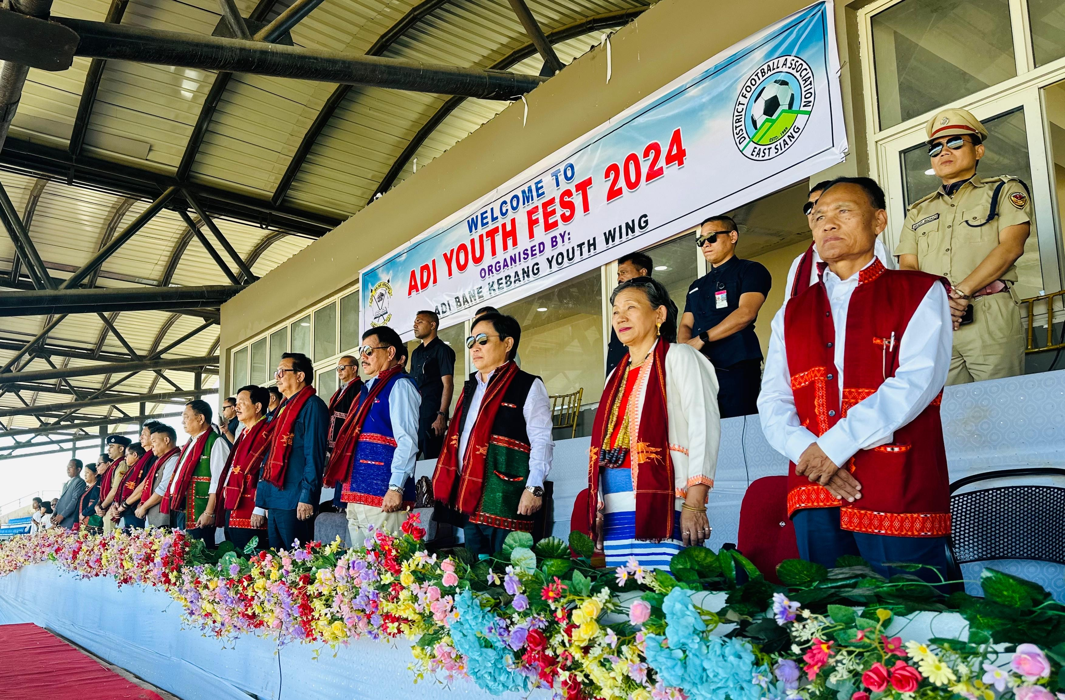

Mein assured attendees that the government is implementing policies and programs to support the youth, including improved educational resources and sports facilities, which aim to promote a well-rounded future for young people. He added that the Arunachal Pradesh government is committed to providing youth with the resources and opportunities needed to thrive and contribute positively to society.

Also speaking on the occasion, Lok Sabha MP Tapir Gao stressed on immense potential and role of youth in transforming the society. He exhorted the youth to excel in sports, culture, literature, academics, and other arenas through discipline and sustained effort, bringing pride to their community and society. He expressed hope that events like the Adi Youth Fest, organized by the Adi Ba:ne Kebang Youth Wing (ABKYW) will serve as a platform to tap and channelize youth energy and skills, while also contributing to the fight against the burning issue of drug menace gripping society.

The program was also MLA Pasighat (West) and Advisor Ninong Ering, MLA Pasighat (East) Tapi Darang, MLA Dambuk Puinnyo Apum, MLA Geku-Mariyang, Oni Panyang, President ABK Tadum Libang, Secretary General ABK Vijay Taram, President ABK Youth Wing Oki Dai, DC and SP Pasighat, among others.

