Press Release
Dated: 6th Nov, 2024
Deputy Chief Minister Chowna Mein Launches ‘Jal Utsav’ in Namsai, Encourages Collective Responsibility for Water Conservation
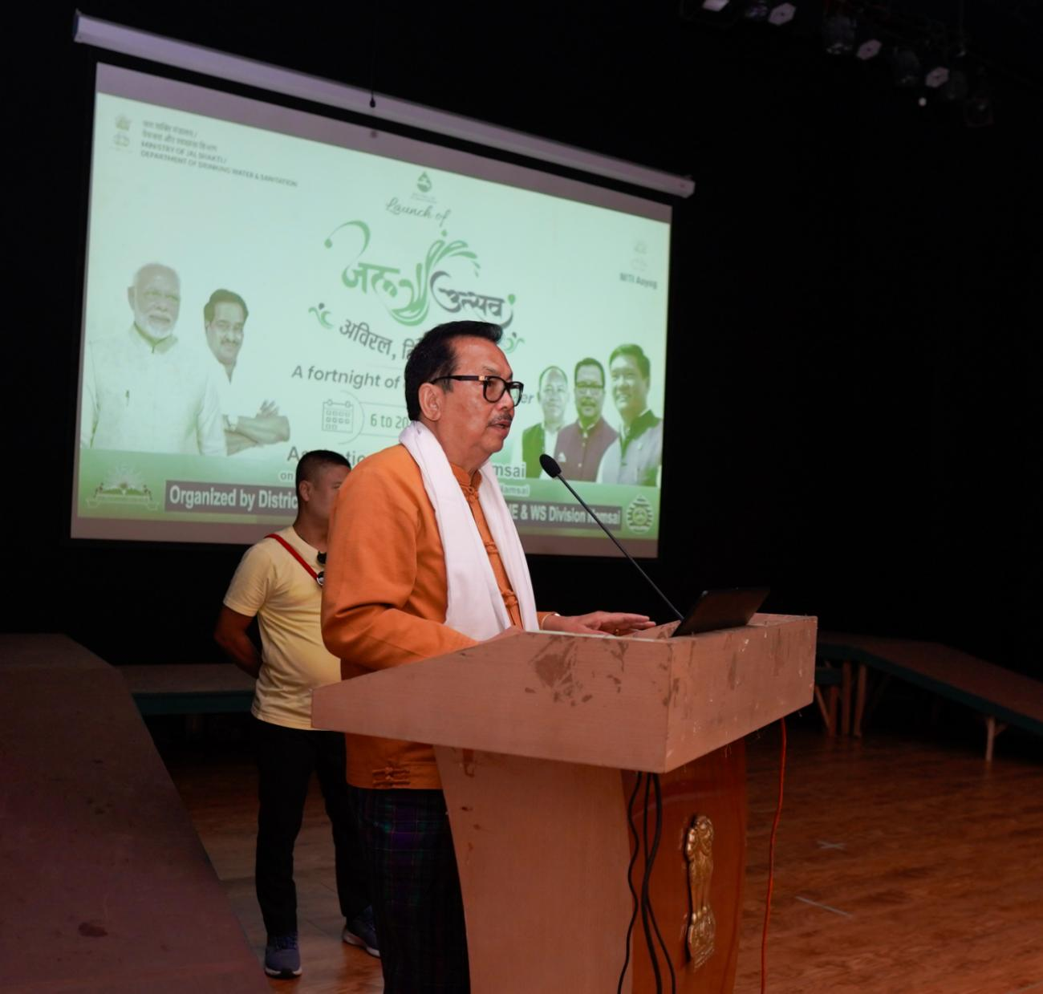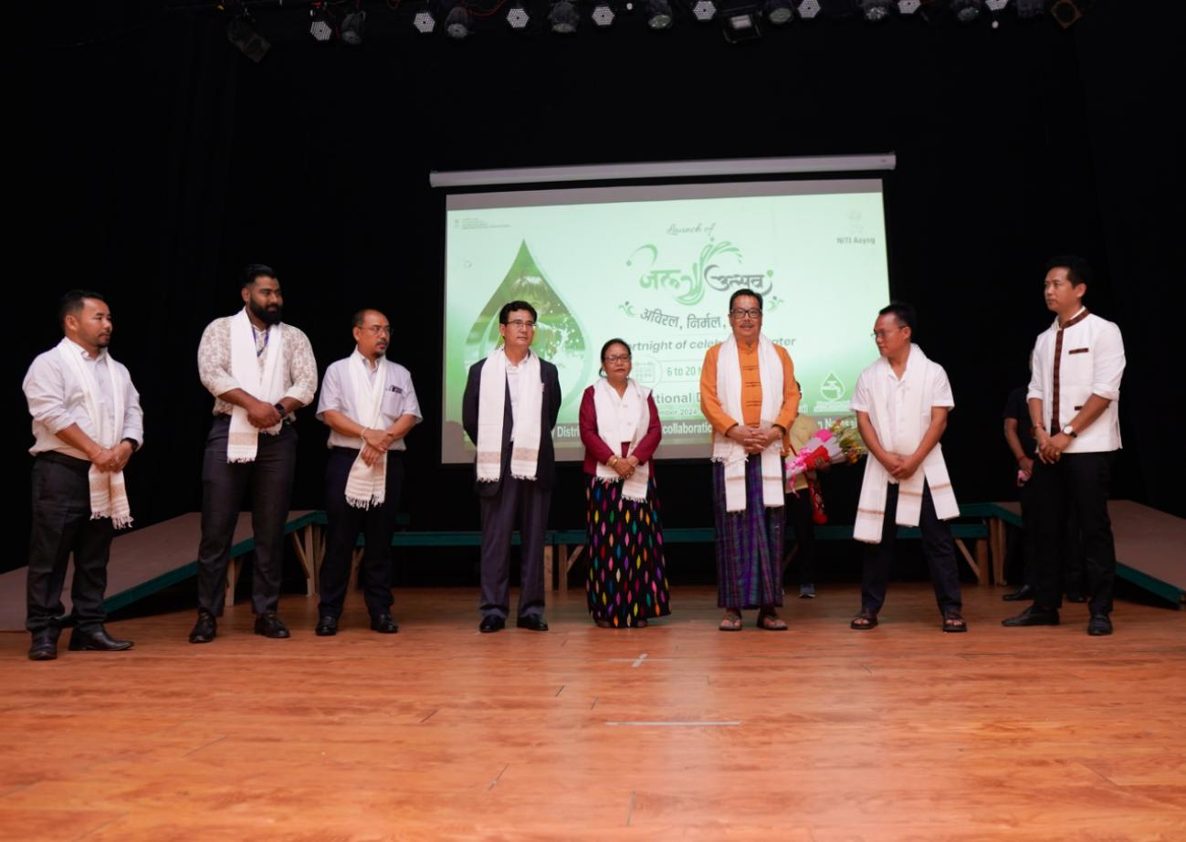
Namsai, November 6 : In a significant step to enhance water conservation and promote sustainable water management, Deputy Chief Minister Chowna Mein launched the 15-day Jal Utsav campaign at the Multipurpose Cultural Hall in Namsai today. The campaign, organized by the District Administration in collaboration with the PHE & WS Department, aligns with Prime Minister Narendra Modi’s vision of creating awareness about water as a life-sustaining resource.
In his address, Deputy Chief Minister Chowna Mein emphasized the need for collective responsibility and sustained community ownership of government infrastructure, particularly assets created under the Jal Jeevan Mission. He announced a special appreciation award for the village demonstrating exemplary participation and ownership in the campaign. "Our efforts must instill a sense of belongingness to these resources within local communities," he stated.
Meanwhile, DC Namsai C R Khampa outlined the campaign's objectives, emphasizing the initiative's alignment with the National Jal Jeevan Mission and the Ministry of Jal Shakti’s efforts to foster water conservation across India’s aspirational districts.
DPO Namsai, Keshab Sharma presented an overview of the campaign's objectives, followed by presentations from various departments, covering topics such as drinking water and sanitation, irrigation, water rejuvenation projects, and the rejuvenation potential of Borbeel Lake.
Led by DCM, the members present also took the Jal Utsav Oath, pledging to uphold the principles of Respect, Reduce, Reuse, Recycle, and Recharge water resources.
The Jal Utsav campaign is part of a broader national initiative led by the National Jal Jeevan Mission and the Ministry of Jal Shakti to foster a nationwide movement for sustainable water management. The Jal Utsav campaign will run from November 6 to November 24, covering 20 aspirational districts, including Namsai. Activities are designed to deepen understanding of water resources and encourage collective action for sustainable management. The key activities include:
- Water Asset Clean-up Drives: Community members will clean and maintain local water bodies.
- al Sanchay Diwas: A day dedicated to celebrating water conservation and recognizing outstanding efforts.
- Nal Jal Mitra Program: Skill-building initiatives for SHGs, ASHA workers, and community members.
- Student Engagement: Students will participate in water quality testing, water treatment plant visits, and tree planting under the Ek Ped Maa Ke Naam initiative.
- Jal Utsav Run/Marathon: A community run to promote awareness of water conservation.
The campaign will also have a Jal Bandhan ceremony, where sacred threads will be tied to local water assets as a symbolic pledge to protect and conserve them, with active participation from community leaders, students, and residents.
Also present on the occasion were Likha Soni, MLA Lekang, ZPC Namsai Nang Urmila Mancheykhun, and Chief Engineer (PHED & WS) Eastern Zone, as well as ZPMs, Young Professionals from NITI Aayog, HoDs, GPMs, VWSC members, and SHGs.

