Press Release
Dated: 29th Oct, 2024
DC inspected District hospital Yingkiong
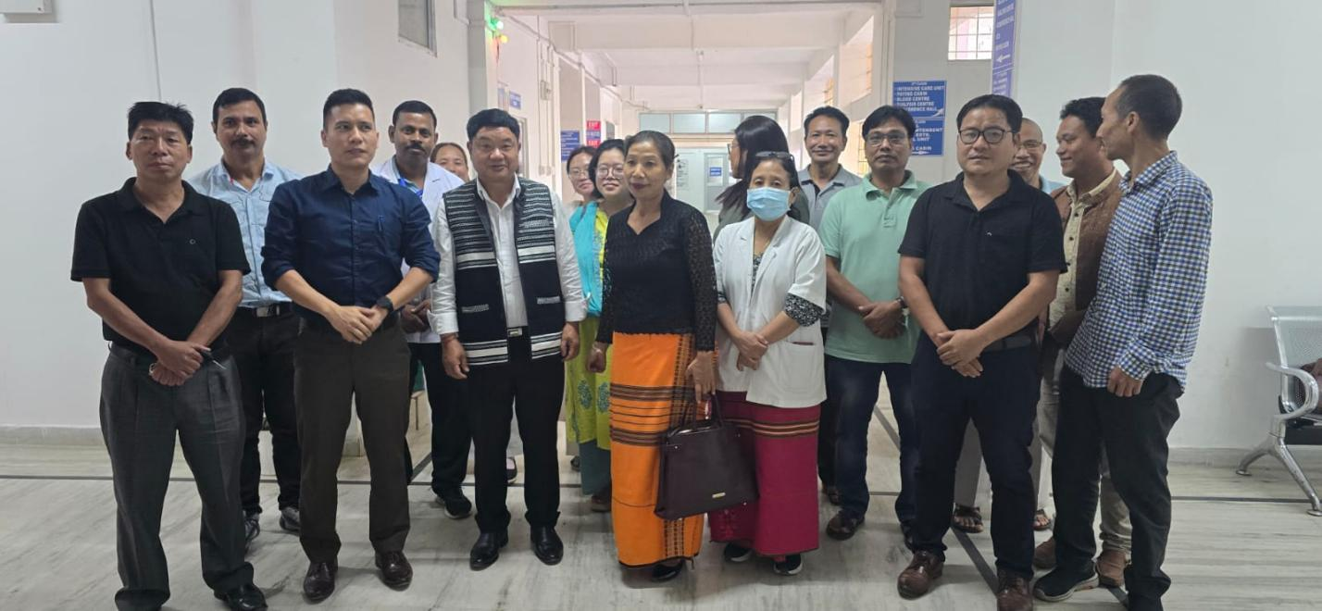

Upper Siang Deputy Commissioner Talo Jerang inspected 50 bedded Dist Hospital, Yingkiong along with SP Token Saring and DMO Dr. G. Litin today on 29.10.2024.
He discussed with Hospital Management about smooth health delivery system, cleanliness of hospital, punctuality of staff, etc and expressed his satisfaction seeing the well-maintained and well- equipped which has attained 66% under NQAS. He also interacted with Doctors, GNMs, ANMs, lab Technicians and appreciated their sincerity and dedication.

