Press Release
Dated: 2nd Nov, 2024
Chief Secretary of Arunachal Pradesh Inaugurates Multi-Sport Stadium in Bomdila, Advocates for Youth Engagement in Sports and Adventure Tourism
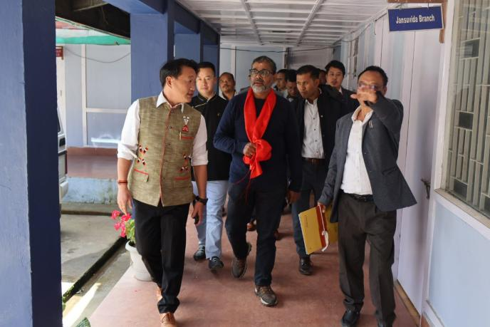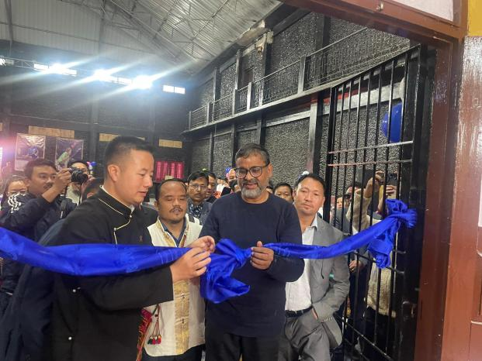

Shri Manish Kumar Gupta, Ld. Chief Secretary of Arunachal Pradesh, is on his maiden tour of West Kameng District. During his visit, he inaugurated the Multi-Sport Stadium in Bomdila under the Khelo India project. While inaugurating, he urged the youth to engage in sports and help deter the drug menace within society. “Arunachal Pradesh is one of the most beautiful states in the country, blessed with stunning ecology and immense potential for adventure tourism. Youth may engage with institutes like NIMAS, Dirang, and pursue adventure tourism courses, which can effectively promote tourism in the region,” he added.
He also commended the District Administration for banning single-use plastic items in Bomdila township and called for active community participation to maintain cleanliness under the Swachh Bharat Abhiyan. “Cleanliness can entirely transform the area’s overall appearance, and the District Urban Development Agency (DUDA) must take this responsibility seriously,” he urged. Choiki Dondup, EAC of Bomdila, welcomed the Chief Secretary and informed him that the Table Tennis (TT) court developed under the Khelo India project is the first of its kind in the state. The indoor stadium offers facilities for various sports, including badminton, boxing, a sports gym, and more, aiming to draw youth toward sports as a preventive measure against the drug menace. Gupta also visited the DC Office to review its new construction under the augmentation project, as well as the new building of the General Hospital Bomdila, where he assessed the progress made. The Medical Superintendent of GH Bomdila highlighted the severe shortage of doctors, which is affecting the hospital’s overall performance, and appealed for additional manpower. Additionally, Gupta inaugurated a new Gompa at Vibrant Village (VV) Pedung and reviewed the progress of various schemes under the VV program. In the Rupa subdivision, he visited the Community Health Center (CHC) Rupa and Gyatpong Stadium, reviewing the services and construction progress. He further visited Chillipam Gompa and interacted with the PRI of Rupa. On an earlier day of his tour, he visited Dirang Subdivision, including the Government Sheep Breeding Farm (GSBF) at Sangti, Shraddha Mission School (SMS) in Khaso, and Thembang Heritage Village.
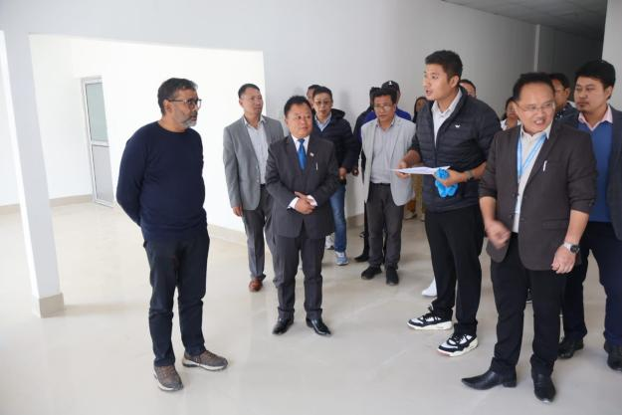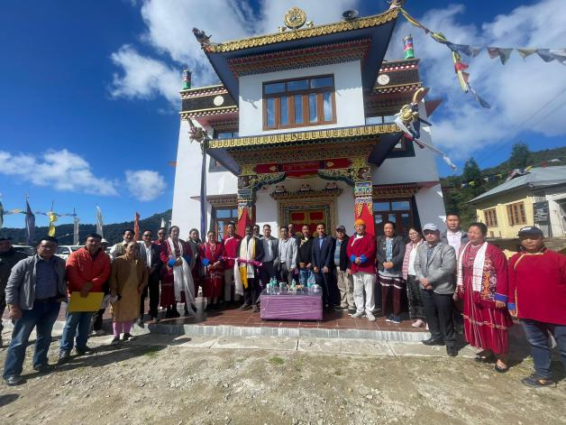
He interacted with officials and teachers at GSBF and SMS, offering suggestions for future development. At Thembang, the Local Coordination Committee (LCC) presented an overview of the heritage project through a PowerPoint presentation. The Chief Secretary advised the LCC to halt modern construction within the core zone of the heritage site, as it detracts from the village’s historical appearance. For the master plan, he suggested dividing it into two parts: the first for underground infrastructure like sewage, drainage, septic tanks, and foundation work, and the second for external structures. The villagers of Thembang also shared the historical significance of the village, including its association with the 1962 Indo-China war.

