Press Release
Dated: 6th Nov, 2024
Chief Minister Pema Khandu Welcomes New Batch of 100 MBBS Students at TRIHMS; Announces Expansion of Medical Education and Healthcare Facilities in Arunachal Pradesh
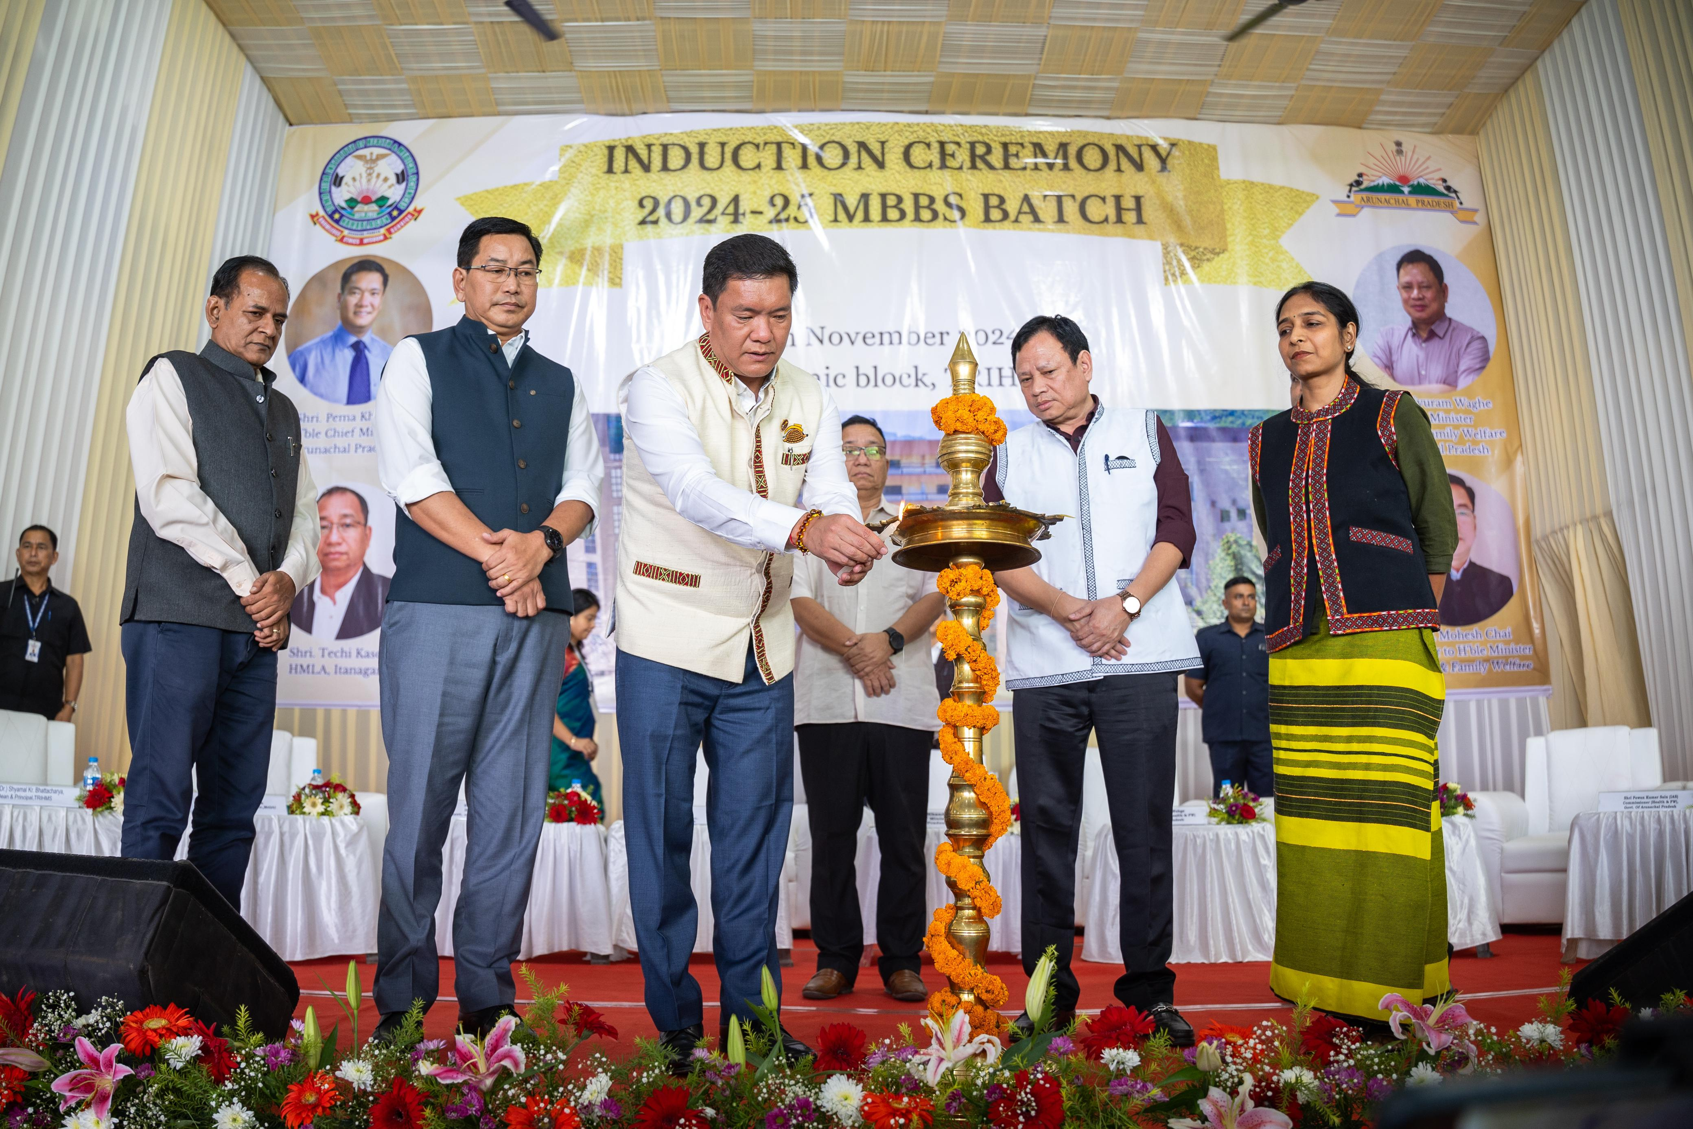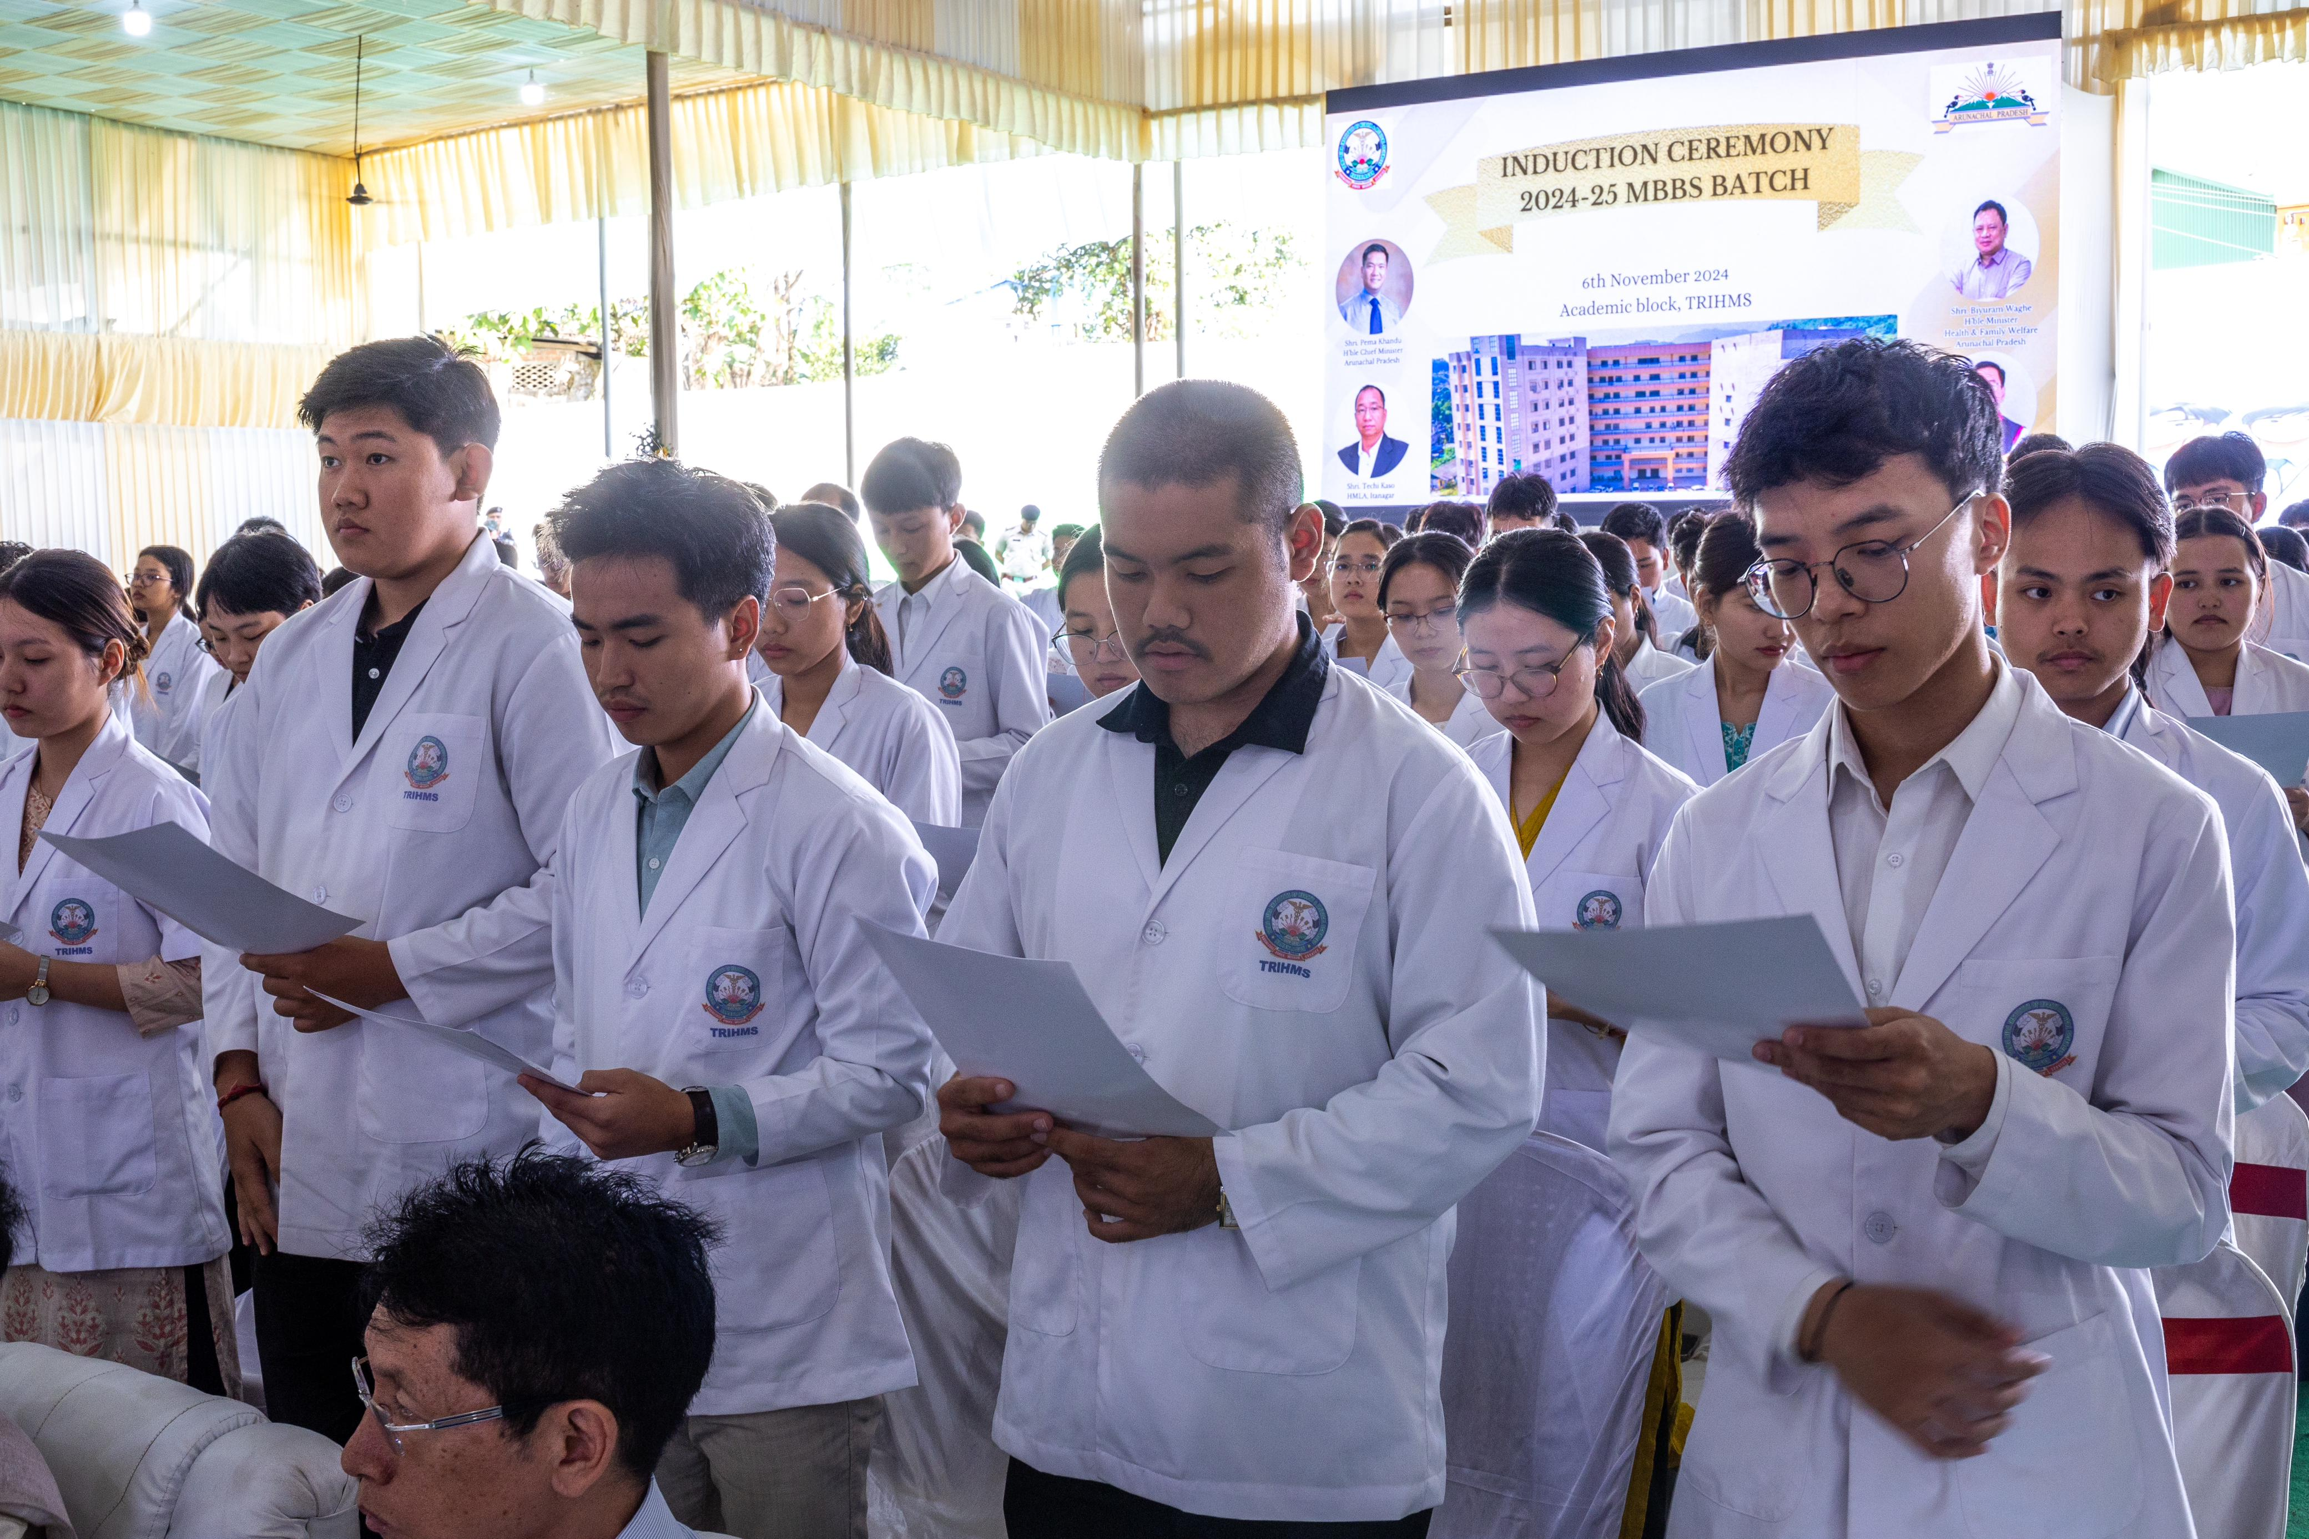
NAHARLAGUN: Chief Minister Pema Khandu today hailed the induction of 100 MBBS students in Tomo Riba Institute of Health and Medical Science (TRIHMS) as a ‘historic day’ not only for the state’s lone medical college but for the state too.
From this academic year the number of seats for the MBBS course in TRIHMS has been increased to 100 from the existing 50, an objective Khandu has been striving for since the college’s inception.
“A new chapter in the history of TRIHMS has been uncovered today,” he said while congratulating and welcoming the newly inducted students in a simple but impressive ceremony here at TRIHMS.
Khandu expressed happiness that the increase in number of seats from this year meant that more number of local youths will get the opportunity to pursue medicine. “What is more substantial is the fact that 85 of the 100 seats are reserved for APST students which is a huge jump from about 30 MBBS seats before the start of the medical college,” he said.
Khandu noted that he state government has fulfilled its promise to the people of Arunachal Pradesh to increase the capacity of TRIHMS medical college along with an increase in seats reserved for APST aspirants.
He recalled the historic day in 2018, when as the Chief minister, he had attended the induction ceremony of the first ever MBBS batch of the institute, who have since completed their internships and passed from the college in May this year. “I am glad to know that the second batch has completed the final MBBS examination and undergoing internship,” Khandu observed.
With the latest milestone achieved, he pointed that it was time for TRIHMS to step up to another level - by starting MD/MS PG and MCh/DM courses in super specialty departments and strengthening the existing departments and service units.
“In this direction the state government has already approved for starting PG courses in 12 specialties and 1 super specialties (DM course in cardiology). We have also approved in principle establishment of 500 bed super specialty block with central assistance,” the Chief Minister informed.
Praising the faculty members, doctors and paramedics of TRIHMS for performing extraordinarily in many cases by conducting operations and emergency procedures saving precious lives, Khandu drew their attention towards two serious concerns, cancer and kidney diseases.
He informed that recently a MoU has been signed between Dr. B. Borooah Cancer Institute and the State Cancer Society of Arunachal Pradesh to investigate the rising cancer rates in the state.
Further, he said that a 200-bedded Regional Cancer Center is being established in Midpu near Doimukh. To deal with kidney ailments, Khandu informed that the state government has approved for establishment of the Department of Renal Science and Kidney Transplantation in TRIHMS in collaboration with Sir Gangaram Hospital and expressed optimism that the first kidney transplantation will happen in TRIHMS as soon as the OT complex is ready. The Chief Minister also revealed that three more medical colleges will be established in the state in coming years. “The second medical college, after TRIHMS, will come up at Pasighat, followed by Namsai under PPP mode. Next college will be established in the West Kameng-Tawang region. When done, we will have four medical colleges to take pride of,” he added.
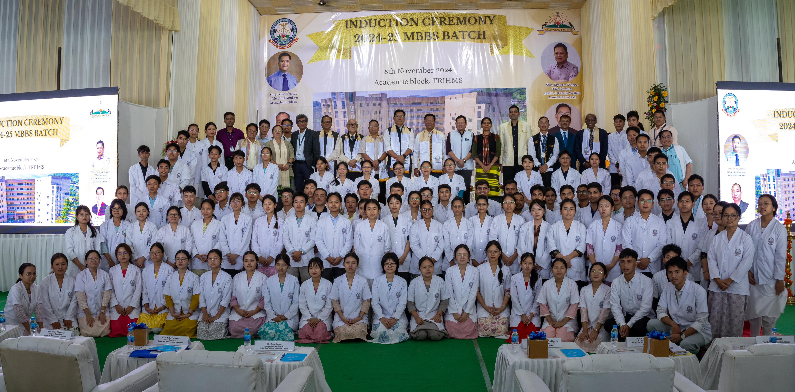
The induction ceremony was also attended by Health Minister Biyuram Wahge, Advisor to Health Minister Dr Mahesh Chai, local MLA Techi Kaso, health officials, administrative officers, faculty members, doctors and students of TRIHMS. Earlier on the day, Khandu along with Wahge and Dr Chai attended the 8th Governing Council Meeting of TRIHMS.

