GOVERNOR’S SECRETARIAT
ARUNACHAL PRADESH
ITANAGAR

Press Communiqué
Dated Nov 28th, 2024

District Level Monitoring Committee Reviews Development Projects in Anjaw
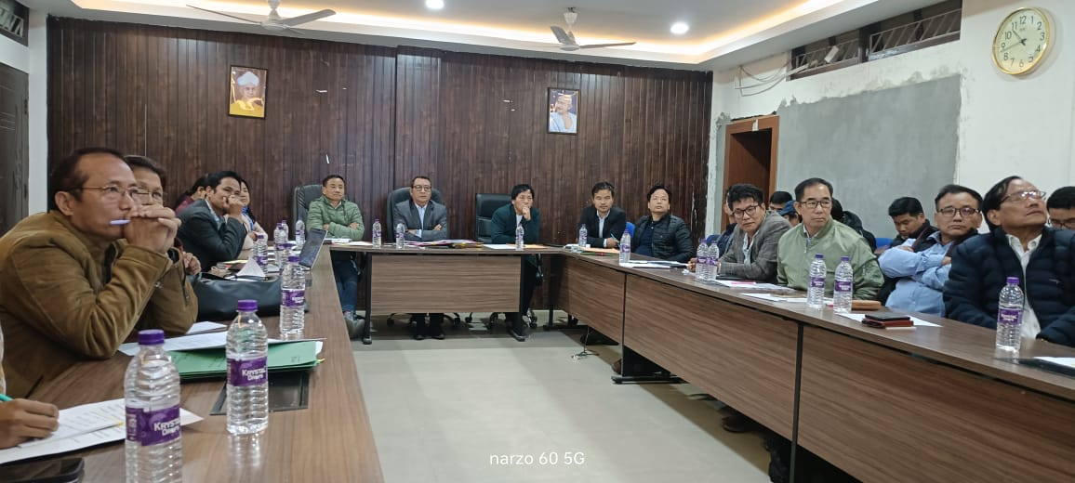

A two (02) day District Level Monitoring Committee (DLMC) meeting w.e.f 27/11/2024 to 28/11/2024 was conducted at District Hq Hawai, Anjaw District under the Chairmanship of Shri Millo Kojin, Deputy Commissioner Cum- Chairman, DLMC to review the implementation of various ongoing central and state sponsored schemes and projects implemented in the District.
The two (02) day DLMC meeting was witness to presentation of schemes and projects implemented by work and other allied Departments namely DMO/PD(RD)/DPDO/DAO/DHO/DVO/DDSE/DFO/ADTH/ARSLM/BDO's Chaglagam, Manchal/ DFDO/DF&CSO/KVK/DDI/ARCS/TAX & EXCISE/PWD/RWD/DHPD/UD as HOUSING /WRD/POWER. The Head of implementing agencies made presentation on the progress and achievement of the work (s) made by concern Departments and also highlighted challenges faced by them.
The Deputy Commissioner Cum Chairman, DLMC observed that the beneficiaries of the Schemes namely ANBY, ANKY, ANPY, ANMY etc are facing problem in implementing them due to slow and untimely progress on disbursement of Govt subsidies and loans from Banking institutions. The DC directed the SBI, the lone Banking institution working under Anjaw District to expedite the matter and also directed the Lead Bank Manager, Tezu to report at DC Office, Hawai to discuss on the matter. Further, the Chairman also requested all the Executing and work Departments to expedite the work and complete all projects in time also maintain work quality.
The meeting was also attended by the ZPC, Anjaw District all ZPMs, Hawai (South)/Hayuliang-Goiling/Chaglagam/Manchal,all Admin Officers, CBOs etc.

