GOVERNOR’S SECRETARIAT
ARUNACHAL PRADESH
ITANAGAR

Press Communiqué
Dated Nov 27th, 2024

Namsai District Gears Up for Organic Farming Boost with MOVCD-NER Scheme
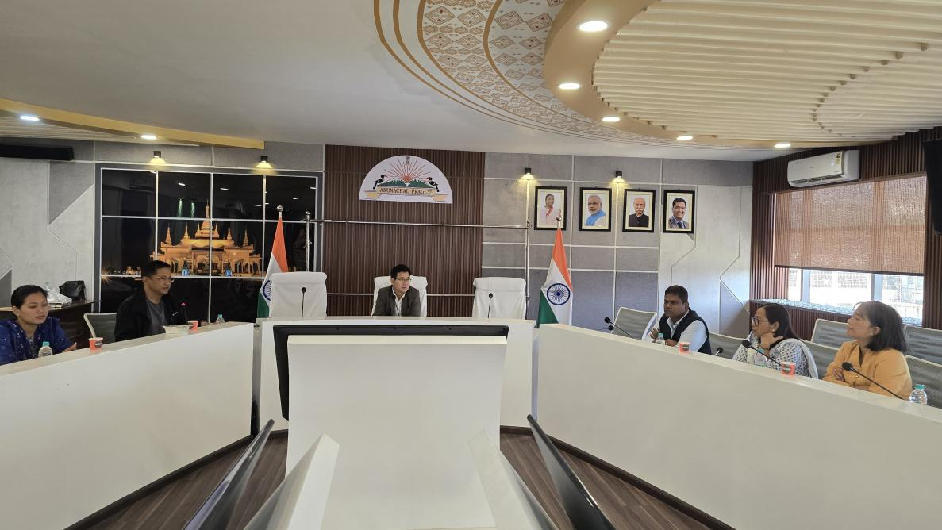

A District Level Implemention Committee (DLMC) for implementation of Mission Organic Value Chain Development for North East Region (MOVCD-NER) Phase IV(2024-25 to 2026-27) Scheme under the Department of Horticulture, Namsai District was convened under the chairmanship of C.R Khampa Deputy Commissioner, Namsai District on 27th November,2024 from 10.00 am onwards in the Conference hall of DC Office, Namsai .A brief and concise presentation on the objectives and overview of the MOVCD-NER scheme for Avocado and Banana crop to be implemented in a mission mode in the district commencing from the financial year 2024-25 was delivered by Mardo Ninu, District Horticulture Officer, Namsai district.During the meeting the Chairman cum Deputy Commissioner,C.R Khampa,MOVCD-NER scheme along with the board members present,had an insightful and fruitful discussion on the objectives of scheme and details of the scheme implementation stages viz.site selection, formation and handholding of Cooperative Societies/FPOs, training of farmers, marketing of produce,post-harvest management,organic certification of the produce etc.Various success stories of FPOs of Arunachal Pradesh formed under MOVCD-NER scheme of agriculture and Horticulture crops was also highlighted by DHO which shows the MOVCD-NER scheme could be a success for the farmers of Namsai District.The meeting was ended by vote of Thanks from DHO, Namsai.

