GOVERNOR’S SECRETARIAT
ARUNACHAL PRADESH
ITANAGAR

Press Communiqué
Dated Nov 27th, 2024

Governor Organizes Blood Donation Camp at Raj Bhavan
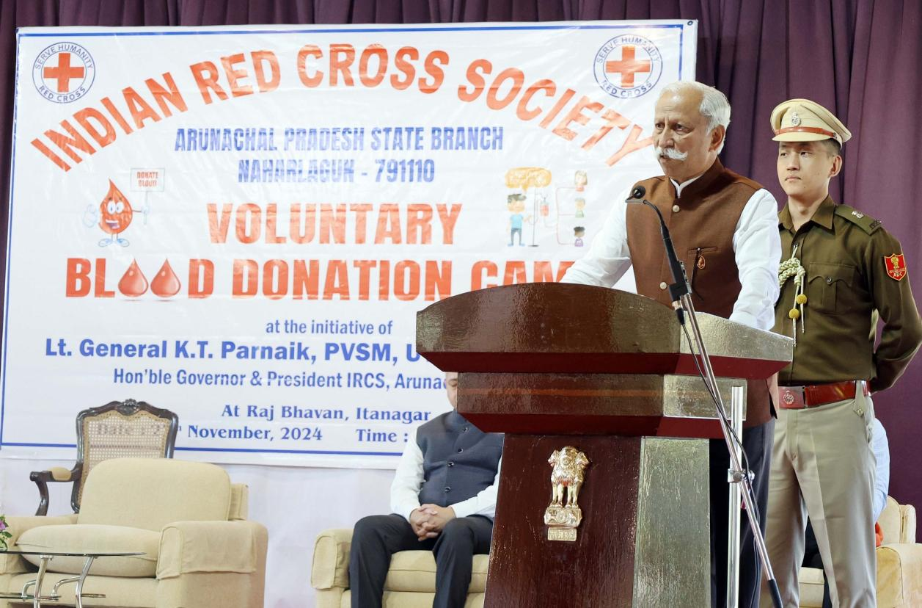

Indian Red Cross Society (IRCS) Arunachal Pradesh State Branch at the initiative of the Governor of Arunachal Pradesh Lt. General KT Parnaik, PVSM, UYSM, YSM (Retd.) organized a voluntary blood donation camp at Raj Bhavan, Itanagar on 27th November 2024. Indian Red Cross Society, in collaboration with the doctors and technical officials of Tomo Riba Institute of Health and Medical Science (TRIHMS), Ramakrishna Mission Hospital (RKMH) and Raj Bhavan Dispensary contributed to organizing the Governor’s initiative.
The Governor, the President of IRCS Arunachal Pradesh State Branch, said that the blood donation is a noble act. He said that it profoundly impacts the lives and well-being of hundreds of millions of people and their families and communities worldwide.
The Governor appealed to the people of Arunachal Pradesh to come forward and donate blood. Poor people and communities should not suffer for lack of blood. It is a service to society and to the nation, he said.
The Governor commended the camp organizations, especially the doctors, nursing officers, medical technicians, and the dedicated volunteers of the Red Cross, for their involvement in Raj Bhavan's humanitarian initiative. He also extended his sincere appreciation to all the blood donors, and said that the blood units they donated will be properly used in saving lives.
The Governor, highlighting the importance of blood during wars and medical emergencies, appealed to the people to create more awareness about blood donation. While recalling the history of the Red Cross, he also exhorted the participants to join the Red Cross Society and be part of the humane service.
Indian Red Cross, Arunachal Pradesh State Branch Honorary Secretary, Dr. Emi Rumi, briefed about the event and Red Cross Society of the State.
Large numbers of voluntary blood donors from 33rd Battalion of Indo Tibetan Border Police (ITBP), 1st Armed Arunachal Police Battalion, 138 Battalion of Central Reserve Police Force (CRPF), Police Training Centre, Banderdewa, Indigenous Faith and Cultural Society of Arunachal Pradesh, The Global University, Naharlagun, Himalayan University, Naharlagun, Oju Welfare association, Naharlagun and NSS Volunteers from Don Bosco College, Itanagar, Hills College of Teacher Education, Jarbom Gamlin Government Law College, Dera Natung Government College and Binny Yanga Women’s Government College.
Raj Bhavan officers and officials and attached departments, led by Secretary to Governor Shri Darade Sharad Bhaskar also donated enthusiastically in the camp.
Dr. Jennifer Tayeng, Senior Medical Officer, Raj Bhavan Dispensary, informed that 104 units of blood were collected on the day. 144 volunteers turned up but many were not allowed by the Medical Counselling Board. The blood units have been sent to the blood banks of TRIHMS, Naharlagun and RKMH, Itanagar.

