GOVERNOR’S SECRETARIAT
ARUNACHAL PRADESH
ITANAGAR

Press Communiqué
Dated Nov 27th, 2024

Tawang Hosts Kisan Mela to Promote Organic Farming
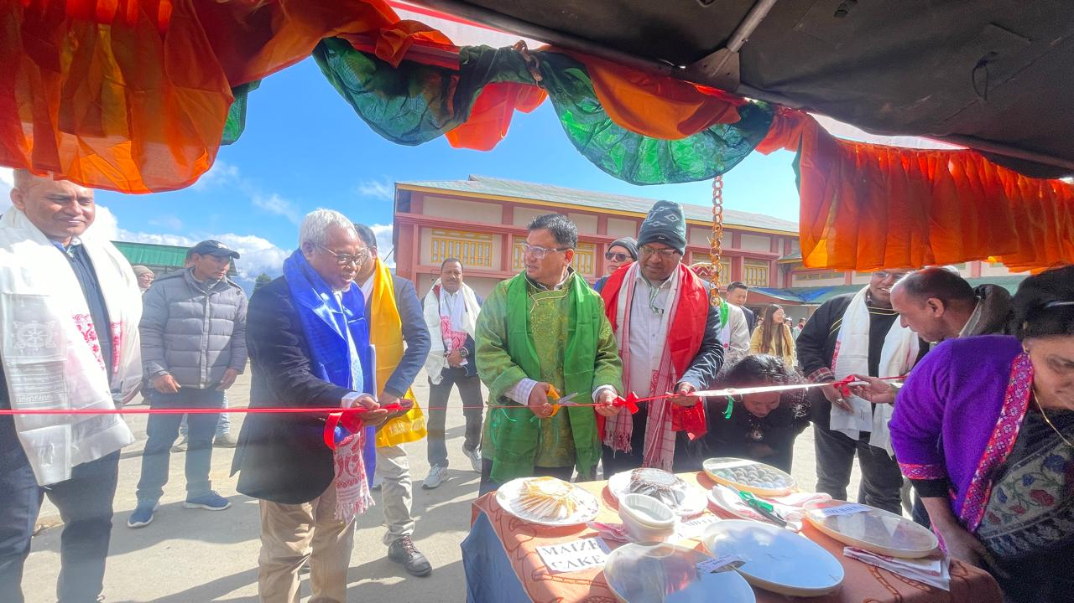

Tawang, November 27: The picturesque town of Tawang recently hosted a Kisan Mela and Kisan Gosthi on Organic Farming, an initiative aimed at promoting sustainable and organic agriculture in the region. The event was organized by the Regional Rainfed Lowland Rice Research Station (RRLRRS), ICAR-National Rice Research Institute (NRRI), Gerua, Assam, in collaboration with the District Agriculture Office, Tawang.
The event brought together farmers, agricultural experts, government officials, and stakeholders to discuss and learn about organic farming practices. The Chief Guest, Kanki Darang, Deputy Commissioner of Tawang, inaugurated the event along with other dignitaries, including Dr. GAK Kumar, Chairman of the NEH Component and Head of the Social Science Division, ICAR-NRRI, and Dr. Lohit Kumar Baishya, Campus In-Charge, ICAR-IARI, Assam.
The event featured a range of activities, including expert talks, farmer-expert interactions, and exhibitions of organic farming tools and techniques. Farmers had the opportunity to learn about the latest advancements in organic farming and seek guidance from experienced experts.
The Deputy Commissioner emphasized the importance of adopting organic farming practices to improve soil health, reduce environmental impact, and enhance the quality of agricultural products. The event concluded with the distribution of agricultural inputs to farmers, further supporting their transition to organic farming. This Kisan Mela served as a platform to empower farmers, promote sustainable agriculture, and contribute to the overall development of the region.
