GOVERNOR’S SECRETARIAT
ARUNACHAL PRADESH
ITANAGAR

Press Communiqué

Dated Nov 27th, 2024

DC Upper Subansiri Inspects Schools, Encourages Wildlife Conservation
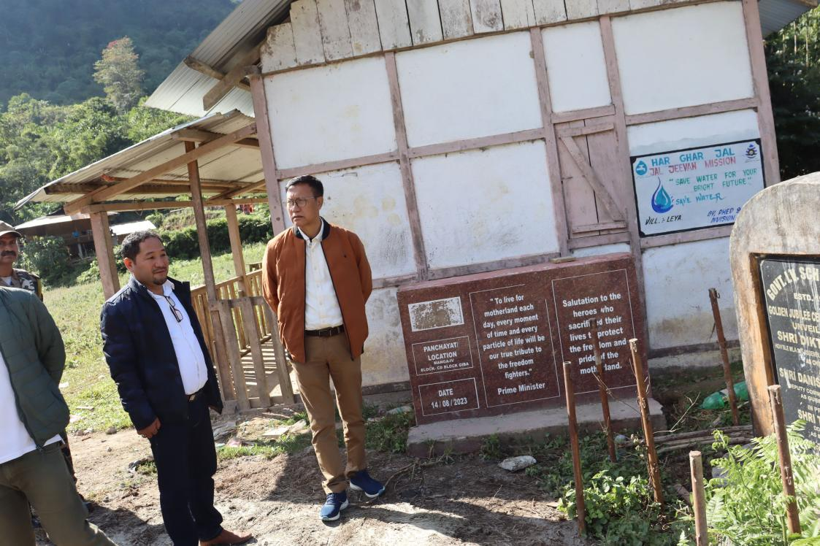

Daporijo, Nov 27: Deputy Commissioner of Upper Subansiri district, Shri Tasso Gambo, conducted a surprise inspection of schools in the Giba Circle on Wednesday. Accompanied by ZPM Giba, Shri Mayum Dobin, the DC assessed the ground reality of school infrastructure and academic progress.
The inspection included visits to Leya Upper Primary School and Giba Secondary School, where the DC interacted with school authorities and management committees. During his visit, he also attended a ceremony marking the foundation stone laying for a new EAC headquarters building, donated by the Tikli clan.
A significant moment during the visit was a community pledge, taken in the presence of the DC, to cease hunting and killing wild animals. The villagers committed to protecting and conserving wildlife, recognizing its importance for the ecosystem and future generations.
The DC commended the villagers for their proactive stance on wildlife conservation. He emphasized the need to safeguard flora and fauna for the benefit of both the environment and society.

