GOVERNOR’S SECRETARIAT
ARUNACHAL PRADESH
ITANAGAR

Press Communiqué

Dated Nov 27th, 2024

Arunachal Aims to Be a Global Tourism Hotspot, Says CM Khandu
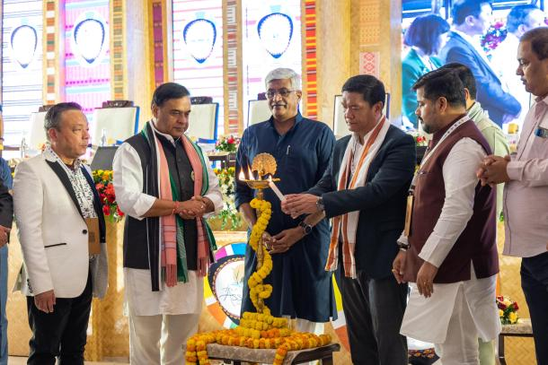

Chief Minister Pema Khandu today informed that the future vision for Arunachal Pradesh’s tourism is to position the state as a premier global destination that celebrates its unique blend of natural beauty, cultural heritage, and adventure opportunities. Speaking at the inaugural ceremony of the 12th International Tourism Mart (ITM) here at Kaziranga, Khandu hailed the event as of utmost significance in strengthening the tourism ecosystem of the Northeast by connecting stakeholders, promoting partnerships, and providing visibility to the region’s unique offerings. Such events, he said, foster unity and collaboration among Northeastern states to promote the region as a cohesive destination.
Talking about Arunachal tourism, he said that the state government is emphasizing on sustainable and eco-friendly tourism. “We aim to enhance infrastructure, improve connectivity, and develop iconic treks, trails, and festivals that attract domestic and international travellers. By empowering local communities through initiatives like homestays and skill development, and leveraging its diverse ecosystems, Arunachal aspires to become a model for responsible tourism. The vision is not just to boost tourism numbers but to create a lasting impact that benefits the economy, preserves cultural identity, and safeguards the environment for future generations,” he said. Mentioning that Arunachal Pradesh shares three international borders: approx.440 kms with Myanmar, 1080 kms with Tibet and 160 kms with Bhutan, Khandu said that considering the state’s sparce population and strategic location, the Indian Army is its biggest partner in developing tourism.
“Under the Vibrant Village Programme (VVP) launched by the Union Home Ministry to develop border villages, we are partnering with the Indian Army and paramilitary forces to develop our border villages in boosting sustainable tourism,” he said. Khandu added that Arunachal Pradesh offers unparalleled opportunities for adventure enthusiasts—from trekking in pristine landscapes to rafting in untamed rivers. “We remain committed to our efforts in promoting sustainable tourism, empowering local communities, and fostering a responsible tourism ecosystem,” he said.
Khandu informed that in the last 10 years the average tourist footfall was recorded at 205% increase, which proves that the state has grown leaps and bounds in the tourism sector. He called upon all stakeholders like tour operators, investors, and influencers to explore Arunachal Pradesh’s potential and partner in developing innovative tourism ventures and assured them of the state’s commitment to providing a supportive environment for sustainable tourism initiatives.
While informing that ArunachaL Pradesh is hosting the 16th Annual Conference of the Adventure Tour Operators Association of India (ATOAI) at Tawang from Dec 3 to 8 next, Khandu invited adventure tour operators to attend the same.
The Chief Minister expressed gratitude to Union Tourism Minister Gajendra Singh Shekhawat, under the able guidance of Prime Minister Narendra Modi, for giving the needed attention in developing tourism in the North East. The ITM was inaugurated by the Union Tourism Minister in presence of Assam Chief Minister Himanta Biswa Sarma and Khandu. Khandu was accompanied by state Tourism Minister P D Sona and his Advisor Mopi Mihu.
