GOVERNOR’S SECRETARIAT
ARUNACHAL PRADESH
ITANAGAR

Press Communiqué
Dated Nov 27th, 2024

Blood donation camp held at Aalo
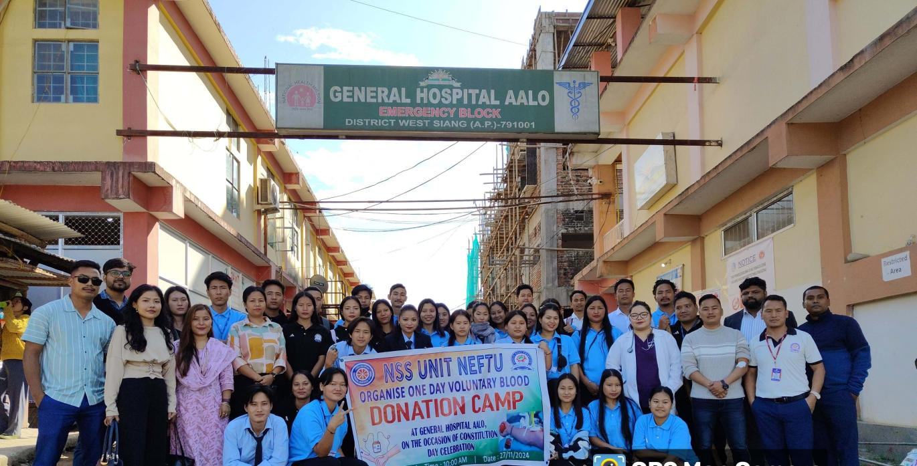

Aalo the 27th November 2024: NEFTU NSS Unit headed by NSS PO Mr. Tabang J Tai, organized 2nd blood donation camp at District Hospital, Aalo, West Siang District, Arunachal Pradesh. The voluntary blood donation camp witnessed generous number of participants from the staff and student community of NEFTU.
The volunteers donated 30 Unit of blood on its 2nd blood donation camp in the Blood Bank unit of District Hospital Aalo. This noble work of NEFTU NSS team was much appreciated by the Aalo Hospital fraternity.

