GOVERNOR’S SECRETARIAT
ARUNACHAL PRADESH
ITANAGAR

Press Communiqué

Dated Nov 26th, 2024

Maths, Science, and Arts Exhibition at
PM SHRI SCHOOL JNV Tawang

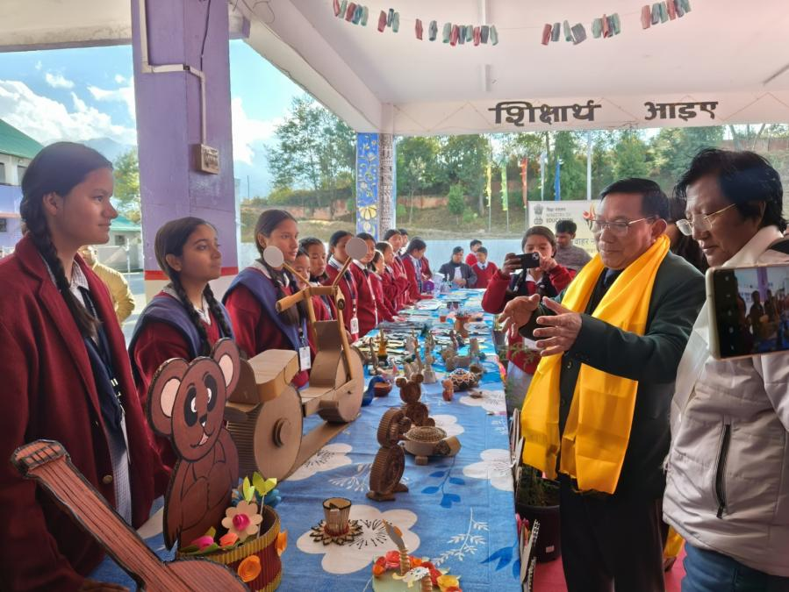

Tawang, 26th November 2024: PM SHRI SCHOOL JNV Tawang hosted a vibrant Maths, Science, and Arts Exhibition at its academic block, showcasing the remarkable talents of its students. The event, inaugurated by Sang Khandu, Additional Deputy Commissioner of Tawang, featured over 50 innovative scientific models, mathematical exhibits, and artistic creations. Dignitaries including M L Meena, Principal, and other officials, parents, and guardians attended the exhibition. The event aimed to foster creativity, critical thinking, and problem-solving among students.
The exhibition concluded with a vote of thanks from T P Praveen, PGT English.
