GOVERNOR’S SECRETARIAT
ARUNACHAL PRADESH
ITANAGAR

Press Communiqué

Dated Nov 26th, 2024

Lohit District Celebrates Academic Brilliance at Golden Jubilee Awards
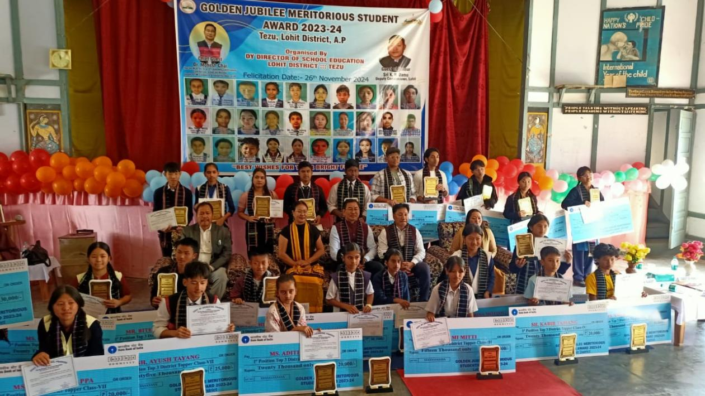

The District Education Department, Lohit District organized a felicitation Award Ceremony for Meritorious Students from Class III to XII under the aegis of Golden Jubilee Meritorious Students Awards for the academic session 2023-24 at the Auditorium of Govt. Higher Secondary School Tezu No. I on 26th November 2024.
The Golden Jubilee Meritorious Students Awards is a noble initiative of Govt. of Arunachal Pradesh. The objectives of this award is to improve quality education in the states by encouraging the students to build themselves with competitive will power and set up their bright future. This award is selected only on the basis of scholastic performance of the students from class III to Class XII respectively.
The award consisting of Cash Prizes, Certificates, Momentos have been given away by Chief Guest Dr. Mohesh Chai, HMLA cum-Adviser to HM Health & FW, Commerce & Industry, Govt. of Arunachal Pradesh, Shri TobangPertin, IFS, DFO Tezu, Guest of Honour and Mrs. Tumngam Nyodu, DDSE Lohit in presence of students, Parents Head of Schools and officials of Education Department.
Chief Guest, Dr. Mohesh Chai, HMLA cumAdviser to HM Health & FW, Commerce & Industry congratulates the Meritorious Students, Teachers and Guardians and urge the students to excel their academic performance in the coming academic session, Shri TobangPertin, Guest of Honour, request the students to study hard and advise for three methods i.e. Long planning, Hardworking and self-determination and Mrs. Tumngam Nyodu, DDSE Lohit highlighted the aims & objectives of the award and congratulate the meritorious students, Teachers and Parents.

