GOVERNOR’S SECRETARIAT
ARUNACHAL PRADESH
ITANAGAR

Press Communiqué

Dated Nov 26th, 2024

DAJGUA program Concluded in Daporijo
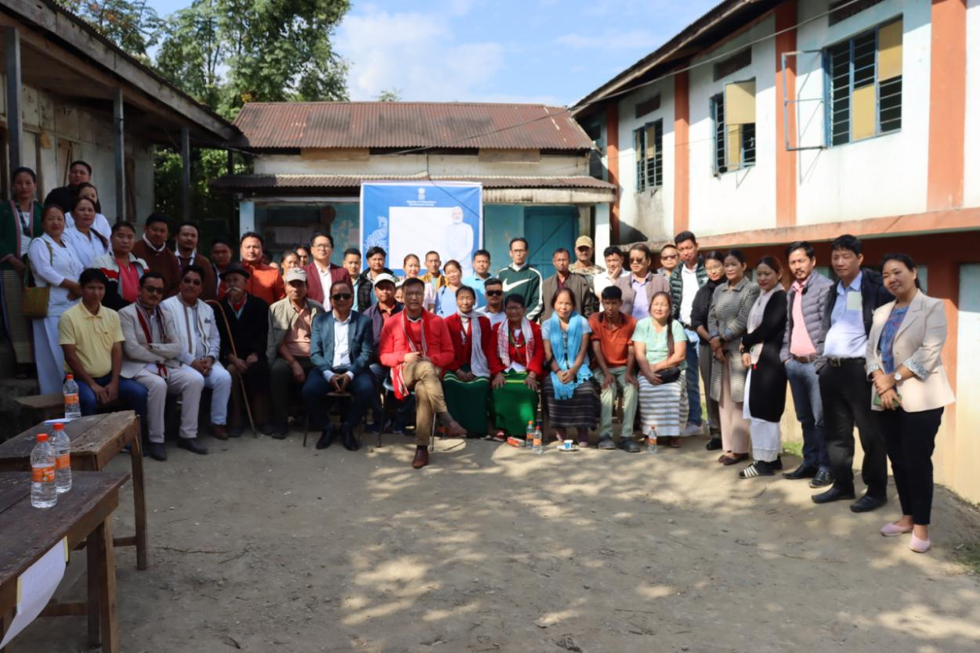

Dapotijo: The Days long program of Dharti Aaba Janjatiya Gram Utkarsh Abhiyan was concluded in Sikar -ii of Sigin -i Gram panchayat under Daporijo Circle. Shri. Tasso Gambo DC attended the program as cheif guest.While attending the event he exhorted to all the concerned departments to remain reachable of public and any program policy of state/central flagship schemes be made accessible for the beneficiary,so that public could availed the befits in timely as well as for mass participation he said. Furthermore, DC stressed on saturation of all schemes ,he urged concerned department to focus on 100% achievement. During the Abhigyan, health camp, Aadhar registration, PMAY, CMAY were rigistered on the spot and Agri-Horti seeds were freely distributed to the farmers.
The program was attended by HoDs and officials of all banking sectors of the district, in where several issues were disscussed.

