GOVERNOR’S SECRETARIAT
ARUNACHAL PRADESH
ITANAGAR

Press Communiqué

Dated Nov 26th, 2024

Balo Raja visits disputed border villages/areas

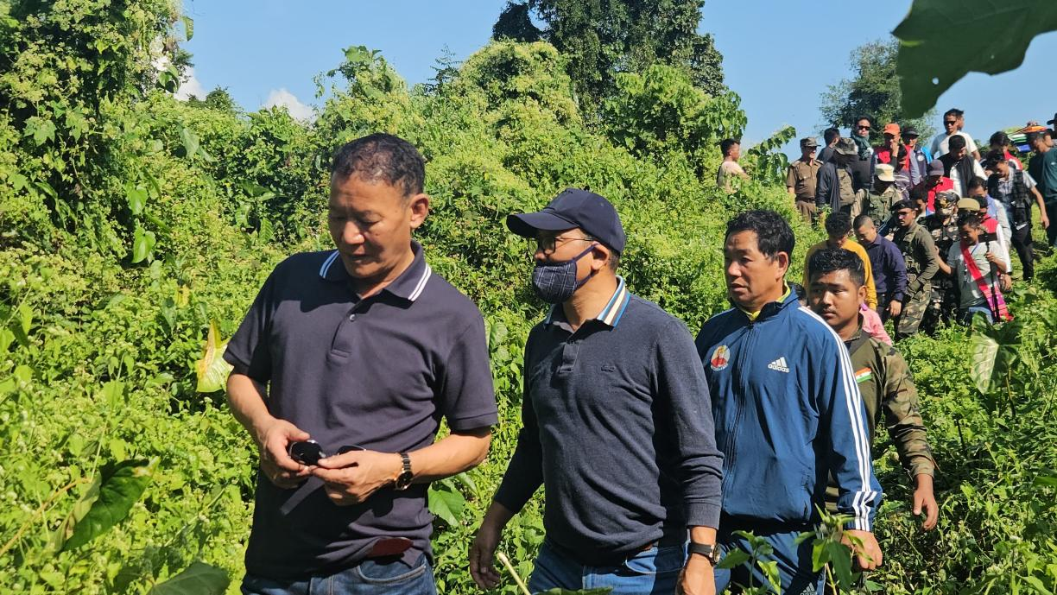

Balijan: Shri Balo Raja, Hon’ble Minister Urban Affairs and Land Management -cum- Chairman of the Regional Committee for Papum Pare visited the disputed villages along the Arunachal – Assam border under Balijan and Banderdewa circle of Papum Pare district on Tuesday. 14-Doimukh MLA Nabam Vivek, DC Papumpare Jiken Bomjen and other members of the committee, ADC Balijan Takar Rava, Deputy Director Border Affairs Rome Mele, EAC Dani Rikang, PRI members, Representatives of Papum Pare Border people’s Forum and All Papum pare District Students Union accompanied the Minister.
Six regional committees were formed to expedite the identification and resolution of disputed areas along the 804.1-km interstate boundary, following the historic Namsai Declaration signed on 15 July, 2022, where the chief ministers of Arunachal Pradesh and Assam agreed to end the decades-old border issue. Shri Balo Raja, who had taken charge as the Chairman of the Regional committee for Papum Pare, in July this year is minutely studying the disputed areas to ascertain facts and workout amicable solutions with the Assam counterpart. The team visited the disputed sites at Dullung Ramghat , Karbi, Radaso under Balijan circle and Tani Hapa, Pichola, Gorubandha under Banderdewa circle.
Highlighting the importance of maintaining cordial relations with neighbouring states and the spirit of negotiation, Raja emphasised that local MLAs, deputy commissioners, and other officials must play pivotal roles in resolving this longstanding issue. He also requested all the villagers to maintain status quo. Papum Pare shares approximately 127 kilometers with North Lakhimpur accounting for around 94 kms and Biswanath district comprising roughly 33 kilometers.

