GOVERNOR’S SECRETARIAT
ARUNACHAL PRADESH
ITANAGAR

Press Communiqué

Dated Nov 25th, 2024

Siang Trust conducts free health camp at Pessing village
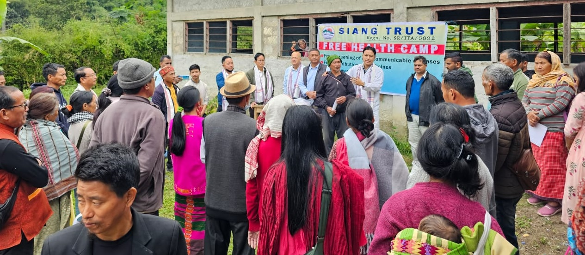

PASIGHAT: A free health camp was conducted today at Pessing village, Rumgong Subdivision, Siang District by Siang Trust (NGO). Total 80 patients were examined including senior citizens. Free pressure tests, sugar tests, free medicines were given during the camp. Medicine Specialist Dr Ogin Jerang, Orthopaedic Surgeon Dr Tiyang Taga, Dental Surgeon Dr O Tatak, Retired Additional Director Dr Saibal Bhattacharjee, medical staff, Vice President of
Siang Trust Group Captain Mohonto Panging Pao VM (Rtd) supporting staff and representatives of Siang Trust participated in the health camp. GBs, village secretary and elders of Pessing village also assisted in the conduct of the camp. Similar free health camps are planned for citizens of remote villages of the area, informed Siang Trust Vice President Pao.

