GOVERNOR’S SECRETARIAT
ARUNACHAL PRADESH
ITANAGAR

Press Communiqué

Dated Nov 25th, 2024

Arunachal Pradesh Football Association Signs MoU with NEUFC for Football Development
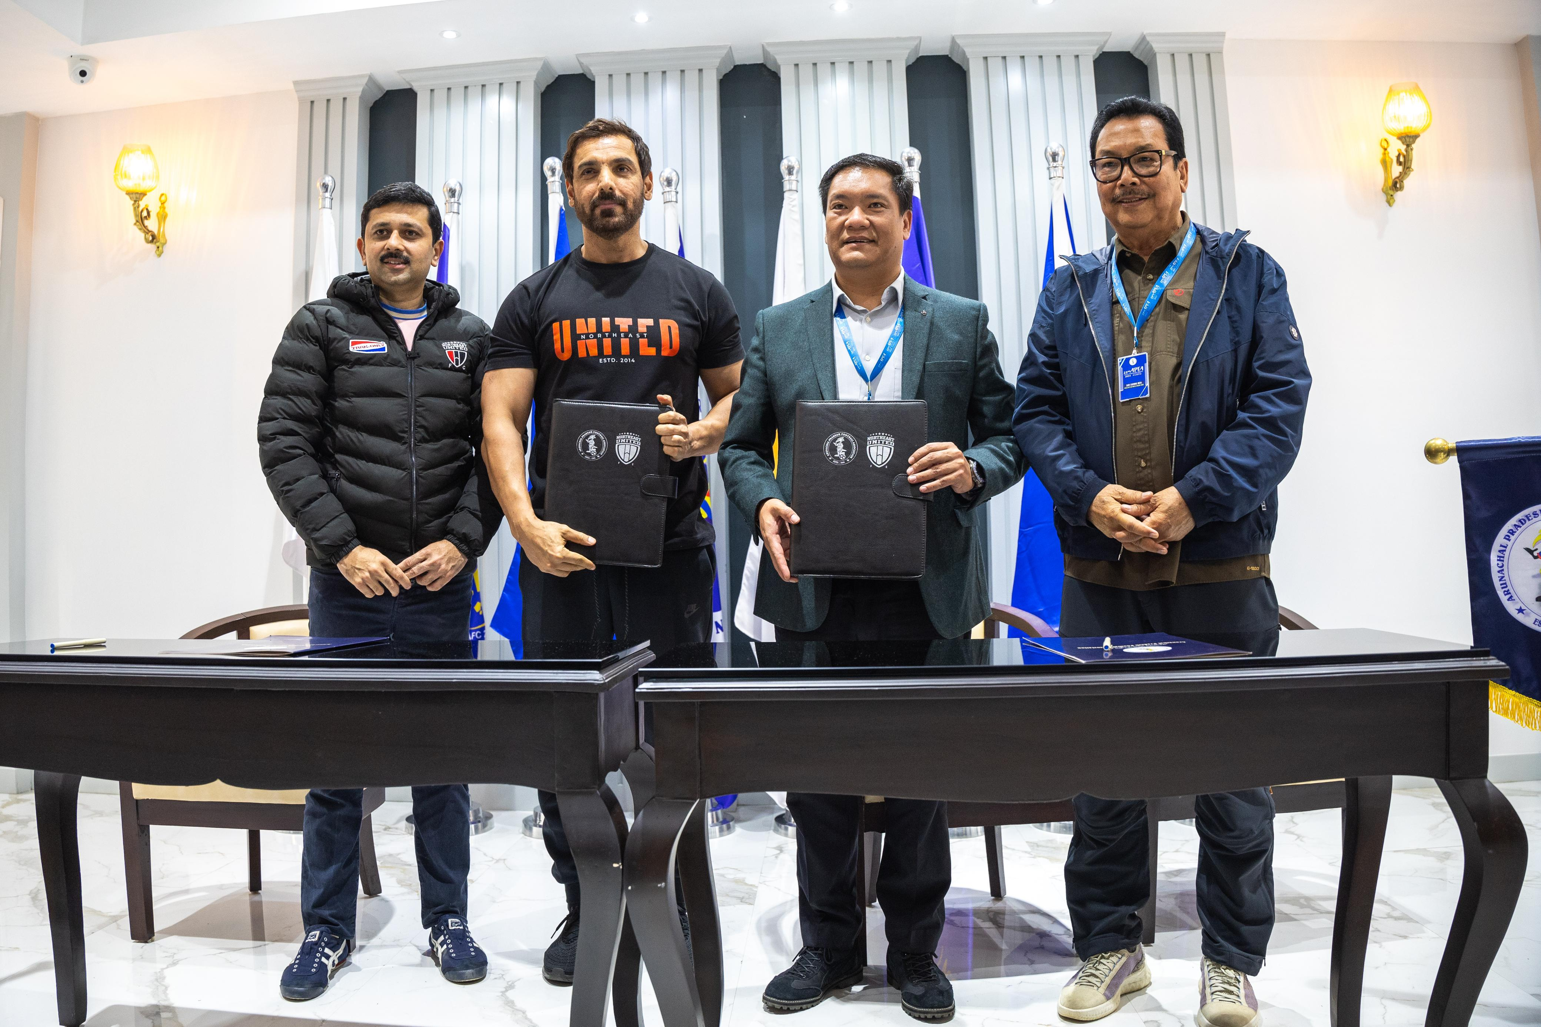

Namsai: In a significant move to boost football in Arunachal Pradesh, the APFA signed a Memorandum of Understanding (MoU) with John Abraham’s NEUFC. Chief Minister Pema Khandu, alongside AIFF President Kalyan Chaubey, facilitated the partnership, aiming to provide scouting, coaching, and youth development through soccer schools and academies. The MoU, effective for five years, will foster local talent, with NEUFC offering technical expertise and APFA providing the necessary infrastructure and support. Khandu expressed confidence in producing world-class footballers from the state.

