GOVERNOR’S SECRETARIAT
ARUNACHAL PRADESH
ITANAGAR

Press Communiqué

Dated Nov 25th, 2024

Chief Minister Pema Khandu Lays Foundation Stones for Water Supply and Sports Facilities in Namsai
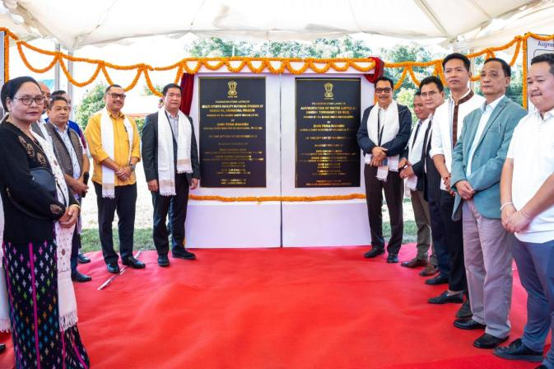

NAMSAI : Chief Minister Pema Khandu today laid the foundation stones of two projects here, which are augmentation of water supply with a capacity of 7.80 MLD and a Multi-sports facility and outdoor stadium, worth Rs 105 crores. Khandu hailed Namsai as one of the fastest developing districts in the state and lauded the people of the district for supporting the cooperating with the government in executing developmental projects resolving all issues amicably.
“Kudos to all stakeholders, the hardworking locals, dedicated officers and visionary leadership for making Namsai one of the fastest-developing districts in Arunachal Pradesh,” he said. Responding to few requests placed by local legislators, Khandu assured to develop Namsai as a center of learning and excellence with establishment of a Medical College, Nursing College and a Fishery College. He also announced establishment of a new convention centre and a football academy in the district.
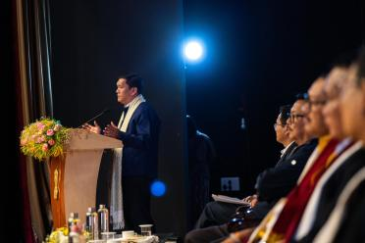 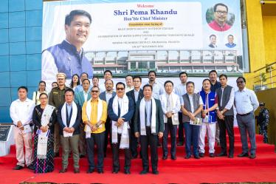
Khandu drew attention of the people towards the vice of drug consumption, which is prevalent in the district. He sought unstinted support from the leaders, elders, CBOs and students organizations in the state government’s fight against drug abuse. “We have a wholesome Act in place to tackle substance abuse. But the state government alone cannot fight and win this battle. Proactive role of each member of the society alone can save our youths from this menace,” he said. He gave the instance of the ongoing Arunachal Rang Mahotsava and asserted that youths of the state have immense talent. The only challenge, he remarked, is to give them the right direction and the right platform to flourish. “To lure our youths towards progress and away from substance abuse, we need to give them platforms to engage themselves positively. The Arunachal Rang Mahotsava is one such platform,” he said.
Mentioning that sports is another platform where youths can participate and develop. Khandu informed that the state government has given much emphasis on sports in the last few years. Going a step further, Khandu, who is also President of Arunachal Pradesh Football Association (APFA), informed that in collaboration with the North East United Football Club APFA will run two football academies – one at the Golden Jubilee Stadium, Yupia and one at Namsai once the proposed football stadium is completed. Also present were Deputy Chief Minister Chowna Mein and legislators Zingnu Namchoom and Likha Soni.

