GOVERNOR’S SECRETARIAT
ARUNACHAL PRADESH
ITANAGAR

Press Communiqué

Dated Nov 26th, 2024

One Day Sensitization Program on Right to Information conducted at Aalo
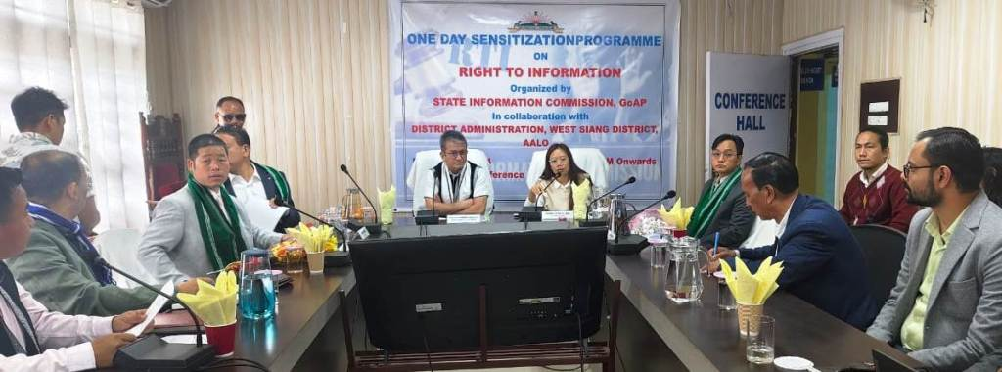

Aalo: A one-day RTI sensitization programme was held in Aalo on November 26, 2024, chaired by Hon'ble State Chief Information Commissioner, Major General Jarken Gamlin. DC Mamu Hage welcomed the attendees and emphasized the importance of knowledge-sharing about the RTI Act. Key highlights included presentations on the provisions of RTI, its practical applications, and challenges faced by officers. The session aimed to encourage transparency and effective communication, with plans for more sensitization programmes across the state. Officers, Panchayat leaders, and RTI activists actively participated and shared their views.

