GOVERNOR’S SECRETARIAT
ARUNACHAL PRADESH
ITANAGAR

Press Communiqué

Dated Nov 23rd, 2024

Deputy Chief Minister Chowna Mein reviews progress of Comprehensive Scheme for Strengthening of Transmission and Distribution System in Arunachal Pradesh

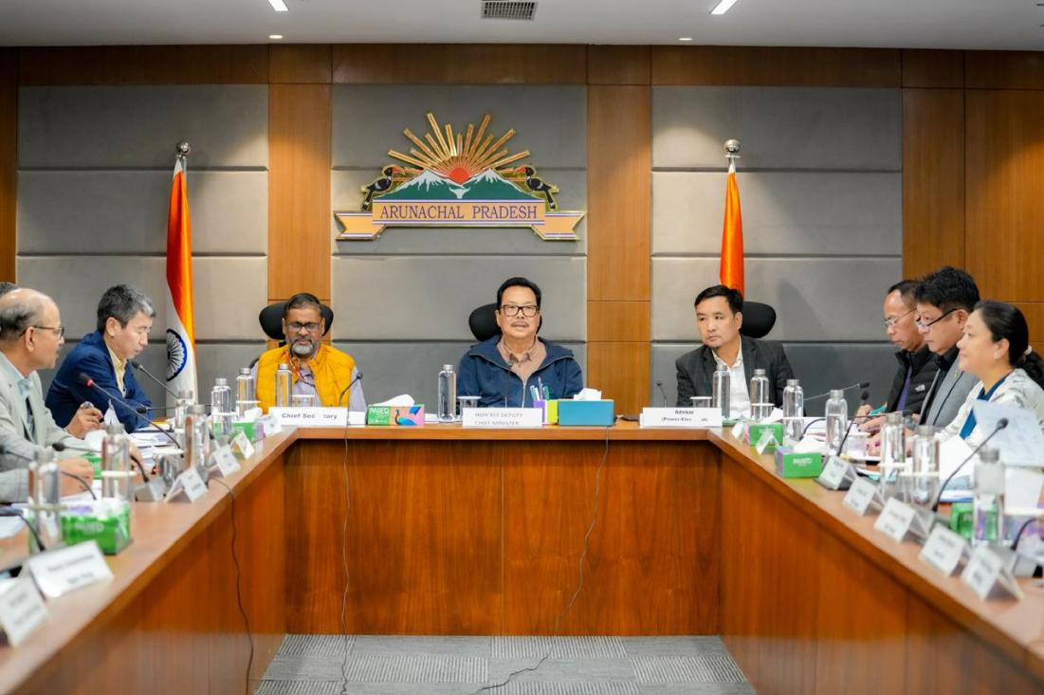

Itanagar, 23 Nov 2024 - The Deputy Chief Minister and Minister In-charge of Power Department, GoAP Chowna Mein today reviewed the status and progress of the State’s Comprehensive Scheme for Strengthening of Transmission and Distribution System (CSST&DS - AP) at the Secretariat Office in Itanagar. The meeting focused on expediting the implementation of the transmission and distribution system, while addressing key challenges including disbursement and compensation issues for the transmission lines stretching from Tawang to Longding.

With emphasis on accelerating progress, Mein urged concerned officials to ensure project completion by March 2025, within the specific timelines for each transmission line which were fixed during the meeting. Adding on, Mein requested the local representatives to be involved personally in order to resolve local issues for smooth implementation of the Scheme. He also asked PGCIL to take the local representatives in confidence and coordinate with the District Administrations, while maintaining a friendly association with the locals.
He further directed the Power Department to come up with proper SOP to prevent accidents and casualties during the maintenance of the power line. The Deputy Chief Minister conveyed deep sorrow over the loss of lives of the electrical staff during maintenance, stating that such incidents should not happen in the age of advanced technology. With regards to the pending issues raised during the meeting, the Chief Secretary has also asked the DCs to resolve them at the earliest and the POWER GRID to work in close coordination with the DCs. He further instructed the officials to complete the pending demands within a timeframe of 15-20 days and has asked to charge all the commissioned lines at the earliest.
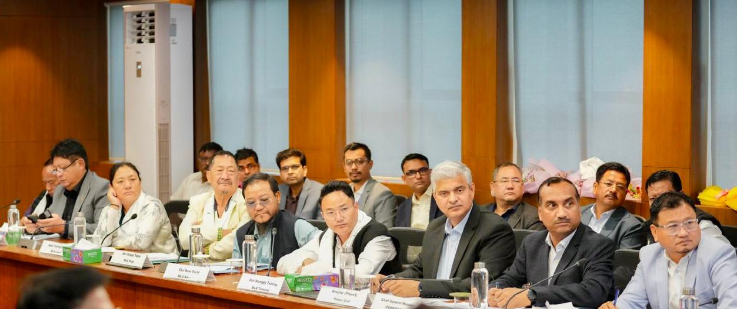

The meeting was attended by Advisor to Power Minister, Jikke Tako, Deputy Speaker, Kardo Nikyor, MLAs, Chief Secretary, Manish Gupta, PCCF, P Subramanyam, Principal Secretary, Kaling Tayeng, Secretary (Planning), R K Sharma, Secretary (LM) A K Singh, Deputy Commissioners, Chief Engineers (TP & MZ), CE (Commercial), CE (Eastern Zone) of Power Department, Director of Project & CGM (Power Grid), ADCs and DLRSOs among others

