GOVERNOR’S SECRETARIAT
ARUNACHAL PRADESH
ITANAGAR

Press Communiqué

Dated Nov 23rd, 2024

District Administration Organizes Sewa Aapke Dwar Camp Under DAJGUA at Lazu

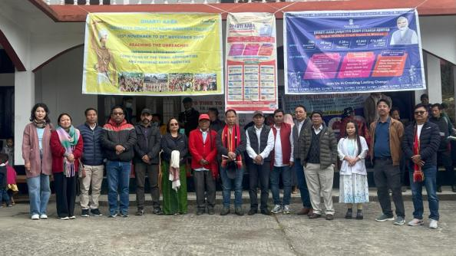

Lazu, 23rd November 2024: The District Administration of Tirap successfully organized a Sewa Aapke Dwar Saturation Camp under the week-long Dharti Aaba Janjatiya Gram Utkarsh Abhiyan (DAJGUA) at Lazu. The camp provided vital services, including birth certificates, Aadhaar registration, Scheduled Tribe (ST) certificates, and a comprehensive medical camp, benefiting residents from nine villages: Lazu, Upper Chinhan, Lower Chinhan, Lonyen, Noglo, Sinnu, Raho, Pongkong, and Barap Camp. A total of 1,546 beneficiaries availed themselves of various government schemes during the camp.
The program saw participation from Heads of Departments, including those from Medical Services, Women and Child Development (WCD), Agriculture, Horticulture, Fisheries, Food & Civil Supplies, Economic & Statistics, ArSRLM, the Block Development Officer (BDO) Lazu, Jan Suvidha Khonsa, Lazu Administration, Animal Husbandry & Veterinary, the Electricity Department, and the Krishi Vigyan Kendra (KVK), Deomali.
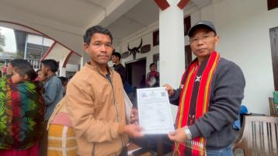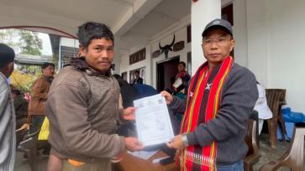
Speaking at the event, Deputy Commissioner of Tirap, Shri Techu Aran, emphasized the importance of government welfare schemes in improving the quality of life for tribal communities under DAJGUA. He commended the youth of the Lazu area for excelling in sports, particularly Judo, and encouraged them to continue bringing laurels to the district. Shri Aran also urged the community to shun the cultivation and use of opium (kaani) and replace it with cash crops through the support of the Agriculture, Horticulture, and allied departments. He reminded attendees that cultivating poppy is illegal and punishable under the NDPS Act, 1985.
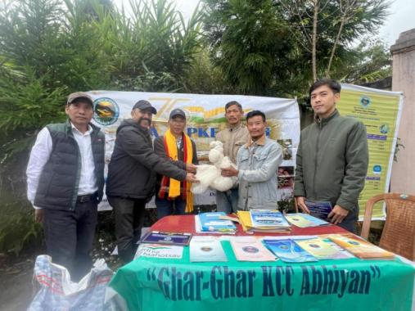
Key officials, including Shri Tana Bapu, ADC (I/c) cum DEO, Khonsa; DD(WCD), Smti H. Bangsia; DMO (I/c), Dr. T. Gao; DFDO, S.K. Jawal; DF&CSO, N. Songtheng; ADO, Rajen Tokbi; Dr. Narendra Kumar, KVK Scientist; and BDO Lazu, Kaming Ramwa, highlighted various government schemes under their respective departments. The camp was effectively supervised and monitored by EAC (I/c) Lazu Noklem Wangjen, CO Borduria Yowa Anya, and Dr. Metung Taku, I/c DIPRO and CO Dadam.
The event underscored the government’s commitment to bringing essential services to the grassroots level and empowering tribal communities through initiatives like DAJGUA.
Shri Rangmo Rantu, ZPM, Lazu Block, expressed his appreciation for the District Administration’s efforts in conducting the Sewa Aapke Dwar camp at Lazu, even on a Saturday, demonstrating their dedication to serving the public.

