GOVERNOR’S SECRETARIAT
ARUNACHAL PRADESH
ITANAGAR

Press Communiqué
Dated Nov 22nd, 2024

Regional Review Meeting of Health and PHED Held at Dirang

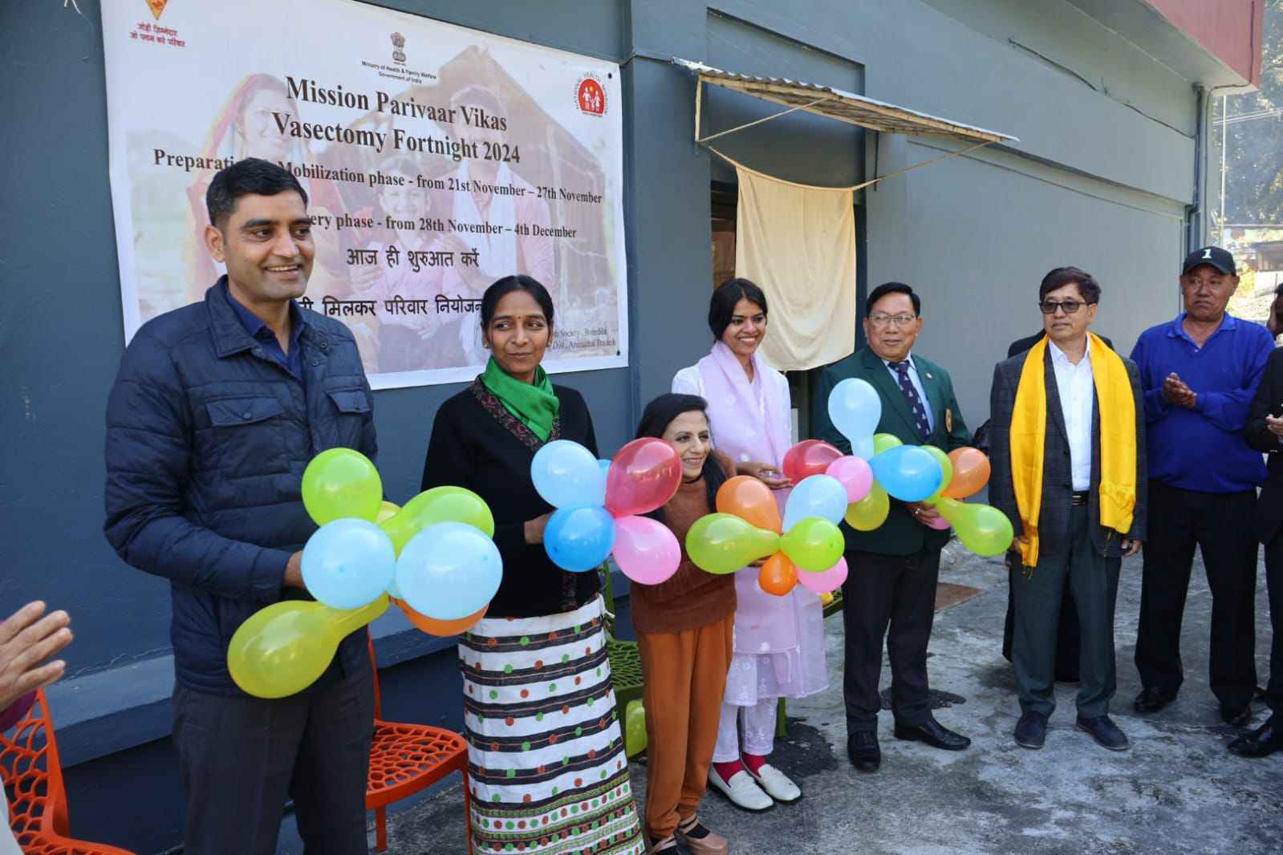

Dirang, 22 November: A regional review meeting for the Health and PHED departments of Tawang, West Kameng, East Kameng, and Pakke-Kessang districts was held at the conference hall of NRC-Yak, Dirang. Chairing the meeting, I/C Chief Secretary, Padmini Singla IAS, lauded the Health Department for organizing such regional review meetings, where stakeholders from all levels can participate, facilitating effective information dissemination and necessary discussions. She directed the department to issue a proper action plan and timeline along with the meeting minutes based on the discussions. Highlighting the importance of proper data management, Singla urged the District Medical Officers (DMOs) to maintain accurate and comprehensive databases. She emphasized the responsibility of districts to monitor private-public partnerships (PPP) to ensure their proper functioning, with regular reporting to the headquarters.
Furthermore, she appealed to health staff to demonstrate politeness and courtesy toward patients and create awareness about the free tests and facilities available in hospitals. Commissioner of Health and PHED, Pawan Kumar Sain, IAS, outlined the objectives of conducting regional meetings. He called on Deputy Commissioners (DCs), DMOs, and PHED Executive Engineers (EEs) to hold coordination meetings, inspect health facilities and infrastructure, and submit plans to ensure that all health centers are equipped with boundary walls, LPCs, single entry and exit points, water supply, electricity, and other essential amenities. He also suggested placing services such as NCD testing, X-rays, free blood tests etc near registration counters to enhance public awareness of these facilities. Sain further directed the Health Department to display TELE-MANAS helpline numbers prominently on posters, pamphlets, and banners to ensure public awareness of this facility. Secretary of Health, Ira Singal IAS, informed the gathering that the Health Department is taking responsibility for Aadhaar enrollment to ensure it is properly linked with health schemes. She added that a mother-daughter duo system will also be linked through Aadhaar for better integration.
Sharing national data on AIDS patients and drug consumption, she expressed concern over Arunachal Pradesh’s high ranking in these areas and called for collective efforts to address the issue. She also shared measures to control these problems and encouraged the use of TELE-MANAS and its various services.The DCs and DMOs of the four districts presented progress reports and updates through PowerPoint presentations, which were closely reviewed during the meeting. On this occasion, Mission Parivaar Vikas was also launched. The meeting was attended by the Director of Health, Director of NHM, nodal officers, DRCHOs, doctors, PHED engineers, ASHA workers, and other officials.

