GOVERNOR’S SECRETARIAT
ARUNACHAL PRADESH
ITANAGAR

Press Communiqué

Dated Nov 22nd, 2024

Dlsa Upper Siang Conducted Legal Awareness Camps At Tuting

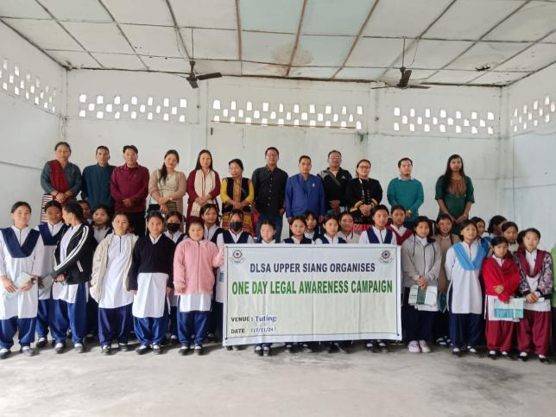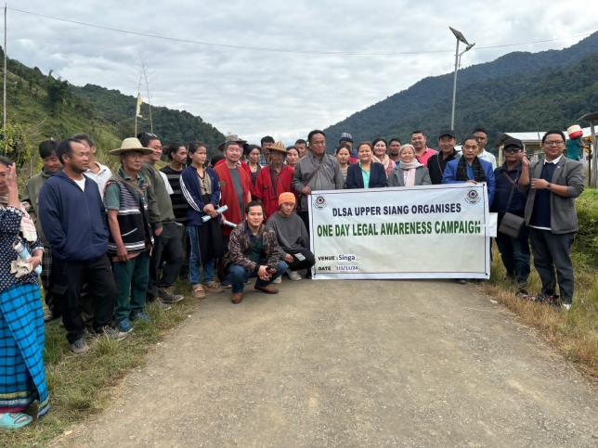

DLSA Upper Siang organized series Legal Awareness Campaign across Tuting Sub Division from 14 to 18th November 2024 on various topics- victim compensation scheme, Domestic Violence Act, Legal Aid Clinic, JJB, AP MarriageAct, AP Civil Code and POCSO Act.

