GOVERNOR’S SECRETARIAT
ARUNACHAL PRADESH
ITANAGAR

Press Communiqué
Dated Nov 22nd, 2024

Deputy Chief Minister Chowna Mein Chairs Key Meetings on Unsung Heroes and GI Festival 2025
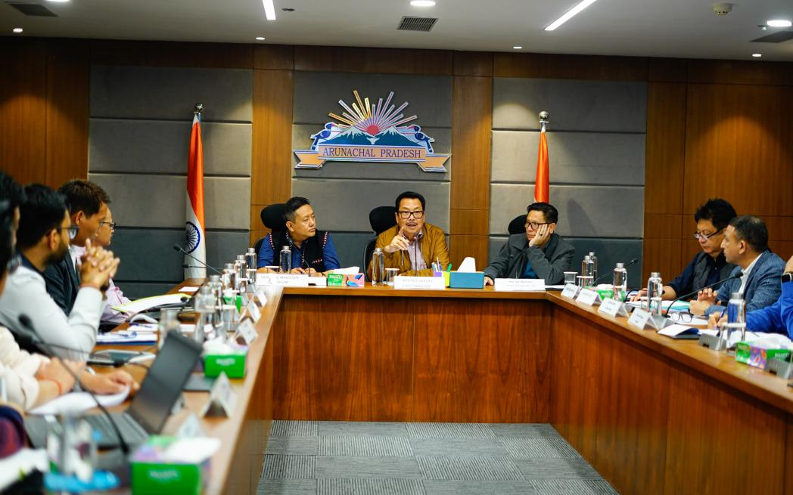

Itanagar, November 22, 2024: Deputy Chief Minister Chowna Mein today chaired two important meetings focused on preserving Arunachal Pradesh's history, cultural heritage and promoting its indigenous products.
A meeting of the Core Committee on Unsung Heroes of Arunachal Pradesh was held at the Deputy Chief Minister’s Office Conference Hall. Considering the claims from various communities, the committee has decided to extend research works to uncover and document more heroic contributions of the State's unsung heroes and integrate these findings into educational curricula.
It also urged the Rajiv Gandhi University for early publication of these research findings in book format to be further incorporated in the school syllabus.
The Department of Art & Culture was also urged to expedite the construction of 13 war memorials across the State.
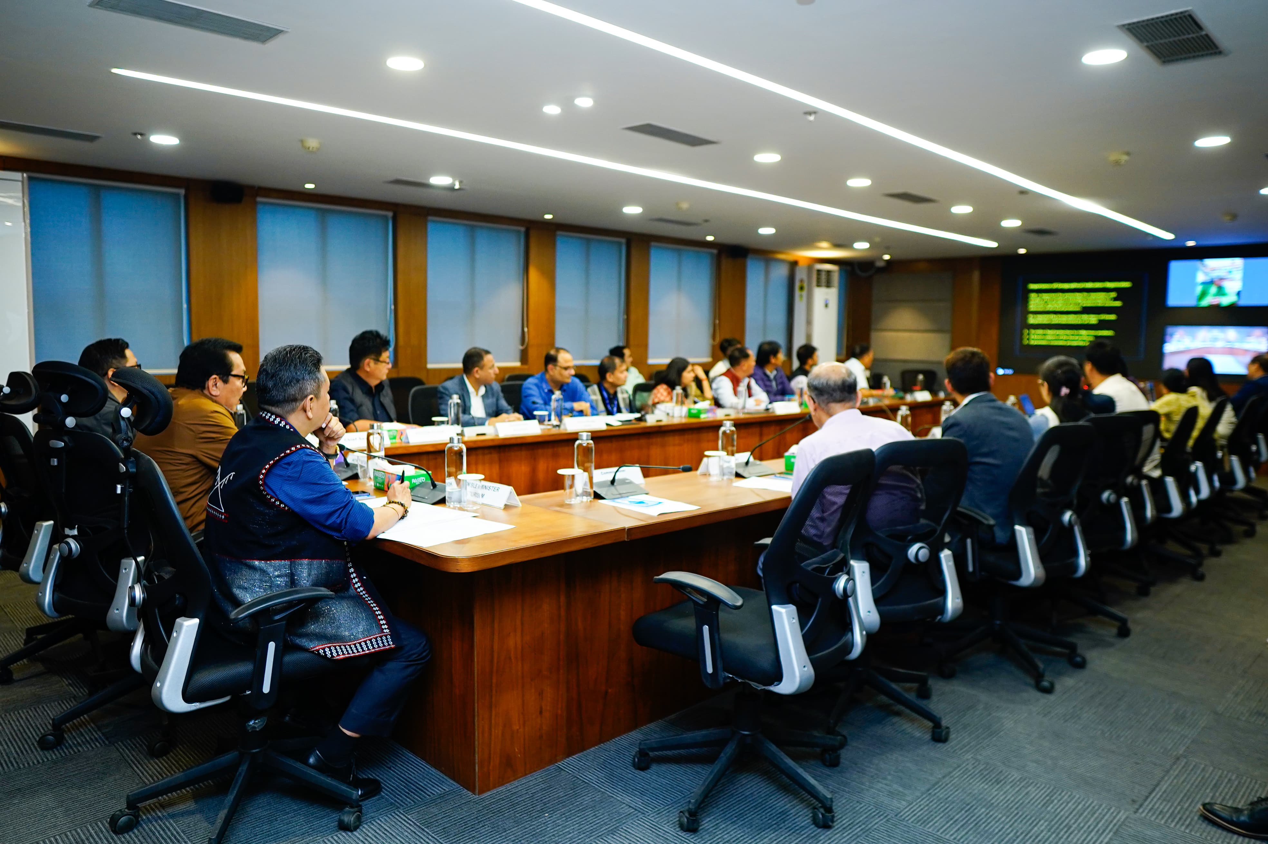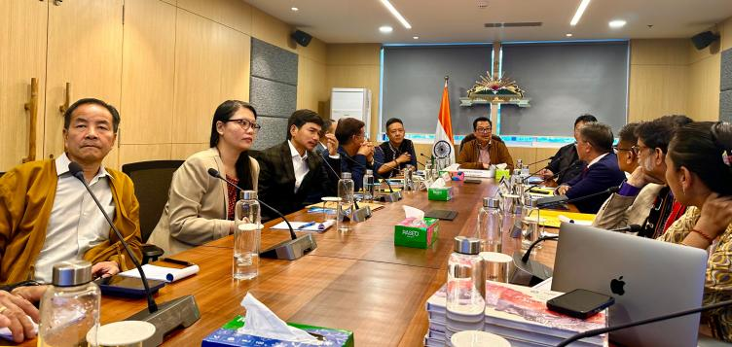
The Deputy Chief Minister assured to enhance funding for the timely completion of these projects. The memorials will serve as lasting tributes to the sacrifices of these heroes and help preserve their legacy for future generations.
The meeting was attended by Minister of Education, Tourism, etc Pasang Dorjee Sona, Advisor to the Deputy Chief Minister, Anupam Tangu, Commissioner (Education), Amzad Tak, Secretary (Education), Duly Kamduk, Vice Chancellor (In-Charge) of Rajiv Gandhi University, Prof. S.K. Nayak, along with faculty members, officials from the Department of Art & Culture, and the research team from Rajiv Gandhi University.
Another important meeting was chaired by DCM to discuss the much-anticipated GI (Geographical Indication) Festival, a major initiative announced in the 2024-25 state budget. During the meeting, a decision was taken to hold the festival in New Delhi during the month of January/February 2025 to showcase Arunachal Pradesh's GI-registered indigenous products, bringing the State’s unique crafts, cuisine, and culture to the national capital. The festival will feature 20 GI-tagged products from the State, including 5 agricultural products, 11 textile and handicraft items, 3 manufactured products, and 1 foodstuff.
A high-level committee has been formed to oversee the event under the chairmanship of Minister of Education & Tourism, Pasang Dorjee Sona, with the GI Man of India and Padmashree recipient Dr. Rajanikant and Secretary to Chief Minister, Sadhana Deori as advisors and Director SHRD, Shri Egan Basar as the Member Secretary.
Other attendees at the meeting included Minister of IPR, Textiles & Handicrafts, Nyato Dukam, Residential Commissioner, Arunachal Bhawan, New Delhi, Amzad Tak, GM NABARD, Secretaries and Directors of Agriculture, Horticulture, Textiles & Handicrafts, and Director SHRD.
Both initiatives reflect the government’s ongoing commitment to promote Arunachal Pradesh’s rich cultural heritage while honouring its history and showcasing the state’s vibrant traditions to the rest of India.

