GOVERNOR’S SECRETARIAT
ARUNACHAL PRADESH
ITANAGAR

Press Communiqué
Dated Nov 22nd, 2024

DTFI meeting held at Yingkiong

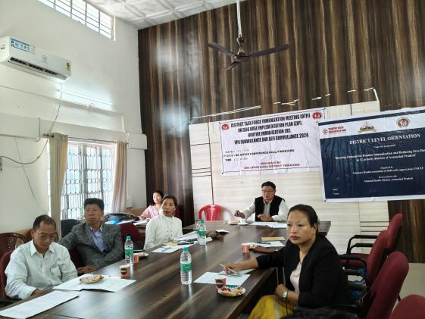

Yingkiong Nov 22: The meeting of District Task Force (DTFI) on Zero Dose Implementation Plan (ZIP), Routine Immunization (RI), VPD Surveillance and AEFI Surveillance 2024 held under the chairmanship of Deputy Commissioner cum Chairman DHS Upper Siang Sri Talo Jerang here at DC office conference hall, Yingkiong today. While presiding over the meeting DC enquired over the low performing CHCs and PHCs and urged upon all MO i/cs to work with dedication and utter sincerity according to their respective micro plan to achieve the target that are being set by the Govt.
During the meeting, Dr.Diptojyoti Mandal, RRT Consultant WHO, gave power point presentations on Zero Dose Implementation Plan (ZIP). Routine Immunization (RI) and VPD Surveillance, Dr. Nabho Borang on Upper Siang District Routing Immunization Coverage till 3rd Qtr 2024 and Sri Hemen Bora, State Programmer UNICEF VHAI on overview of VHAI on RI Programme under GAVI District in Arunachal Pradesh respectively.
Earlier, DMO Dr.Gepeng Litin highlighted aims and objective of the meeting. MO i/cs from CHCs and PHCs , representatives from CBO, education, ICDS and staff attended the meeting.

