GOVERNOR’S SECRETARIAT
ARUNACHAL PRADESH
ITANAGAR

Press Communiqué
Dated Nov 22nd, 2024

DCPU East Siang celebrate National Adoption Awareness Month

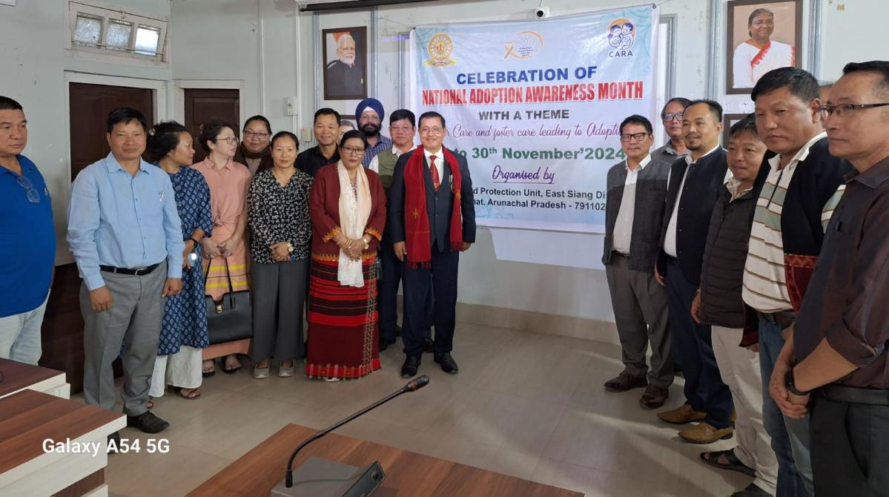

PASIGHAT, November 22, 2024: The monthlong National Adoption Awareness Month with the theme of “ foster care and foster care leading to Adoption” was organized by the District Child Protection Unitl under Mission Vatsalya Scheme at DC Conference hall today and chaired by the Deputy Commissioner Tayi Taggu.
The DC stressed on the importance of such initiatives to create larger public awareness on promoting legal adoption and foster care of children in need of care and protection in a supportive and caring homes to become worthy citizens of the country.
DDICDS , WCD cum District Child Protection Officer, Machi Gao in the session disseminated on the various aspects, provisions and procedures for legal adoption and its need for secure future for the child in need of foster care and subsequent adoption. The Nodal officer,DCPU spoke on the importance of adoption and foster care in providing a safe,secure and caring ,enabling environment for the children in need of care and protection and also older child in need of care and support and a nurturing home for them.

HoDs, CDPOS, DCPU Staff and other stakeholders attended the session.

