GOVERNOR’S SECRETARIAT
ARUNACHAL PRADESH
ITANAGAR

Press Communiqué

Dated Nov 15th, 2024

Janjatiya Gaurav Diwas Celebrated at Yupia to Honor Birsa Munda's Birth Anniversary

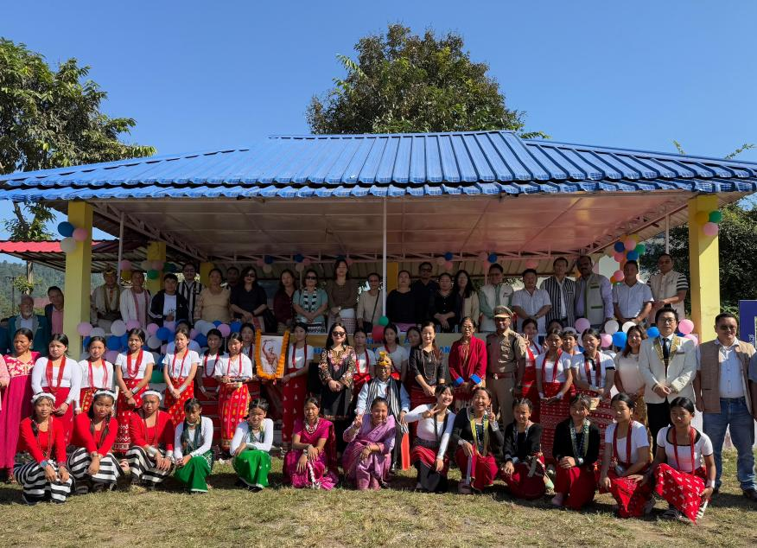

Yupia, 15th November 2024: The Papum Pare District Administration commemorated Janjatiya Gaurav Diwas by paying floral tribute to tribal hero Bhagwan Birsa Munda on his 150th birth anniversary at Yupia on 15th November 2024.
The celebration featured various activities to serve the local community. A medical camp, organized with the support of the District Medical Officer, provided free health check-ups. Additionally, the Department of Statistics and Economics facilitated Aadhaar card-related services, including new applications and corrections. Beneficiary certificates under several government schemes were distributed to villagers. Students from the Government Upper Primary School and Netaji Subash Chandra Bose Avasiya Vidyalaya, Yupia, performed vibrant traditional dances, adding color to the event.
Shri Tai Arun, Trade Development Officer, shared a brief history of Birsa Munda's life, encouraging youth to emulate his bravery and foster a deep love for the motherland.
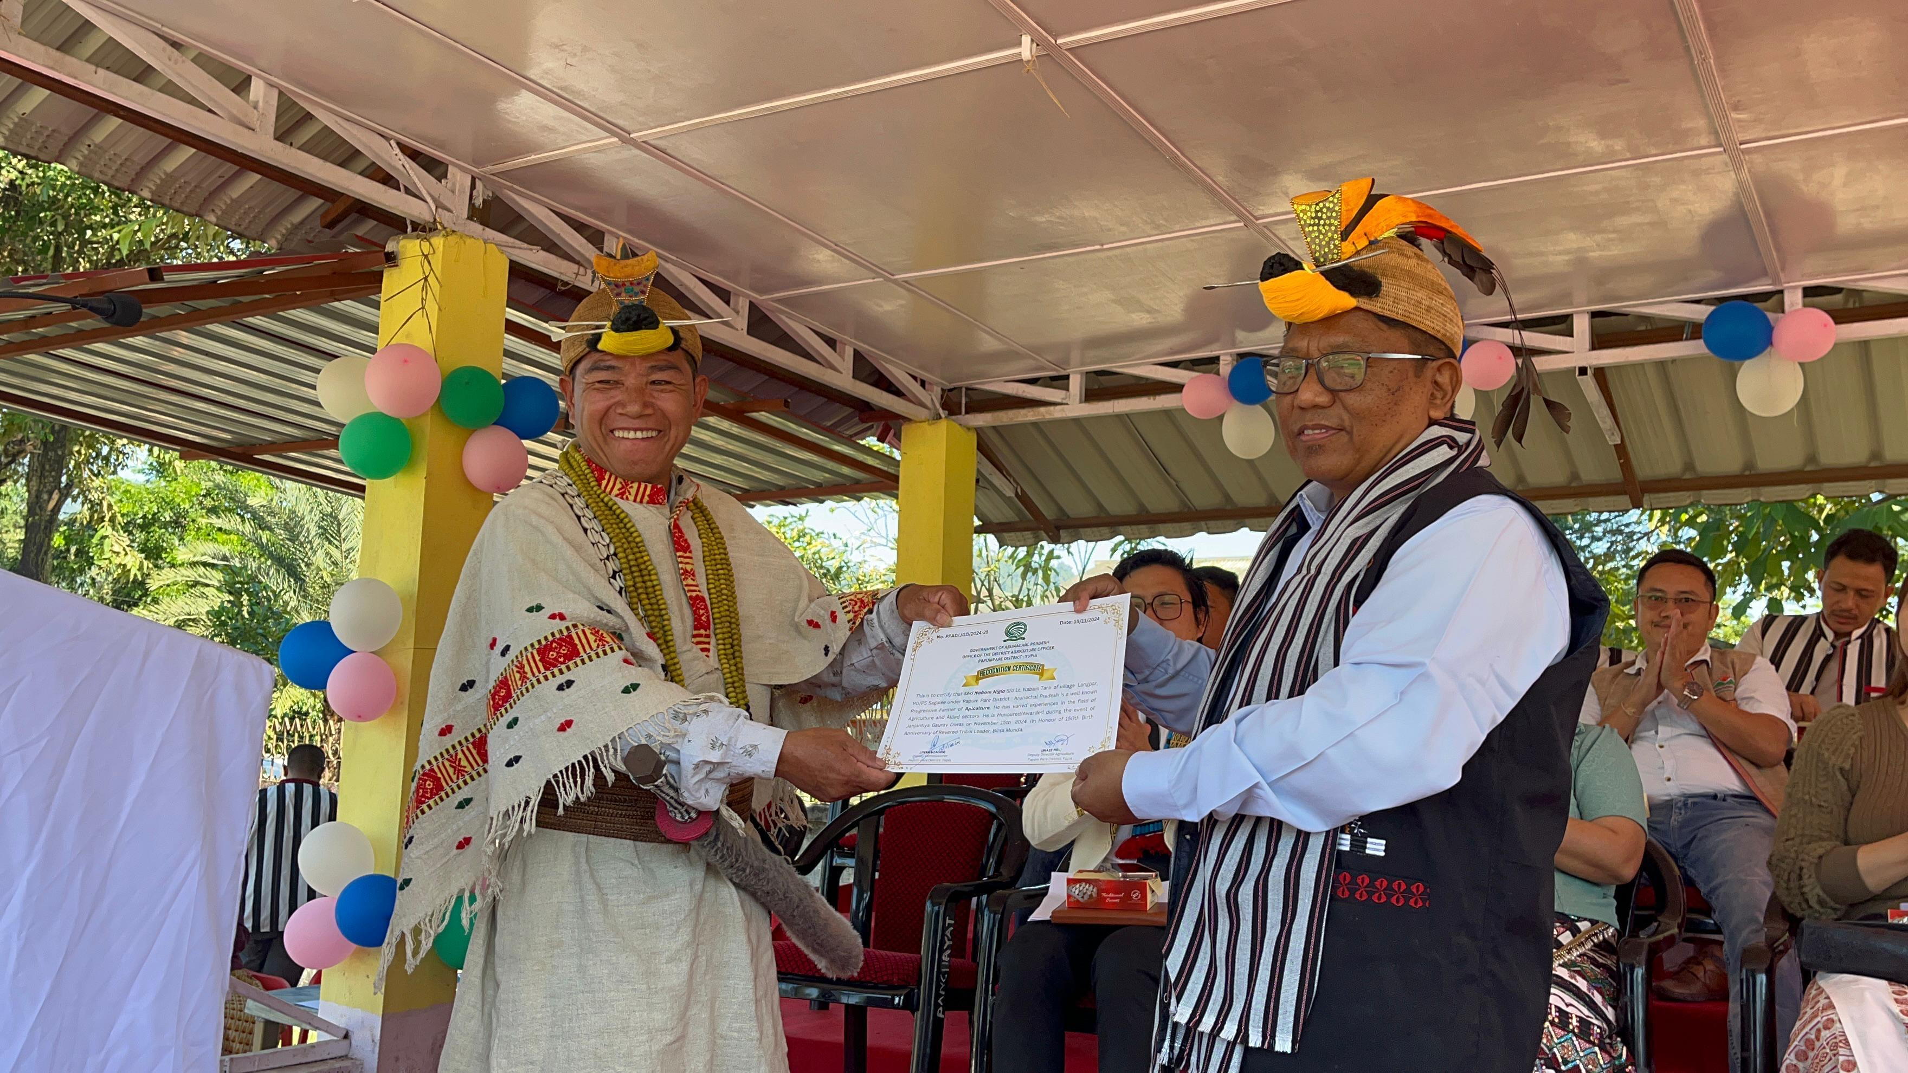
Deputy Commissioner Shri Jiken Bomjen, the Chief Guest of the event, highlighted various tribal-centric government initiatives, including quotas and relaxations for tribal students in higher education and competitive exams. He also urged the promotion of traditional attire in schools and offices, aligning with the 'Vocal for Local' initiative. However, he expressed concern over the rising costs of traditional dresses, particularly those considered “High Class Dresses,” which foster inequality within tribal society. He appealed to manufacturers to make traditional attire more affordable, ensuring inclusivity in celebrations of local festivals.
The event was attended by district officials, police personnel, PRI leaders, and villagers. Following the program, the Deputy Commissioner and district officials participated in a live telecast of the Hon’ble Prime Minister’s address from Jamui, Bihar, at NIC Yupia.

