GOVERNOR’S SECRETARIAT
ARUNACHAL PRADESH
ITANAGAR

Press Communiqué

Dated Nov 15th, 2024

HDCM PR 15 Nov - Honoring Tribal Heritage and Legacy - Celebrating Janjatiya Gaurav Divas in Namsai

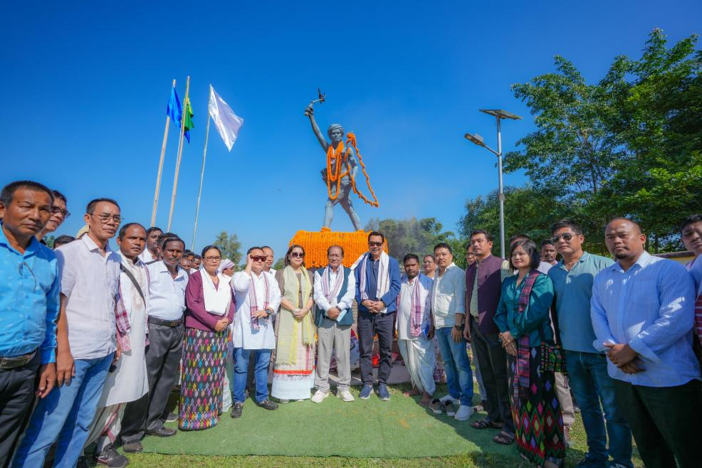

Lekang, November 15: The 150th birth anniversary of Veer Birsa Munda was commemorated with great reverence and enthusiasm at the Veer Birsa Munda Auditorium, Kumari Adivasi, Lekang, as part of the Janjatiya Gaurav Divas celebrations. This event honored the invaluable contributions of tribal communities to India's history, culture, and freedom struggle, while paying tribute to the legendary tribal leader and freedom fighter, Veer Birsa Munda.
In his keynote address, Deputy CM Mein highlighted the significance of Veer Birsa Munda’s legacy, stating "Veer Birsa Munda’s courage, vision, and steadfast commitment to the upliftment of his people remain a beacon of hope for all. His legacy is one that must be cherished, celebrated, and passed onto future generations."
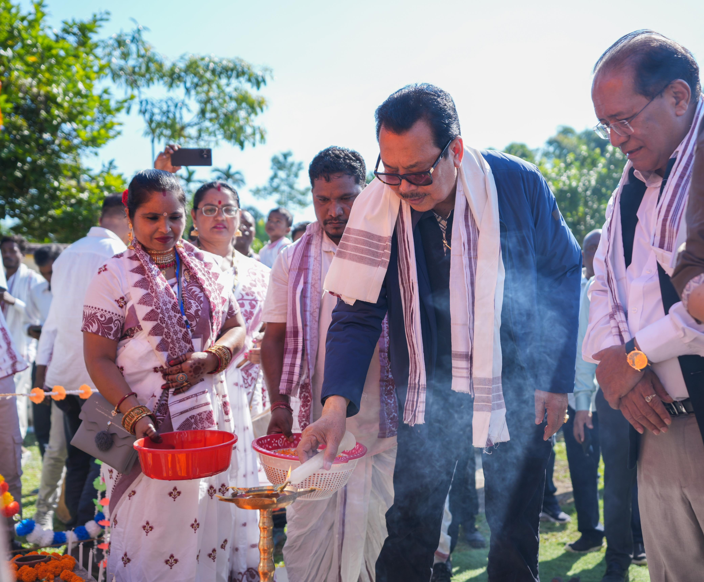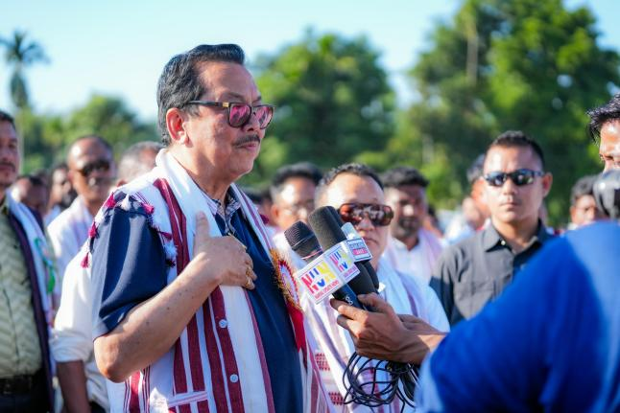
Expressing his gratitude to Prime Minister Narendra Modi, Deputy CM Mein said that it’s the BJP led NDA Govt that has recognized the vital role tribal leaders like Veer Birsa Munda played in India’s freedom struggle and their efforts in safeguarding indigenous traditions. He added that PM Modi’s vision has made Janjatiya Gaurav Divas a national occasion to honor our tribal heritage and ensure that this date is etched in our collective memory. He reiterated the government’s unwavering commitment to preserving and promoting the rich tribal heritage of the region.
On the occasion, Deputy Chief Minister and the dignitaries present paid homage to Bagwan Veer Birsa Munda and offered floral tributes. They also inaugurated guest rooms in the premise.
Also present on the occasion were BJP National Vice President Chuba Ao, Zilla Parishad Chairperson Urmila Mancheykhun, District BJP President Sujana Namchoom, Former MLA (Lekang) Jummum Ete Deori, State ST Morcha President, Kame Yangfo, State Yuva Morcha President, Ritemsu Manyu, BJP Karyakartas, PRI Leaders, government officers, and members of the Adivasi community.

