GOVERNOR’S SECRETARIAT
ARUNACHAL PRADESH
ITANAGAR

Press Communiqué

Dated Nov 14th, 2024

Pema Khandu Inaugurates Arunachal Pradesh Pavilion at 43rd India International Trade Fair, Highlights Entrepreneurial Growth and Sustainability

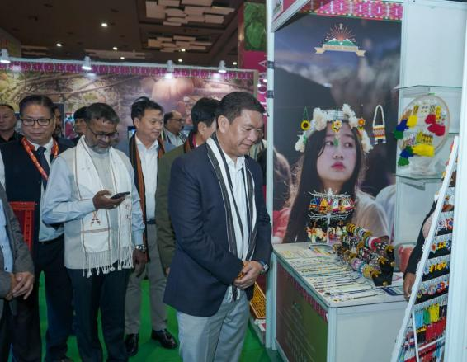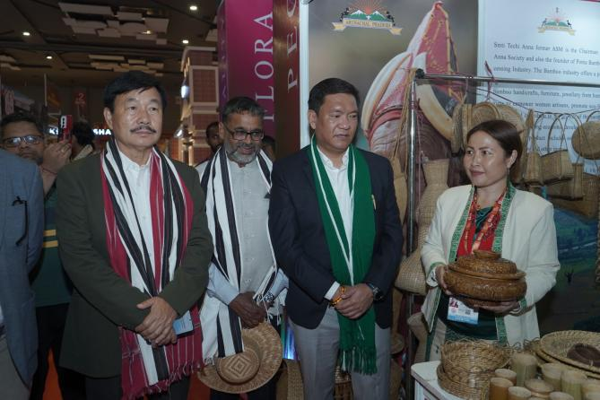

New Delhi, 15/11/2024 - Chief Minister, Arunachal Pradesh, Pema Khandu today visited the Arunachal Pradesh Pavilion put-up in the 43rd India International Trade Fair here. He was accompanied by Member of Parliament, Eastern Arunachal Pradesh, Tapir Gao; Chief Secretary, Arunachal Pradesh, Manish Gupta; MLA, Mebo, Shri. Oken Tayeng and other senior officers of the State.
Chief Minister, Pema Khandu, lit the ceremonial lamp and took a round of the stalls. He alongwith the rest of the dignitaries interacted with the entrepreneurs and urged them to expand their business ventures for even bigger participation next year. He highlighted the importance of packaging and branding of the various products being produced by the entrepreneurs from remote villages of Arunachal Pradesh.

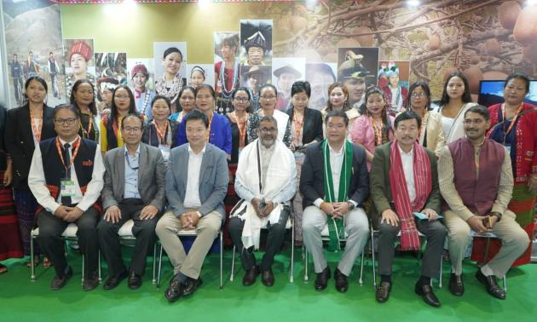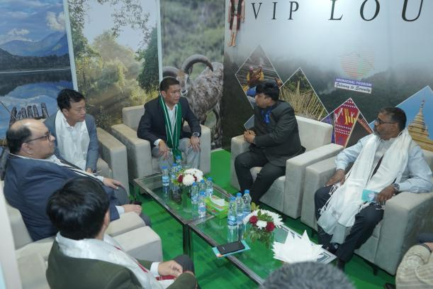
Pema Khandu urged the women SHG members to take maximum advantage of the exposure in the India International Trade Fair, make business linkages and learn from entrepreneurs of other states too.
Chief Minister appreciated the Trade and Commerce Department of Arunachal Pradesh for organizing the first ever State Pavilion, roping in an eclectic mix of entrepreneurs under one umbrella in the trade fair at New Delhi, and desired that this endeavour be expanded in the years to come with even greater participation from all regions of Arunachal. He had an encouraging interaction with the organising team from the Trade and Commerce department.
Chief Secretary, Manish Gupta, while interacting with the entrepreneurs endorsed the need for having food testing laboratories and other institutional mechanisms for supporting entrepreneurs from the State. He assured the participants complete support from the government.
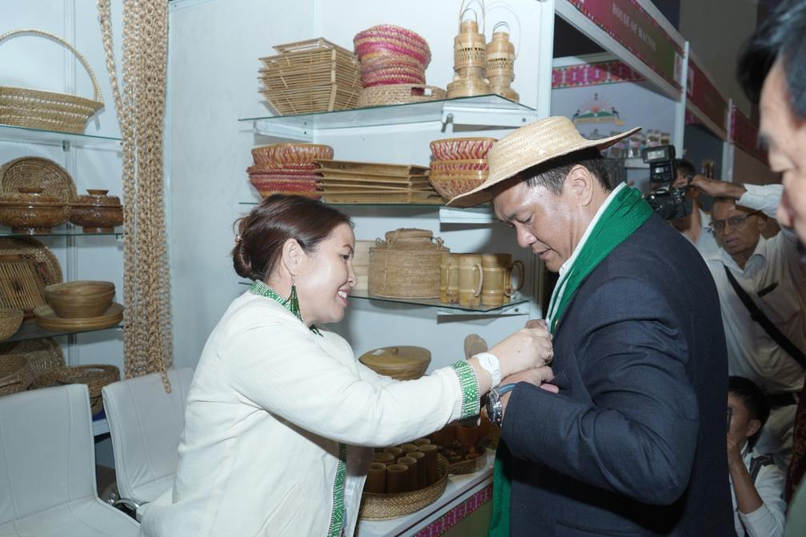
Commissioner, Trade & Commerce, Shri. Saugat Biswas, while taking the delegates around briefed that the focus of the Pavilion has been to provide a platform to the entrepreneurs of Arunachal Pradesh from exposure at the national level, make business linkages and adopt sustainable trade practices.
Commissioner, Coordination, GoAP, Ankur Garg, Commissioner to CM, Sonam Chombay, Commissioner, Education, Amjad Tak, Secretary, Trade & Commerce, Taru Talo, Secretary, Tourism, Ranphoa Ngowa, Director, Trade & Commerce, Sonyung Modi, and the Director, Shri. Manjunath R also accompanied the visiting delegation. The participants were deeply encouraged by the visit.

