GOVERNOR’S SECRETARIAT
ARUNACHAL PRADESH
ITANAGAR

Press Communiqué

Dated Nov 14th, 2024

W.R. Govt College celebrates XXII Annual College Week 2024

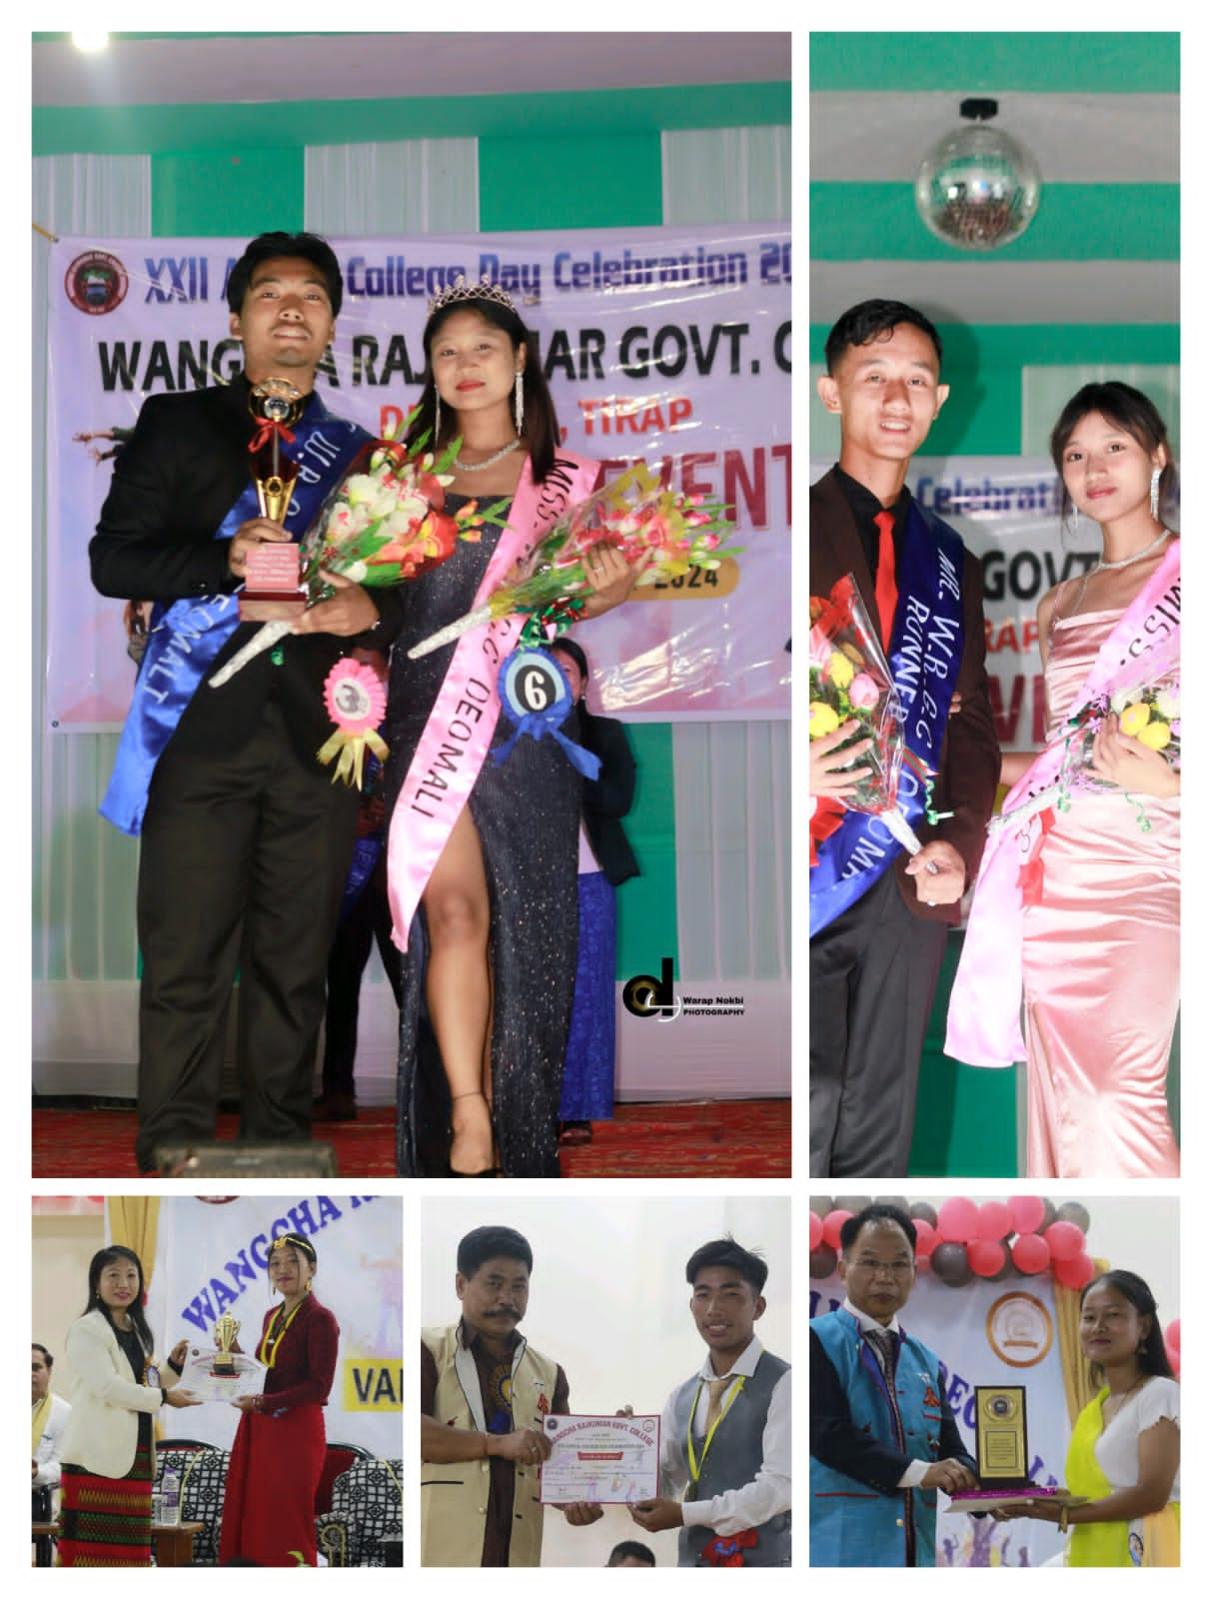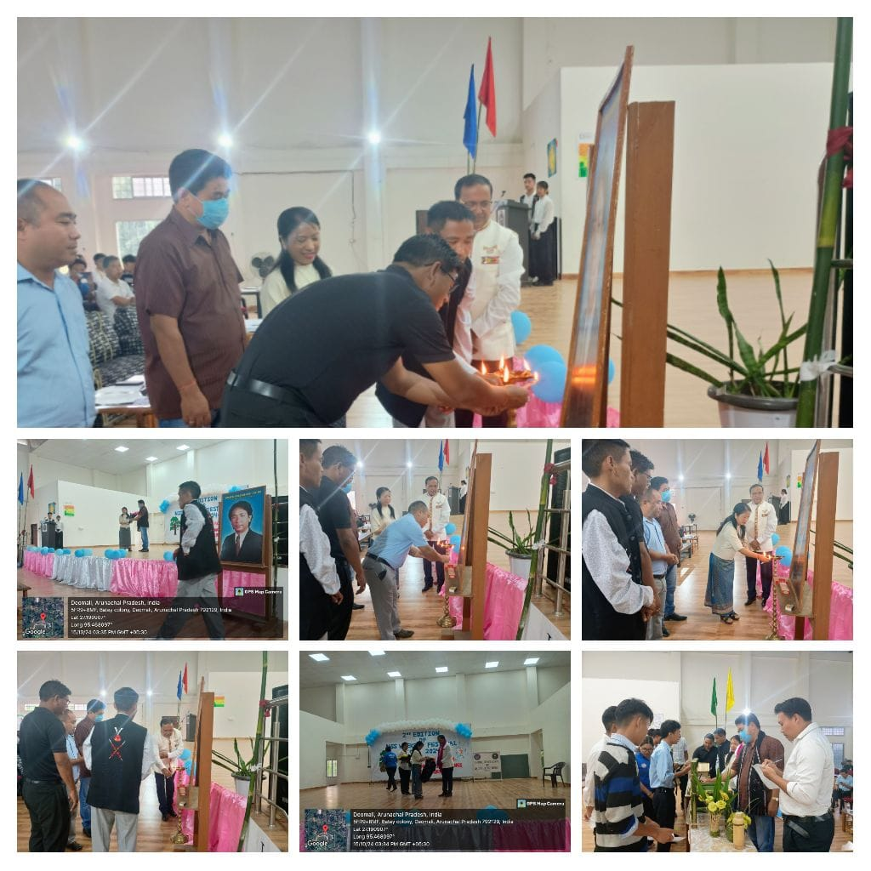

Wangcha Rajkumar Govt College, Deomali, celebrated the inauguration of the XXII Annual College Week on 12th November, 2024. The event was graced by Shri, Wanglam Sawin, Hon’ble MLA, 55th Khonsa East A/C as the chief guest and Shri.Wangphoon Lowang, ZPM Namsang Block as the Guest of Honour along with other dignitaries.
Dr. Watsen Bangsia, Principal, WRGC, Deomali, gave the welcome address while receiving the host of guests and highlighted the college’s issues and achievements. She briefed the audience regarding the importance of college week celebration and accentuated the various events conducted during the ensuing celebration including sports and literary competitions between the four houses.
Shri.Wangphoon Lowang, stressed on the rising issue of substance abuse prevailing in Tirap district while reminding the students to focus on their studies as the primary objective.
The chief guest Shri.Wanglam Sawin, appreciated the college fraternity and insisted on hard work as being the crown of success. He also assured to address the problems of the college in days to come.
The second day of the college week was filled with cultural extravaganza in which students showcased their latent and inherent talents including: singing, dancing and acting skills.
Shri.Techu Aran, Deputy Commissioner Tirap, graced the Valedictory Function as the chief guest and assured every possible aid towards facilitating the progress of college infrastructure. He emphasized on the need of hard work rather than wits. He said, “It is better to be hard working than to be intelligent and lethargic”. Shri.Badonlum Tawsik, ADC Deomali, elevated the function by appearing as the Guest of Honour. He appreciated the persons concerned involved in making the event as an astounding success. Shri.Dingzang Boham, Circle Officer Deomali along with HODs of various departments of Deomali also attended the same.
The students were divided into four groups and named after the major festivals of the region namely: Loku, Pongtu, Worang and Oriah with Oriah House bagging the champion house of the annual college week celebration 2024.

