GOVERNOR’S SECRETARIAT
ARUNACHAL PRADESH
ITANAGAR
Press Communiqué
Dated Nov 14th, 2024

Governor participates in the 62nd Walong Day celebration

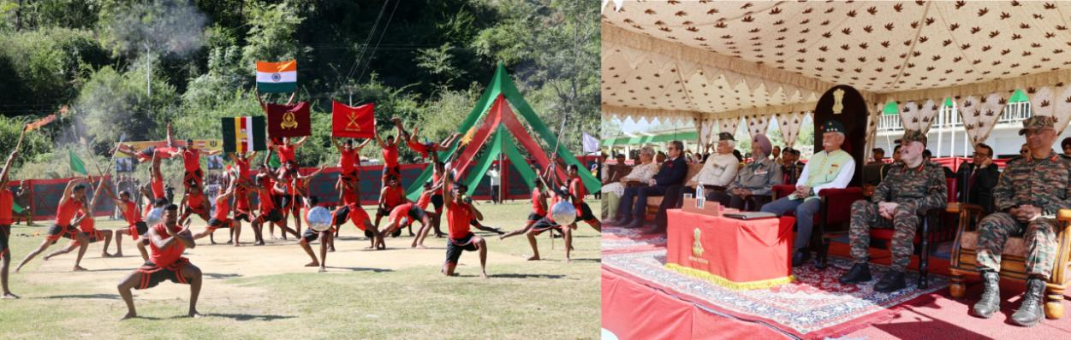

- Governor lays wreath at the Walong War Memorial paying tributes to the valiant soldiers of Indian armed forces
- Walong Day reflects the heroism displayed by our brave hearts during the India-China War: Governor
- Governor exhorts the youth to embrace the noble path of serving the nation with the same courage and dedication shown by the heroes of Walong
- Arunachal Pradesh is making huge progress in every sector of development and the Indian armed forces have a role to play: Governor
The Governor of Arunachal Pradesh Lt. General KT Parnaik, PVSM, UYSM, YSM (Retd.) participated in the finale of the month-long 62nd Walong Day celebration at Walong in Anjaw District on 14th November 2024. The Governor laid a wreath at the Walong War Memorial paying tributes to the valiant soldiers of Indian armed forces. He also felicitated the veterans of the 1962 War, next of kin of War heroes and families of the local people who assisted the Indian Army in the operations during the War, on the occasion.
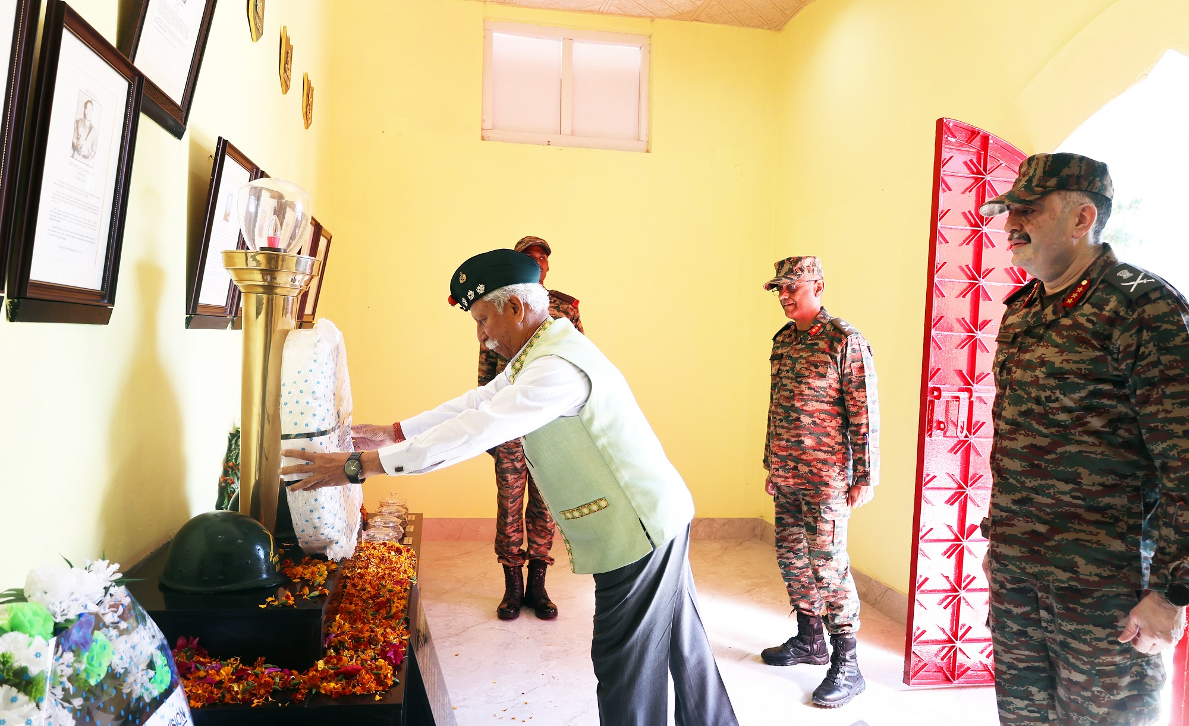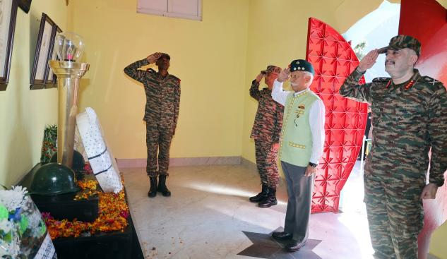
Addressing at Walong Stadium, the Governor said that Walong Day reflects the heroism displayed by our brave hearts during the India-China War. Their courage in the face of adversity and their steadfast dedication to the nation’s sovereignty is a testament to their unwavering spirit. He said that their legacy continues to inspire all, reminding of the values of sheer determination, bravery and ‘Naam, Namak aur Nishan’.
The Governor commended Spear Corps (4 Corps) and Dao Division (2 Mountain Division) for the impressive initiative to ensure that the stories of our heroes remain alive and that future generation understand the significance of their sacrifices. He appreciated the participants and said that their presence has enriched the commemoration and made it befitting tributes to the valiant soldiers of Walong.
Pleased by the participation of school children and NCC cadets, the Governor said that their presence fills with hope and pride, while extending his children’s day greetings. He said that their enthusiastic and spirited involvement shows the foundations of a bright and secure future for the nation.
The Governor exhorted the youth to embrace the noble path of serving the nation with the same courage and dedication shown by the heroes of Walong. He said that they are the future of the nation and their commitment can make a significant difference.
The Governor appealed to the people to carry forward the spirit of Walong, upholding the ideals of duty, honour and nation. He urged them to pledge to continue to honour the memories of heroes and to strive for a future that reflects the values the war heroes fought to protect.
The Governor said that Arunachal Pradesh is making huge progress in every sector of development and the Indian armed forces have a role to play. He called upon the people to continue the bonhomie and strengthen the collaborative endeavour, which will facilitate security of the borders and peace and prosperity in the State.
The Governor interacted with participants of car and motorcycle rallies, cycle expeditions, battlefield and adventure treks, river rafting expeditions and Walong Half Marathon. He said that their participation has promoted the spirit of Nationalism and also the pristine tourism potential of Arunachal Pradesh.
General Officer Commanding, 3 Corps Lt. Gen. Abhijit S Pendharkar, AVSM, YSM and Commander 82 Mountain Brigade also spoke on the occasion.
The Governor also interacted with troops of Indian Army, Indian Air Force, Border Road Organization, Indo Tibetan Border Police, NCC, veterans, Gaon Burahs and District Officers of Anjaw District Administration over a high tea.
Mishmi and Meyor communities enthusiastically participated in the programme with traditional dances. Indian Army troops presented the world famed ancient Indian martial art ‘Kalaripayattu’. The NE Warriors Team also displayed martial arts of the North East region.
State Chief Information Commissioner, Major General Jarken Gamlin,AVSM, SM, VSM (Retd), GOC, 2 Div Major General VS Deshpande, Deputy Commissioner Shri Millo Kojeen, senior officers of the armed forces and State Police were present on the occasion.
A large number of veterans and members of the Indian Army Units, which participated in the 1962 Sino-Indian War at Walong Sector, including 6 Kumaon, 4 Sikh, 4 Dogra, 3/3 and 2/8 Gorkha Rifles and 2 Assam Rifles attended the finale.
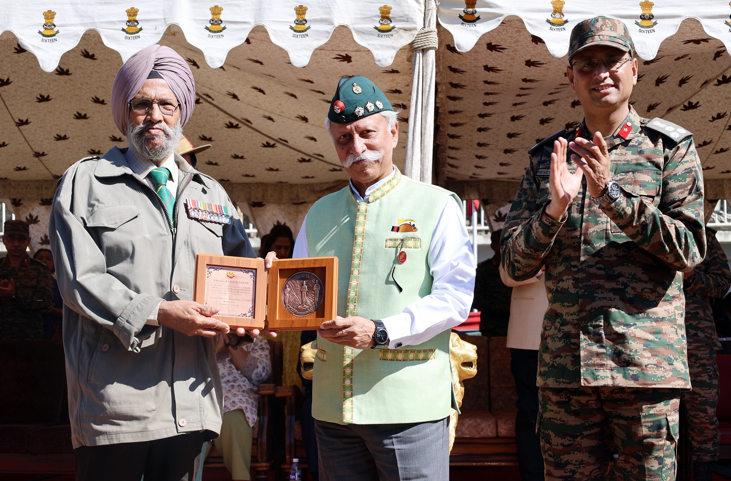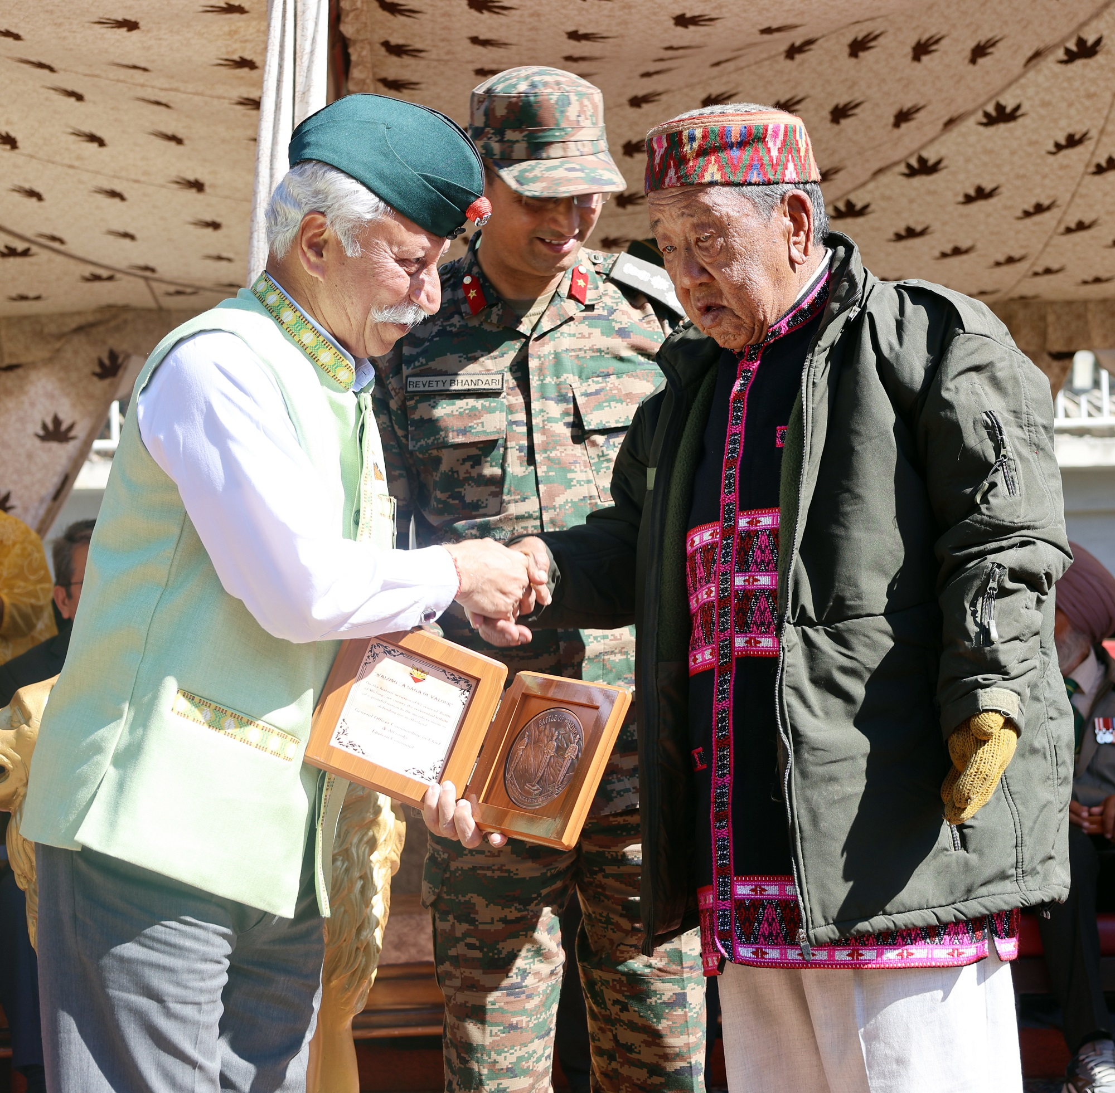
The Walong Day was organized by the 2 Mountain Division under the aegis of 4 Corps to commemorate the ‘Battle of Walong’ in 1962. The historical event has rekindled the valour and sacrifices of Indian armed forces in the War, igniting a sense of patriotism and ‘Nation First’ spirit amongst the people.

