GOVERNOR’S SECRETARIAT
ARUNACHAL PRADESH
ITANAGAR

Press Communiqué

Dated Nov 14th, 2024

Empowerment of Fish Farmers through Skill Development Training and Input Distribution by ICAR-Central Institute of Fisheries Education at Tezu
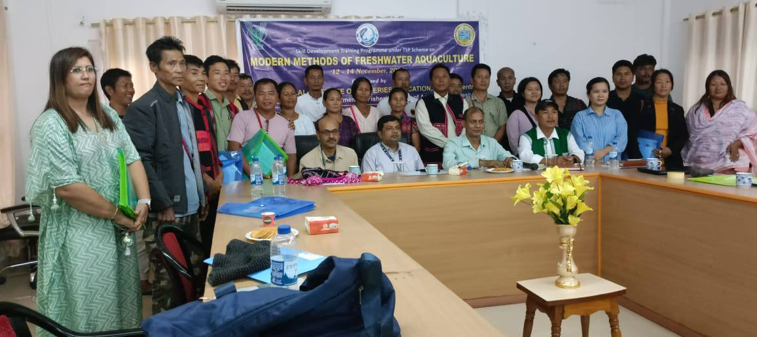

Tezu, 14th November, 2024 – In an effort to address the growing demand for fish amidst India's increasing population, the ICAR-Central Institute of Fisheries Education (CIFE) has launched a skill development initiative aimed at empowering fish farmers in Arunachal Pradesh. A three-day training programme on Modern Methods of Freshwater Aquaculture commenced on 12th November, 2024, at the Conference Hall, Circuit House, Tezu, in collaboration with the Department of Fisheries, Government of Arunachal Pradesh, and the Lohit District administration.

The training programme was officially inaugurated by Mr. Kenbom Chisi, District Fisheries Development Officer, Lohit District, who emphasized the importance of advanced aquaculture techniques in boosting fish production. He expressed appreciation for ICAR-CIFE's efforts in bringing this training to a remote region like Tezu, which is poised to benefit significantly from the knowledge and skills imparted. He encouraged participants to fully leverage the skills gained and make use of the critical inputs, such as soil and water test kits, for better pond management.

Dr. Gouranga Biswas, Principal Scientist and Coordinator of ICAR-CIFE’s Kolkata Centre, led various theory sessions and practical demonstrations on topics such as composite fish culture, soil and water quality analysis, and fish health management. He also introduced participants to the use of high-value fish species to enhance returns from aquaculture. Dr. S.K. Sau, Assistant Professor at the West Bengal University of Animal and Fishery Sciences, Kolkata, conducted a session on species diversification in carp polyculture. He also highlighted the importance of cost-effective, farm-made aquafeeds using locally available ingredients, to help farmers reduce feed costs. Ms. Olik Jomang, Fishery Officer of Lohit District, introduced participants to integrated fish culture systems, suggesting ways to increase income by combining fish farming with animal husbandry in the same water body.
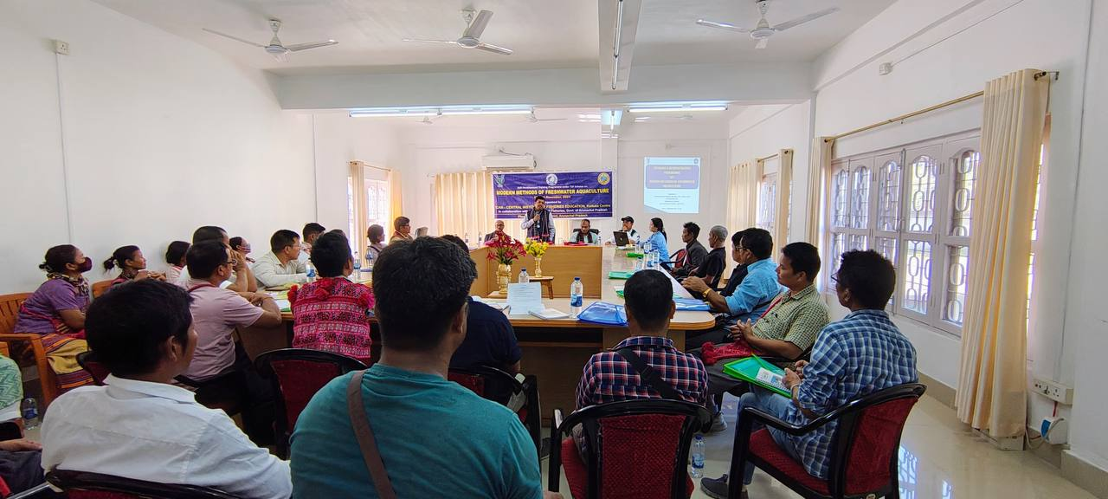

A total of 20 tribal fish farmers, including 7 women, participated in the training and received essential inputs, such as the CIFE-developed water testing kits and educational materials. The farmers expressed their gratitude for the programme, noting how the knowledge and tools provided would help them improve fish production in the region. They also lauded ICAR-CIFE for conducting this capacity-building initiative in a remote location, far from Kolkata, and urged the continuation of such support to sustain the development of fish farming in Arunachal Pradesh. The programme aims to equip local farmers with modern techniques to increase fish production, contributing to the region's economic growth and enhancing livelihoods through sustainable aquaculture practices.

