GOVERNOR’S SECRETARIAT
ARUNACHAL PRADESH
ITANAGAR

Press Communiqué

Dated Nov 13th, 2024

Minister kick off sports and cultural meet at Yomcha

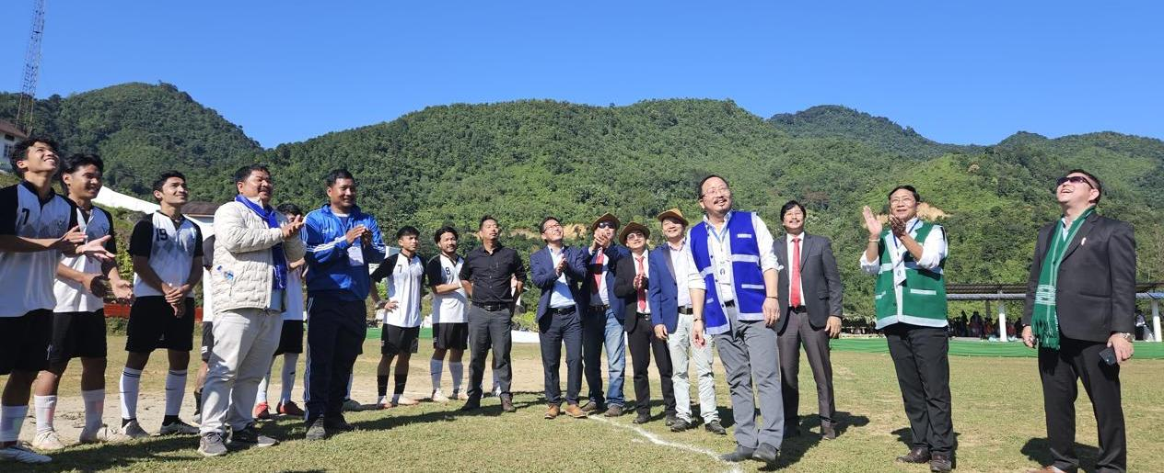

Aalo : Adv Kento Jini, Honorable Minister for Sports, Law, legislative, SJETA and Youth Affairs, Govt of Arunachal Pradesh, Sri Pesi Jilen HMLA 27TH Liromoba Assembly Constituency attended the 27 Loum Bango Sports and cultural competition as Chief Guest and Guest of Honour respectively.
While addressing the public Hon. Minister exhorted the players to take sports as profession as the state and National government led by Pema Khandu and Narendra Modi focusing on sports seriously. The Minister also spoke at length about the policy initiated by the government and urged the sportsmen to availed the benefits of sports policy.
Guest of Honour Sri Pesi Jilen, HMLA lauded the National and State Government sports policy as these policies encouraged the sportsman of the state and exhorted the players to display skills, maintain discipline and sportsman spirit.
Sri Gyamar Amte, ADC Yomcha is the organising Chairman and Sri Nidu Yomcha as organising Secretary.
During the programme HoD's, Officers, Officials, Gaon Buras and public of Yomcha attended and witnessed the programme.

