GOVERNOR’S SECRETARIAT
ARUNACHAL PRADESH
ITANAGAR

Press Communiqué

Dated Nov 13th, 2024

Governor inaugurates the Arunachal Literature Festival

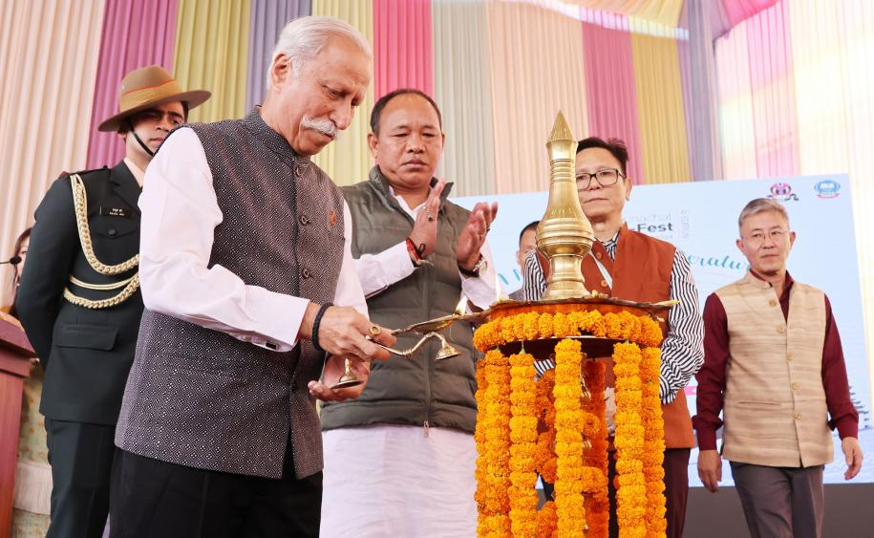

- Governor calls for preservation and promotion of indigenous literary assets and languages
- Reading enriches our soul, opens the doors to a plethora of information, expression, sentiment, articulations and perceptions, shapes young minds, moulds our opinion and helps in problem solving: Governor
- Literature festivals have a profound positive impact by promoting cultural exchange, sparking creativity, and inspiring a love for reading and learning: Governor

The Governor of Arunachal Pradesh Lt. General KT Parnaik, PVSM, UYSM, YSM (Retd.) inaugurated the 6th edition of Arunachal Literature Festive at the Dorjee Khandu Convention Centre, Itanagar on 13th November 2024.
Speaking in the inaugural session, the Governor stated that literature has the power to transform lives. It can amplify unheard voices, provide fresh perspectives, and encourage all to reconsider their views of the world. He expressed hope that the inauguration will open an exciting new chapter in the State's literary journey, honoring the storytellers, poets, writers, and thinkers who, over generations, have enriched the vast reservoir of knowledge that sustains us all.
The Governor said that literature festivals have a profound positive impact by promoting cultural exchange, sparking creativity, and inspiring a love for reading and learning. They help build a more literate, empathetic, and connected society, enriching individuals, strengthening community bonds, and supporting the creative economy. Such festivals provide a valuable platform for local authors and poets, encouraging them to advance in the field of literature, he said while commending the Department of Information & Public Relations and the Arunachal Pradesh Literary Society, Itanagar, for organizing this event annually.
Urging all to cultivate the habit of reading, the Governor emphasized that reading enriches our soul. It opens the doors to a plethora of information, expression, sentiment, articulations and perceptions in various genres of literature. From Drama to Fiction – Non Fiction – Prose and Poetry. It shapes young minds and moulds our opinion and helps in problem solving, he said.
The Governor, while calling the youth to inculcate the habit of reading, said that reading, which is the essence of the festival, is a transformative practice that profoundly impacts personal growth and overall well-being. It is a powerful habit that enriches the mind, nurtures the soul, and provides individuals with the tools to lead informed, empathetic, and fulfilling lives, he said.
The Governor called for the preservation and promotion of indigenous literary assets and languages.
The Governor applauded the festival organizers for initiating unique ways of promoting literary activities by creating dedicated corners for children, using Ane’s (Mother’s) Home at the Women Police Station, Itanagar as the Satellite Venue, renaming halls in the names of writers from Arunachal Pradesh and conducting workshops on film making.
As part of the inaugural function, the Governor released a book, titled ‘Myth, Memory and Folktale of the Wancho Tribe of Arunachal Pradesh’, authored by Tara Douglas and Jatwang Wangsa on the occasion.
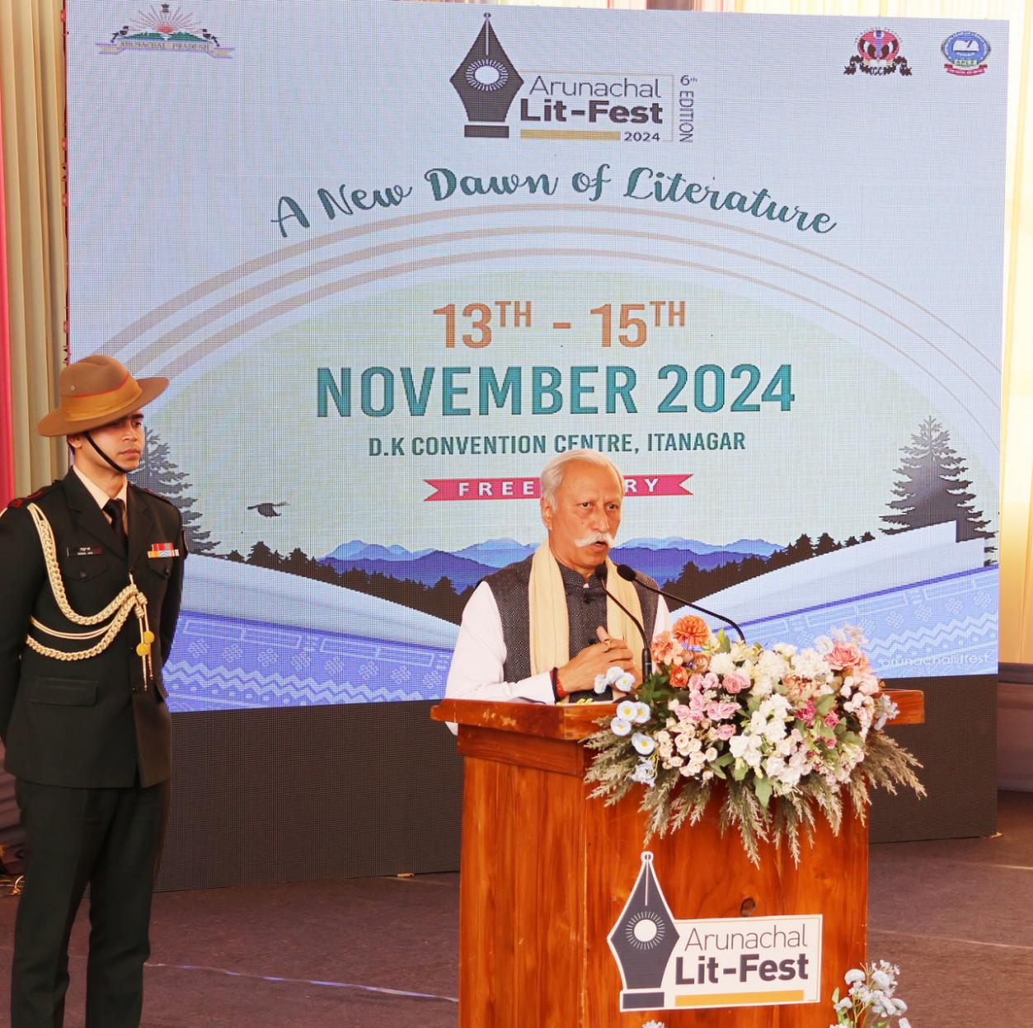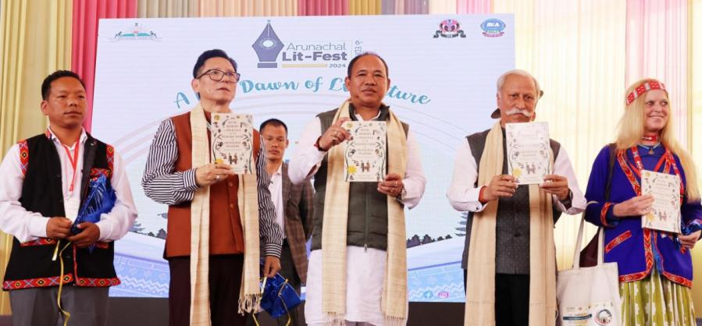
State Home Minister Shri Mama Natung, IPR Minister Shri Nyato Dukam and IPR Secretary Shri Nyali Ete also spoke on the occasion. Padma Shree Awardee and Festival Advisor Ms Mamang Dai delivered the introductory remarks.
The three-day literary festival is being organised by the Department of Information & Public Relations, in collaboration with the Arunachal Pradesh Literary Society. Large numbers of participants, including authors, story writers, poets, screen play writers and reputed literary personalities are participating in the festival. Arunachal Literature Festival aims to give a platform to the local authors and poets and encourage them in the field of literature. The festival invited national and international level authors to spark meaningful discussion centring on literature. It also aims at letting the youths meet both big and small publishing houses to know the details of publishing.

