GOVERNOR’S SECRETARIAT
ARUNACHAL PRADESH
ITANAGAR

Press Communiqué

Dated Nov 7th, 2024

Deputy CM Chowna Mein attended the Power Ministers' Conference at Delhi
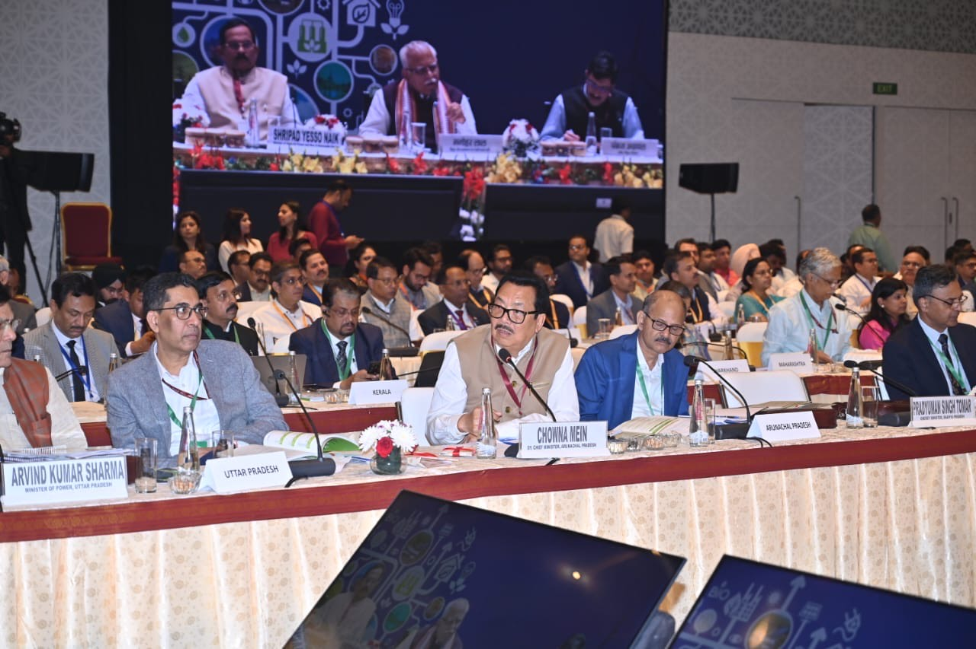

New Delhi: Deputy Chief Minister of Arunachal Pradesh, Chowna Mein, participated in the Power Ministers' Conference of States and Union Territories in New Delhi, chaired by the Union Minister for Power, Housing and Urban Affairs, Manohar Lal Khattar. The meeting was also attended by Minister of State for Power , New & Renewable Energy, Shripad Yesso Naik and senior officials from the Ministry of Power and MNRE, focused on advancing India’s energy goals. Representing Arunachal Pradesh, Mein highlighted the State’s progress in the energy sector, including the improved financial health of DISCOMs, reduction in AT&C losses, and significant developments in smart metering under the Revamped Distribution Sector Scheme (RDSS). He underscored the State’s immense hydropower potential of 58,000 MW, with major projects like Subansiri (2,000 MW) and Dibang (2,880 MW) driving growth.

The Deputy CM projected a 4.98% increase in energy demand for FY 2024-25, with plans for adding 634 MW of new capacity. He sought central assistance for transmission upgrades, Pumped Storage Projects, and Arunachal's inclusion in the Green Energy Corridor to meet India’s renewable energy target of 500 GW by 2030.

In line with India’s sustainability vision, Mein emphasised the importance of solar-based rural electrification and the development of EV charging infrastructure under the State’s Electric Vehicle Policy. These initiatives aim to improve energy access and quality of life in remote areas while promoting a green future. He reaffirmed Arunachal Pradesh’s commitment to overcoming challenges and contributing to India’s sustainable energy mission.

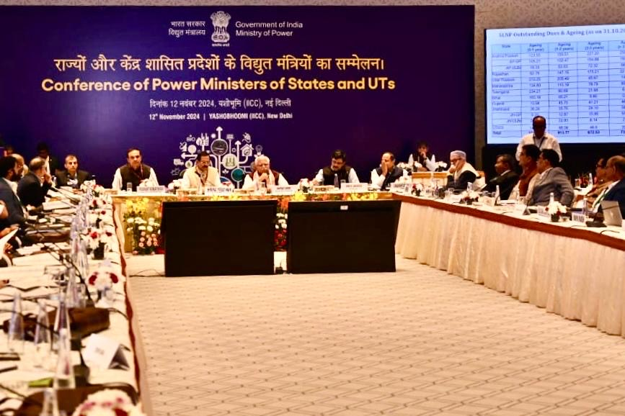
He was accompanied by Secretary (Power) R.K. Sharma and Chief Engineer cum Nodal Officer RDSS & Member Secretary, APDA, Ginko Lingi.

