Dated 7th Oct, 24
PRESS RELEASE

TAWANG MARATHON REVIEW MEETING

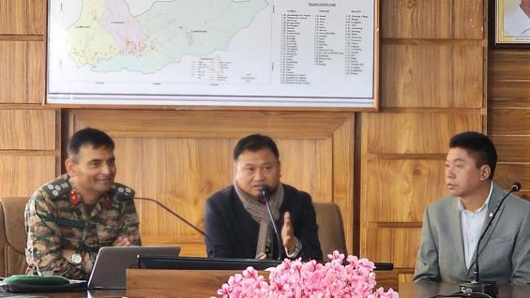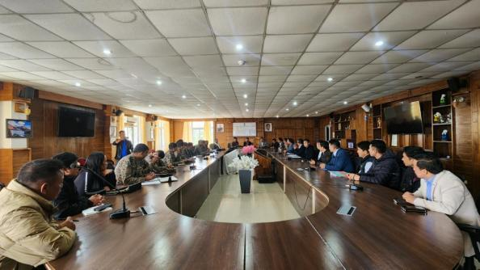
In preparation for the upcoming Tawang International Marathon 2024, scheduled for October 24, which coincides with United Nations Flag Day, a review meeting was held today by Deputy Commissioner Tawang, Kanki Darang, and Commander of the Tawang Brigade, Brigadier VS Rajput. The meeting, held in the conference hall of the DC Office, was attended by Zilla Parishad Chairperson (ZPC) Tawang, Leki Gombu, ADC (Headquarters) Sang Khandu, and senior officers from both the military and civil administration.
As the marathon is a joint effort between the army and civil administration, Brigadier VS Rajput provided an update on ground preparations and assigned responsibilities. He also shared that promotional runs are being organized in various locations across the country, with more than ten international marathon runners confirming their participation in this year's event.
Deputy Commissioner Kanki Darang expressed gratitude to the Commander for his efforts in preparing the ground plan and urged all departments to cooperate for the success of the event. He informed that online registrations for participants from across the country will remain open until October 16, to allow non-local participants ample time to acclimatize to the high altitude. It was also noted that the marathon route will remain the same as last year. More follow-up meetings are planned as the event approaches.

