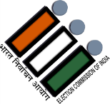
OFFICE OF THE CHIEF ELECTORAL OFFICER
ARUNACHAL PRADESH:: ITANAGAR
E.mailId :ceo_arunachalpradesh@eci.gov.in
En/OP/REV-02/2024 Date: 24th October, 2024.
PRESS RELEASE

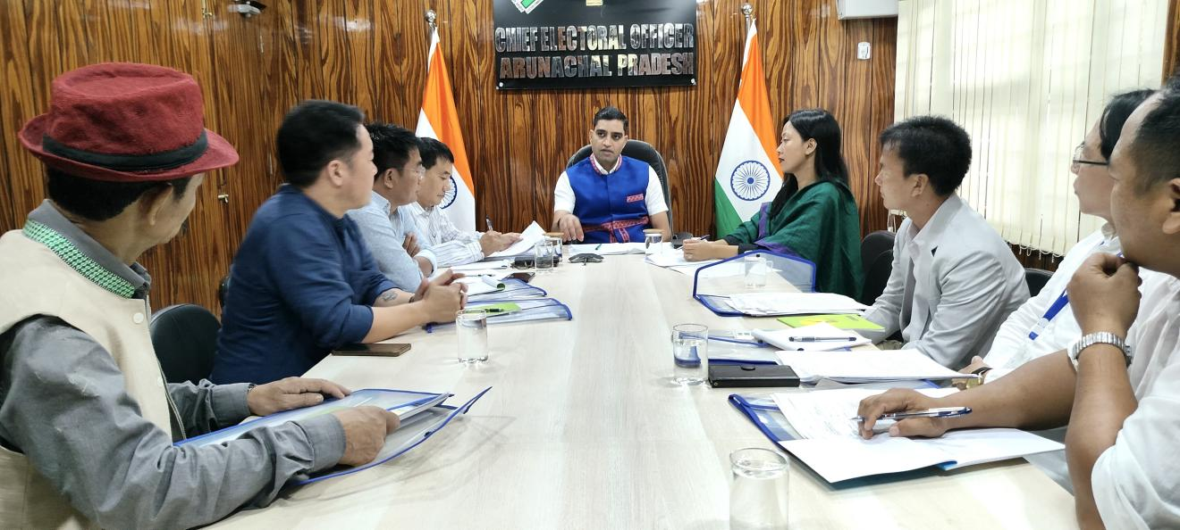

The Chief Electoral Officer of Arunachal Pradesh, Shri Pawan Kumar Sain, IAS, has convened a State Level Meeting with representatives of all political parties on 24.10.2024 at the conference hall of Nirvachan Bhawan, Itanagar. The Annual Summary Revision of Photo Electoral Rolls is ongoing in all 60 Assembly Constituencies, with reference to 01.01.2025 as the qualifying date. Hence the CEO Arunachal Pradesh has initiated a coordination meeting with the political parties and urged them to take active participation in purification of Electoral Roll. The CEO emphasized that political parties should activate their district units and ensure appointment of Booth Level Agents against all polling stations to assist the Booth Level Officers in order to obtain an error free electoral roll in the state.
It was also highlighted that during the revision period of claims and objection, a BLA can submit maximum 10 forms in a day and not more than 30 forms during the entire period of filing of claims and objections. The BLA must furnish a declaration citing he has satisfied with the correctness of submitted claims and objections.
the Deputy Chief Electoral Officer, Shania Kayem Mize, APCS, addressed the attendance and explained the quintessence details of the Special summary Revision. She informed that the Integrated Draft Electoral Roll will be published on 29.10.2024 and the copies of will be shared with Political Parties on the same day. The Final Electoral Roll will be published on 06.01.2025 and the same will be made available at the official website of the Chief Electoral Officer www.ceoarunachal.nic.in.
The schedule for revision is as follows:

Sl.No. | Revision Activities | Schedule
1. | Publication of Integrated draft electoral roll | On 29/10/2024 (Tuesday)
2. | Period for filing claims & objections | 29/10/2024 (Tuesday)  to  28/11/2024 (Thursday)
3. | Special campaign dates | 2nd& 3rd November, 2024  &  23rd& 24th November,2024
4. | Disposal of claims and objections | By 24/12/2024 (Tuesday)
5. | Final publication of Electoral Roll | On 06/01/2025 (Monday)

Altogether 2233 (inclusive of 7 new Polling Stations) polling stations, manned by Booth Level Officers (BLOs) at Polling Station Level will witness the execution of revision activities. In Arunachal Pradesh, presently 8,90,762 electors (4, 37,385 Males, 4, 53,374 Females and 3 Third Gender) exist in the draft electoral roll 2025. The Electoral Population ratio is 558. Overall gender ratio of the state is 1037. Total percentage of EPIC is 100%.
The Citizen those who have attained 18 Years Age as on 01.01.2025 as qualifying date can avail this opportunity to enroll their names in the electoral roll by applying in Form-6, to delete duplicate/dead/permanently shifted electors in Form-7 and for any correction/Transposition/replacement of EPIC, it can be done in Form-8. The applicants can avail online service https://voters.eci.gov.in/ or may submit the requisite form to BLO or Assistant Electoral Registration Officer.
The meeting Was attended by representatives of Bharatiya Janata Party, Indian National Congress, People’s Party of Arunachal and Aam Aadmi Party. The meeting ended on a appreciative note from the chair.

Sd/-
(Pawan Kumar Sain) IAS
Chief Electoral Officer,
Arunachal Pradesh, Itanagar

To:

- The Editor, Arunachal Times/ Echo of Arunachal/ Arunachal Front, Itanagar/ Naharlagun, with a request to release the same in your esteem newspaper.
- Director, AIR/DDK, Itanagar for necessary board casting
- The UNI/PTI, Itanagar for necessary action.

(Shania Kayem Mize) APCS
Deputy Chief Electoral Officer
Arunachal Pradesh

