Press Release
ITANAGAR, October 11, 2024
State Review Meeting Highlights Significant Progress in Malaria Elimination Efforts in Arunachal Pradesh
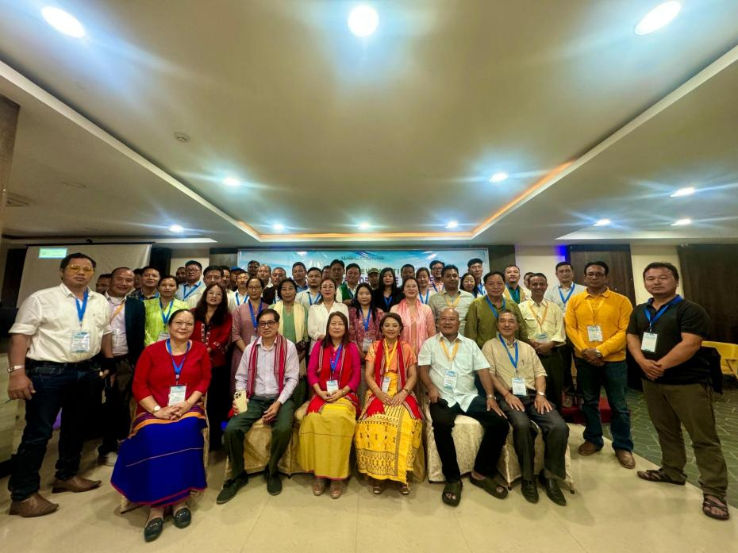
The three-day State Review Meeting on vector-borne diseases, organized by the National Center for Vector Borne Diseases Control (NCVBDC), State Health Society, Arunachal Pradesh, was held on 15th October and will continued untill 17th October 2024 at Hotel Dhassang, Naharlagun. The meeting focused on evaluating the state's efforts towards malaria elimination and reviewing the progress in combating vector-borne diseases.
Prominent attendees included Dr. Juliana Lyngwa, Additional Senior Regional Director, RoH&FW, GOI, Shillong & Guwahati, Dr. Amping Perme, Director of Family Welfare, Shri Marge Sora, APCS (MD NHM), and Dr. K.T. Mulung, Deputy Director of Health Services-cum-State Programme Officer (SPO), NCVBDC. District Programme Officers, State Consultants, and District Consultants were also present.
In his opening remarks, Dr. K.T. Mulung, SPO, NCVBDC, provided a comprehensive overview of the state's current malaria status. He emphasized that 14 out of 25 districts in Arunachal Pradesh are now eligible for Malaria-free certification, marking a significant milestone in the state's ongoing efforts to eliminate the disease.
Dr. Juliana Lyngwa commended the remarkable reduction in malaria cases across the state, attributing this achievement to the dedication of health officials and field staff. She also stressed the importance of proper documentation to ensure smooth progress towards receiving Malaria Elimination Certification.
Dr. Amping Perme, Director of Family Welfare, echoed the sentiments of the participants, recognizing the hard work and continuous efforts of all staff involved in vector-borne disease control. She reiterated the department's commitment to achieving a Malaria-free Arunachal Pradesh in the near future.
Shri Marge Sora, APCS (MD NHM), addressed the attendees, assuring them that he would oversee the proper district fund allocation for vector-borne disease control programs. He urged the vector-borne staff to continue their hard work to achieve malaria elimination in the state.
The inaugural session concluded with this commitment, and the meeting will continue with two days of technical sessions aimed at reviewing strategies and developing actionable plans to accelerate the progress toward a Malaria-free Arunachal Pradesh.

