First-Ever Mega Ronghuan Festival Celebration

Dated 27th Septemberm 2024
Hon’ble Minister of Industries, Trade & Commerce, IPR, etc., Shri Nyato Dukam, graced the first-ever Mega Ronghuan Festival celebration as Chief Guest at Charju in Tirap District. He was accompanied by Shri Hamjong Tangha, Hon’ble MLA, 52-Changlang South Assembly Constituency, as the Guest of Honour, Shri Wangki Lowang, Hon’ble Minister of Environment & Forest, and Smt. Chakat Aboh, Hon’ble MLA, 56-Khonsa West Assembly Constituency, as special invitees. The minister was accorded warm reception by the District Administration and Ronghuan Festival committee at Khonsa yesterday.

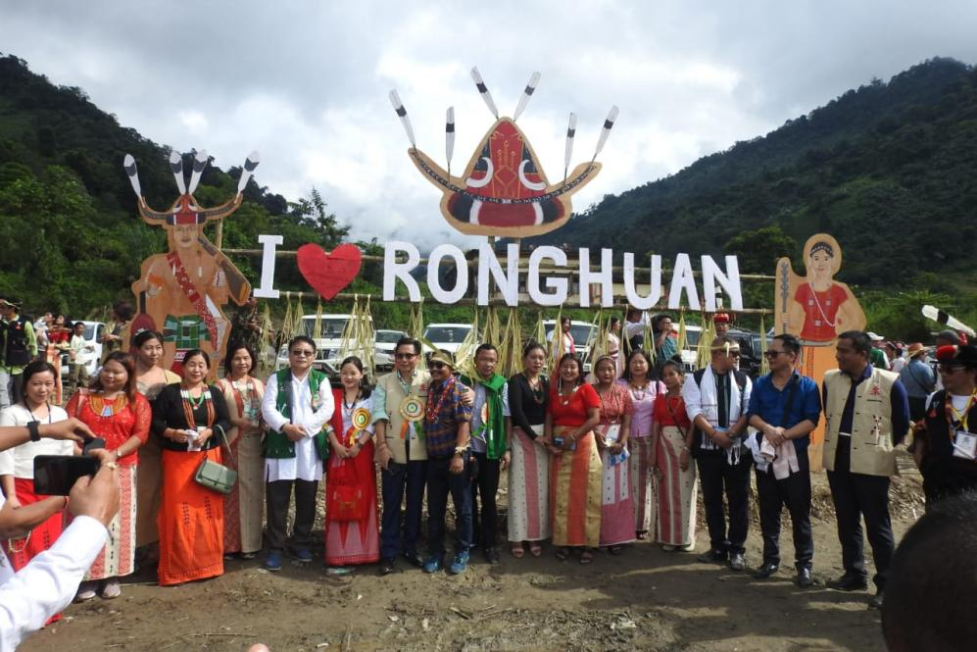
Shri Hamjong Tangha, in his address, emphasized the rich culture and traditions of the TCL (Tirap, Changlang, Longding) belt, which need to be brought to the forefront alongside other major festivals of Arunachal Pradesh. He added that performing rituals is an integral part of any festival, without which the celebration is incomplete.
He further highlighted the pressing need to combat drug abuse in society, noting its detrimental impact on both individuals and the broader community.

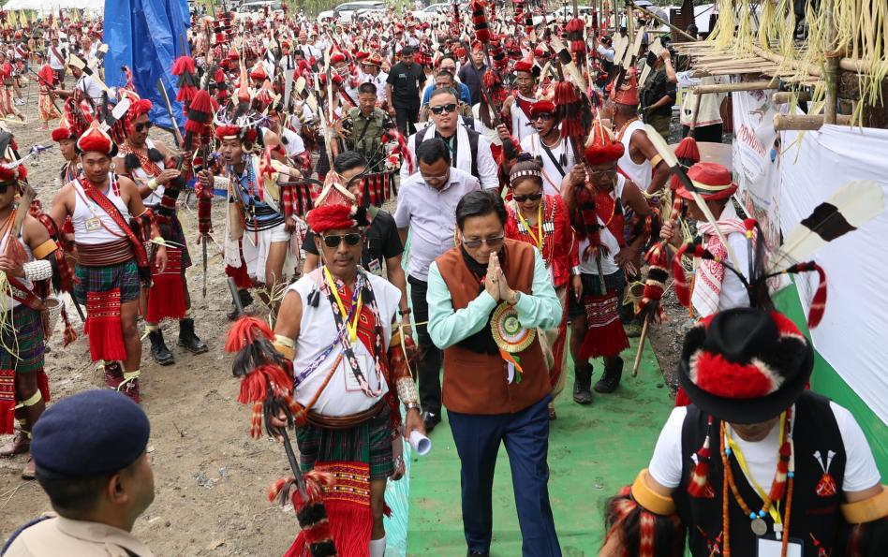
Chief Guest Shri Nyato Dukam extended his heartfelt greetings on the occasion of Ronghuan. He spoke at length about the urgent need to preserve the rich culture and traditions of the region, noting that younger generations are gradually drifting away from their roots. He expressed concern over the growing preference for foreign languages over native tongues, stressing that festivals like Ronghuan are vital in keeping traditions alive. "Our culture is our identity; we must never lose it," he said, urging the community to continue working towards the preservation of their heritage.
Shri Dukam expressed his deep honor in being the first Chief Guest of the Mega Ronghuan celebration. He commended the festival's Chairman and Secretary for their successful organization. Reflecting on his 30-year political career, he noted that although Arunachal Pradesh is home to hundreds of tribes, their festivals, while known by different names, share a common spirit. He particularly lauded the unique aspect of this festival, where two tribes – the Nocte and Tutsa – are celebrating together, symbolizing unity.
The Minister also voiced his concern about the alarming rise in drug abuse among youth, stressing that it poses a serious threat to society as a whole. He called on the community to unite and fight this issue, while reaffirming the government’s commitment to tackling the problem.
Ronghuan, often referred to as the "Millet Festival," is celebrated after the millet harvest. It is revered and widely observed by both the Nocte and Tutsa tribes to celebrate prosperity, good health, and a bountiful harvest.

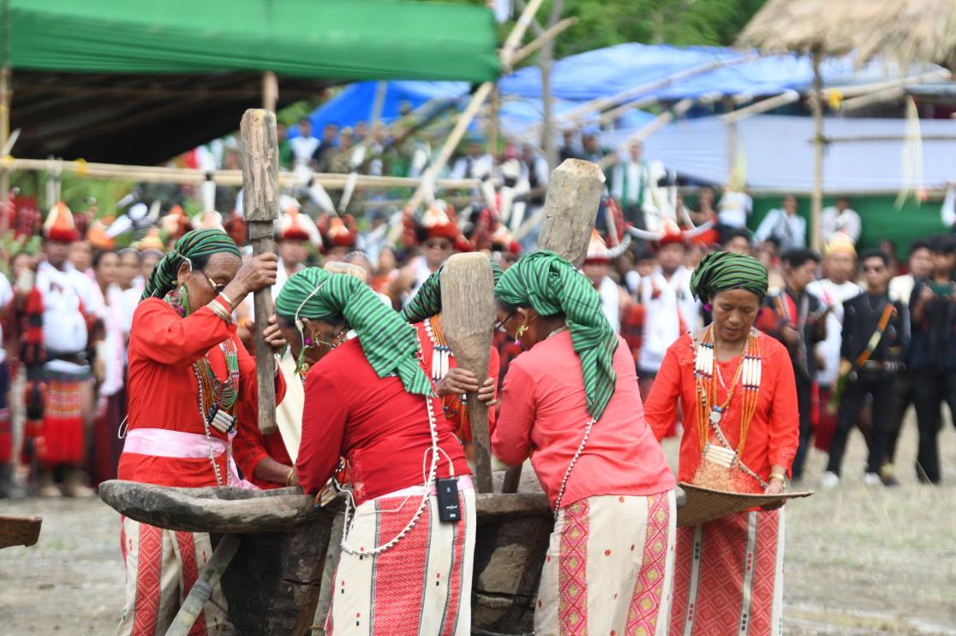
Earlier, the formal program begun with welcome speech from Ronghuan Celebration President Tediap Hallang and the Mythology of the Ronghuan Festival was read out by Ronghuan Festival Secretary Hangrang Bangsia.

