PRESS RELEASE
23rd October 2024
One-Day Training Programme on PARAKH RashtriyaSarvekshan 2024 Held at SCERT, Arunachal Pradesh.

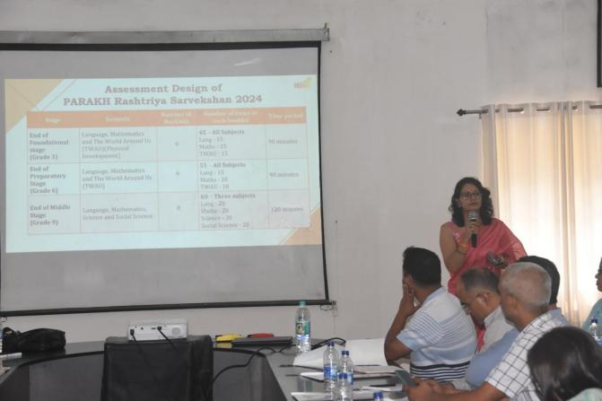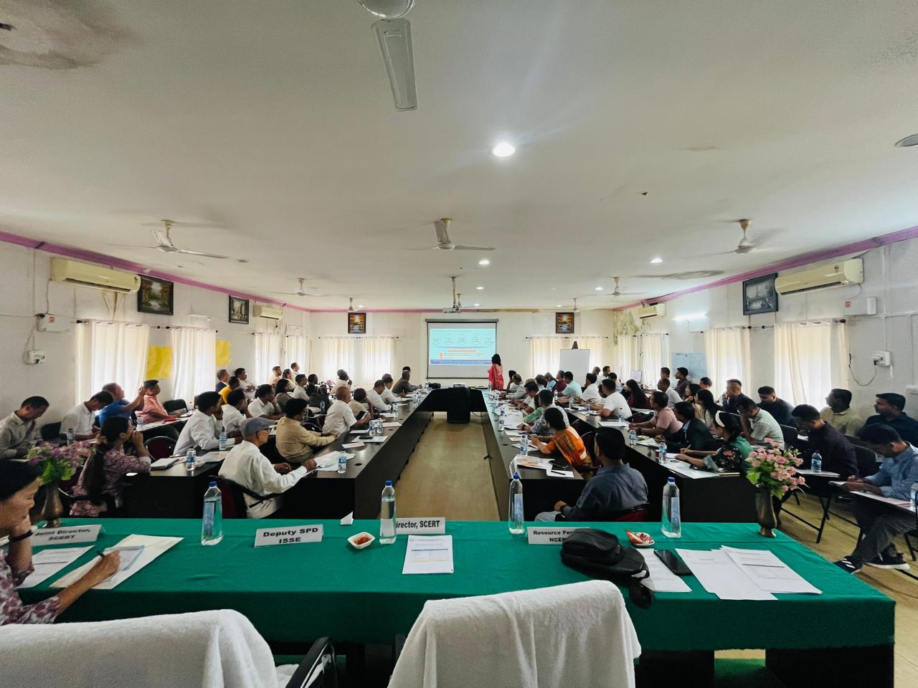
The State Council of Educational Research and Training (SCERT), Arunachal Pradesh, in collaboration with the National Council of Educational Research and Training (NCERT), successfully conducted a one-day training programme at the SCERT Conference Hall, Itanagar, as part of preparations for the upcoming PARAKH RashtriyaSarvekshan 2024 (Previously known as NAS). This assessment survey of student’s competencies is scheduled for 4th December 2024 across the country
The event started with a series of sessions to train District Level Coordinators (DLCs) and Assistant DLCs (ADLCs) from Arunachal Pradesh and Sikkim. These coordinators will serve as master trainers and will further train field investigators and observers, overseeing the survey’s implementation across their respective districts to ensure smooth execution and data accuracy. A total of 52 participants from Arunachal Pradesh and 40 participants from Sikkim participated in the training.
The sessions were led by a resource person from NCERT, New Delhi, with additional guidance provided by Prof. Indrani Bhaduri, CEO and Head of PARAKH at NCERT, who joined virtually to discuss the aims and objectives of the training. The event commenced with a welcome address by the Director of SCERT, who also felicitated the resource person. The Deputy SPD, ISSE delivered the keynote address and emphasized the importanceof the training.
PARAKH RashtriyaSarvekshan is a large-scale assessment initiative aimed at evaluating the learning outcomes of students across the country. With a focus on competency-based questions, NAS 2024 will assess students' critical thinking, problem-solving abilities, and application of knowledge. The survey will target students in grades 3, 6, and 9, with the results expected to guide future educational reforms nationwide. This year’s NAS is significant as it emphasizes competency-based assessments, which are in line with the vision of NEP 2020.
The primary objective of the training was to prepare the District Coordinators (DLCs and ADLCs) to lead the field investigators responsible for conducting the survey. Through this training, participants:
- Gained a comprehensive understanding of the PARAKH assessment design, which focuses on competency-based education.
- Learned the sampling and booklet distribution processes to ensure accurate representation of students across the selected grades and schools.
- Understood the roles and responsibilities of various stakeholders, including NCERT, CBSE, SCERT, and district-level officials.
- Were oriented on skills related to monitoring, field reporting, and documentation to ensure the smooth administration of the survey.
The SCERT remains committed to supporting DLCs and ADLCs in delivering effective training at the district level and ensuring the successful administration of survey. The state aims to leverage the outcomes of PARAKH RashtriyaSarvekshan 2024 to drive educational reforms and improve learning outcomes in government schools.This initiative marks a significant step towards achieving the educational goals outlined in NEP.

