Press Release

Dated Oct 15, 2024

One-Day Training-Cum-Interactive Workshop for Gaon Buras and Gaon Buris Held in Keyi Panyor District

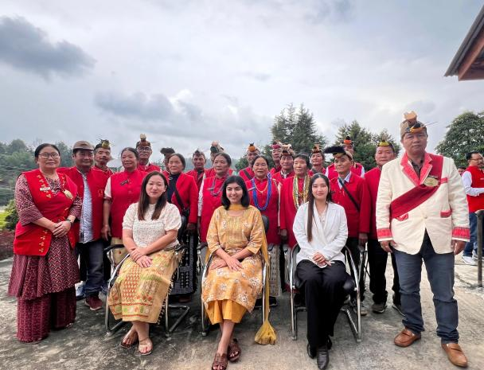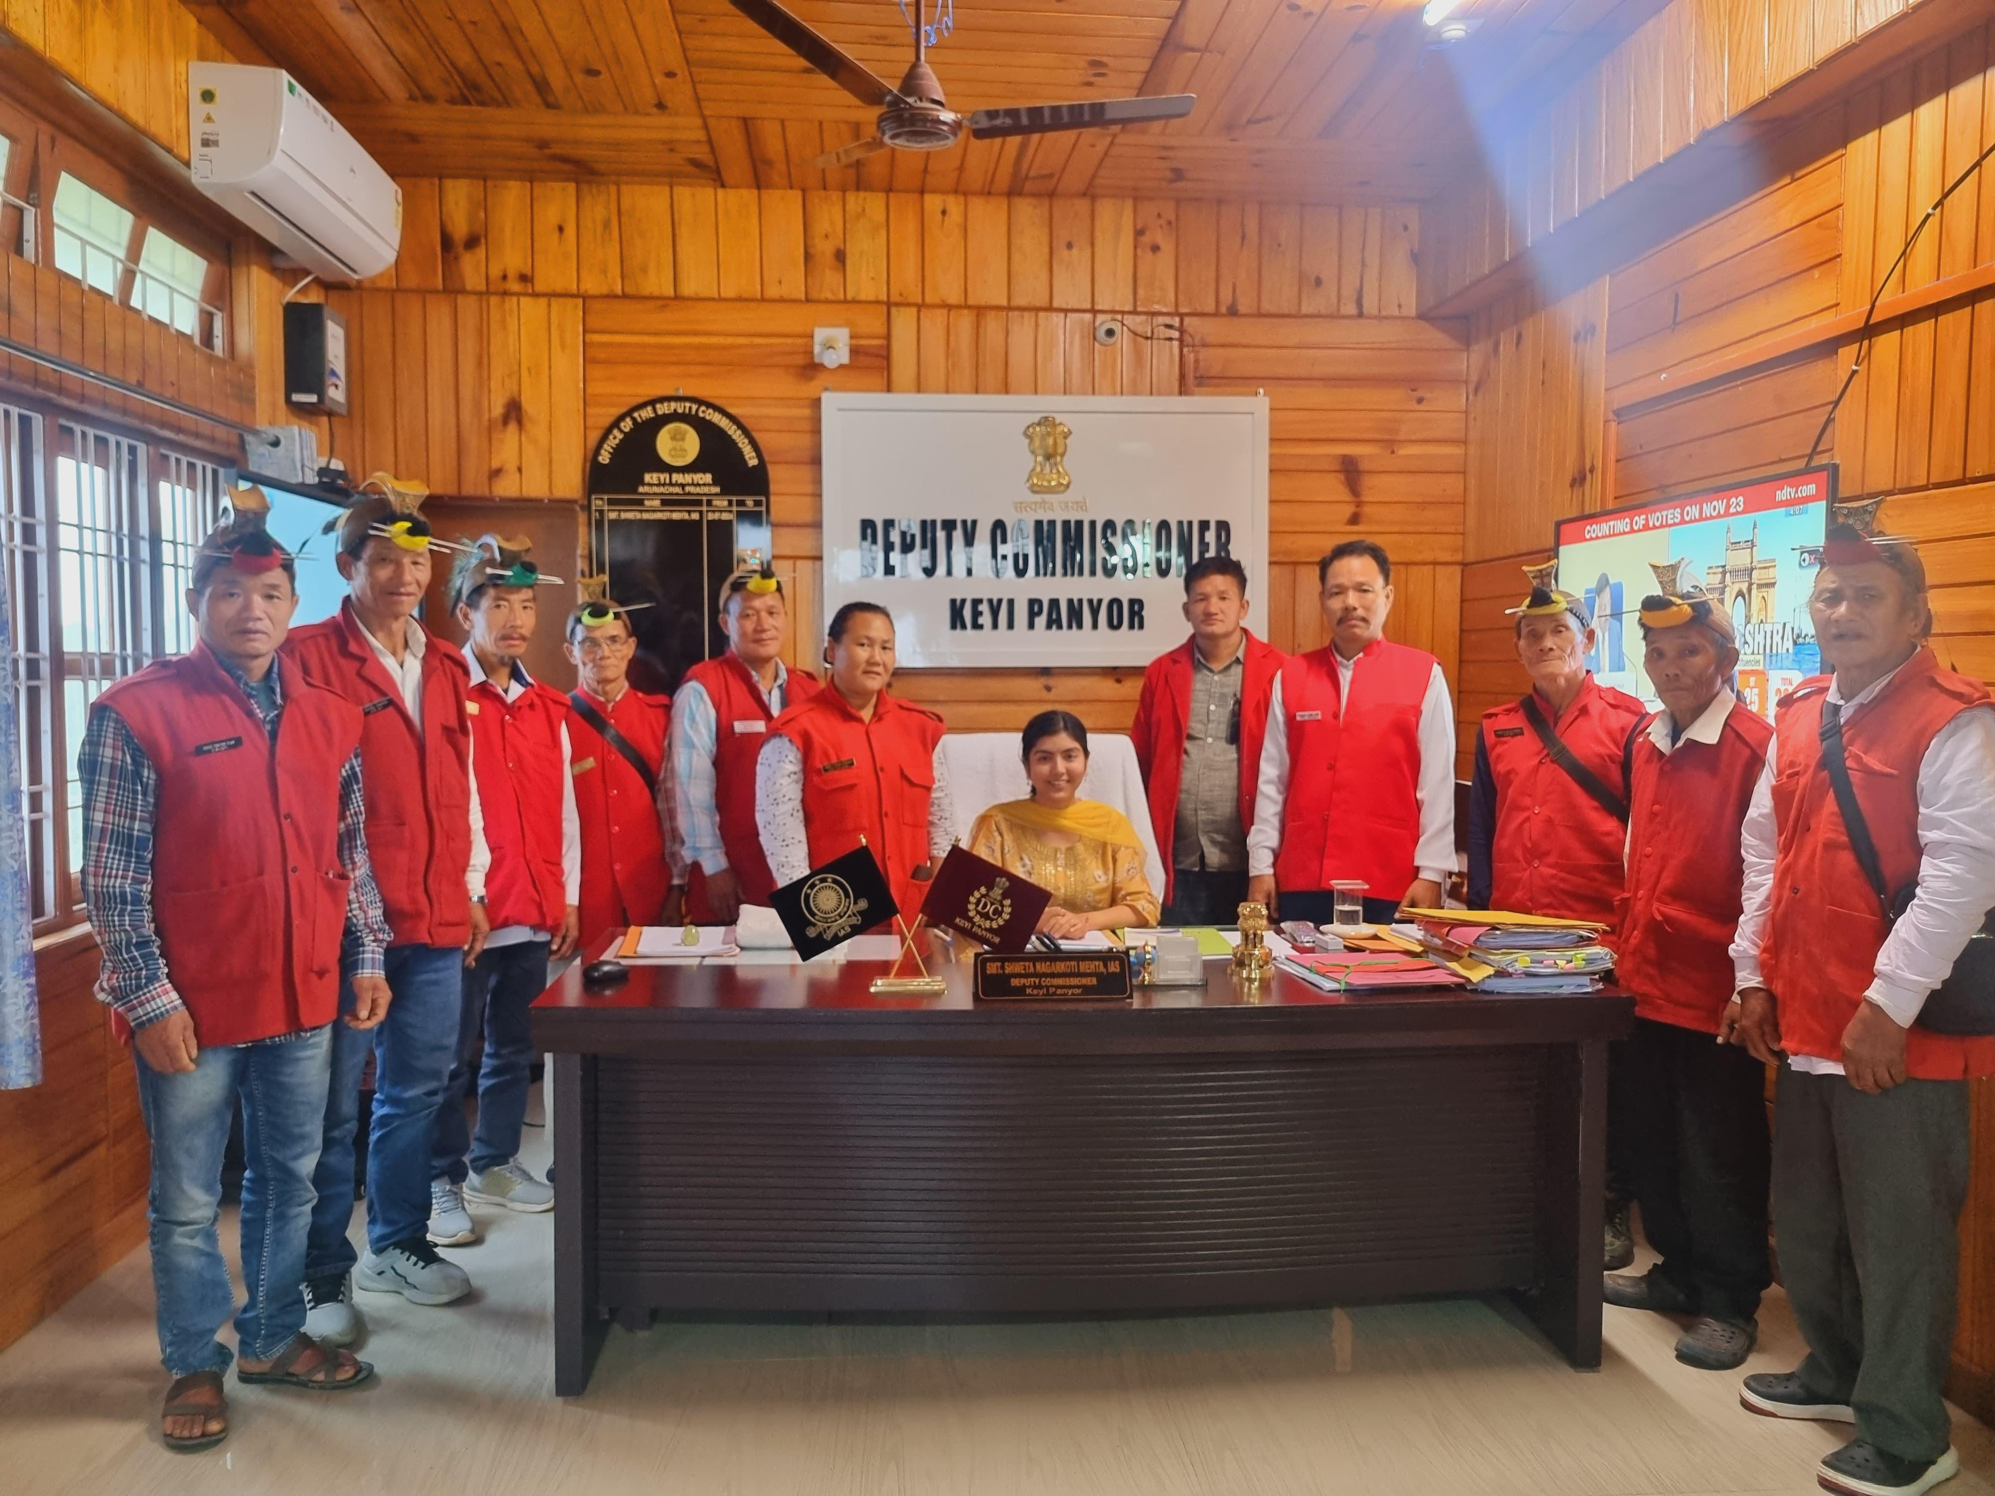

The Department of English at Rajiv Gandhi University, in collaboration with the Arunachal Pradesh Literary Society (APLS), inaugurated the Literary Activities Club on October 15, 2024. The occasion marks a significant milestone for the Department. The event itinerary commenced with an assembly of distinguished guests, faculty members, research scholars and students.

The programme opened with a warm welcome address by Dr. Doyir Ete, Head of Department (In-Charge), Department of English, RGU, who expressed her delight at the establishment of the Literary Activities Club and thanked the attendees for their support. Following this, the esteemed guests were felicitated with marks of honor and appreciation with traditional scarves and floral arrangements. The dignitaries present included Prof. S.K Nayak, Vice Chancellor of Rajiv Gandhi University, Mr. Mukhul Pathak, President of the Arunachal Pradesh Literary Society, Prof. S.S Singh, Dean, Faculty of Languages, RGU and Dr. Sarah Hilaly, Professor from the Department of History, RGU.

Dr. Bompi Riba, Assistant Professor, Department of English, RGU, elaborated on the club’s goals and objectives, emphasizing its role in fostering a vibrant culture of literary engagement and creativity among students. This was followed by an address by Prof. S.S Singh, praising the initiative and acknowledging the role the club would play in enhancing the literary culture of the university. Dr Sarah Hilaly also shared her insights and also called for literary ventures in exploration of the cultural roots of Arunachal Pradesh.

Mr. Mukhul Pathak, representing the APLS, congratulated the Department of English on the launch of the first-ever Literary club affiliated with the APLS. He emphasized on the role of literature and the importance of libraries in the society. He also remarked on the growing need for creative writers and content creators. He encouraged the students to use the club for exploring and nurturing their literary talents.

Prof. S.K Nayak, Vice Chancellor also graced the occasion with his words of encouragement. He congratulated the Department of English on establishing the first ever club of the university, noting the laurels it would bring to the university as a whole. He ended his speech by expressing his support for the future activities of the club.

The event concluded with a vote of thanks delivered by Dr. Prachand Narayan Piraji, Assistant Professor, Department of English, RGU. He expressed heartfelt gratitude to all the guests, faculty members, students and organisers who contributed to the success of the programme.

Following the formal addresses, the ribbon cutting ceremony took place, marking the official opening of the Literary Activities Club. This was a defining gesture which signifies the beginning of an optimistic new chapter in the literary spheres of the university as well as the state of Arunachal Pradesh. The club is now officially open as a space where young and budding writers could come together and celebrate literature and engage intellectually.

