Sept 27, 2024
Press Release

Nocte and Tutsa Tribes Conclude Three-Day Grand Ronghuan Festival

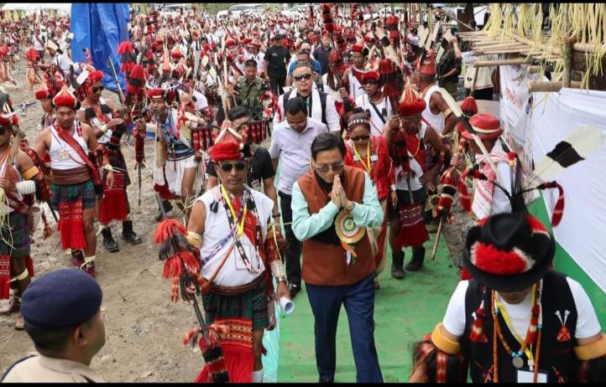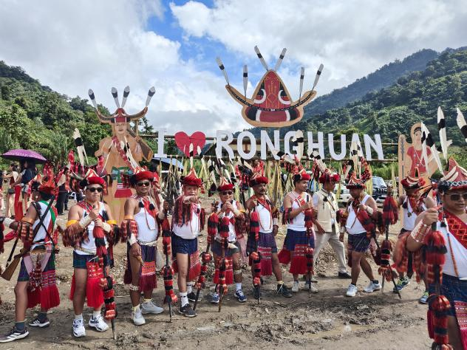
Khonsa, 27 Sept: The Nocte and Tutsa communities of Tirap District successfully concluded a grand three-day celebration of their annual millet harvesting festival, Ronghuan. The festival witnessed participation from over 40 villages, featuring traditional rituals led by a priest, followed by vibrant performances such as the bamboo dance, millet-crushing song, Worrok dance, victory dance, the traditional Ronghuan Parade, and more.
The event was graced by Honourable Minister Nyato Dukam as the Chief Guest and Honourable MLA Hamjong Tangha as the Guest of Honour. The Chief Guest hoisted the Ronghuan flag and emphasized the importance of preserving cultural identity and language amidst the growing influence of Hindi and English. He highlighted that festivals like Ronghuan are vital for maintaining the rich heritage of culture and tradition. Expressing pride in being part of the first historic grand Ronghuan as Chief Guest, he called for the festival to be properly documented and urged the Department of IPR to record this significant milestone.
The Chief Guest also related the Ronghuan festival to his own tribe's harvest traditions, where they pray to Donyi-Polo for a fruitful harvest and prosperous life. He expressed happiness at witnessing different tribes come together to celebrate, something rarely seen in Arunachal Pradesh. In his address, he highlighted the need to guide the region's youth, especially in addressing the growing issue of drug addiction, which he described as the biggest threat facing Arunachal Pradesh today. He concluded by expressing his hope to be invited again to future Ronghuan celebrations.

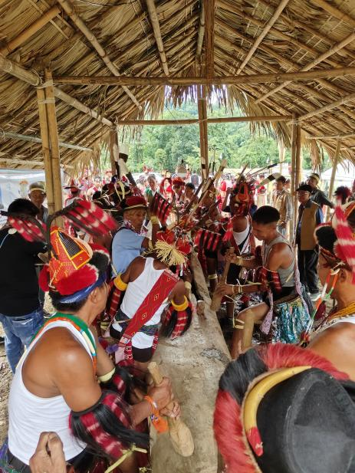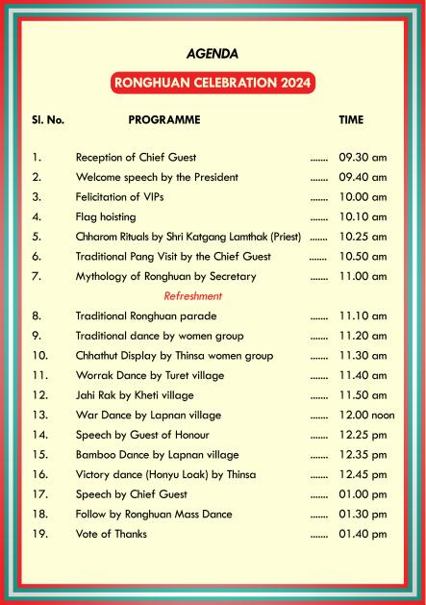
Guest of Honour MLA Hamjong Tangha spoke about the importance of unity among the Nocte, Tutsa, Olo, and other tribes. He also stressed the significance of practicing rituals as a core element of the festival. Tangha expressed concern over the development gap in the Tirap, Longding, and Changlang (TLC) districts compared to other districts and called for collective efforts to eliminate drug abuse among the youth to secure a brighter future.
Ronghuan Committee President Telliap Hallang, who officially invited all attendees, provided an overview of the festival's significance. This was followed by Secretary Hangrang Bangsia, who shared the mythology behind the Ronghuan Festival. Special guests at the event included Honourable Minister Wangki Lowang, Honourable MLA Chakat Aboh, ZPC Chathong Lowang, Former Honourable Minister Thajam Aboh, and other notable figures.

